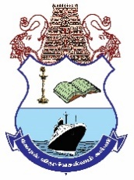 | PERIYAR ARTS COLLEGE,CUDDALORE -1  PG & RESEARCH DEPARTMENT OF ZOOLOGY  AFFILIATED TO THIRUVALLUVAR UNIVERSITY
STUDY MATERIAL
COURSE: | B.Sc. BOTANY | YEAR: I | SEMESTER: I
SUBJECT PAPER | ALLIED ZOOLOGY - I |  | PAPER CODE: BAZO15C
PREPARED BY NAME | 1.Dr. G. MANIMEGALA | 2.Dr. P. SENTHIL ELANGO
DESIGNATION | ASST. PROFESSOR | ASST. PROFESSOR
UNITS | I & II | III, IV & V

UNIT I | 1. Characters of Invertebrates
 | 2. Type study of (Entamoeba) | Entamoeba histolytica is an anaerobic parasitic amoebozoan, part of the genus Entamoeba.[1] Predominantly infecting humans and other primates causing amoebiasis, E. histolytica is estimated to infect about 35-50 million people worldwide.[1] E. histolytica infection is estimated to kill more than 55,000 people each year.[2] Previously, it was thought that 10% of the world population was infected, but these ﬁgures predate the recognition that at least 90% of these infections were due to a second species, E. dispar.[3] Mammals such as dogs and cats can become infected transiently, but are not thought to contribute signiﬁcantly to transmission.  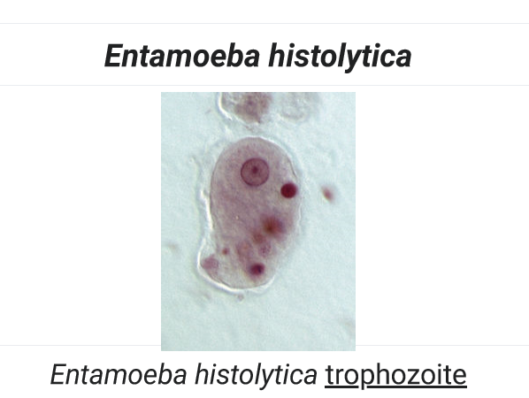  Scientiﬁc classiﬁcation  Domain: Eukaryota  Phylum: Amoebozoa  Family: Entamoebidae  Genus: Entamoeba  Species: E. histolytica  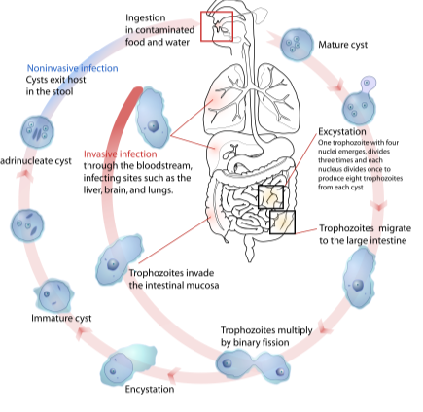  The word histolysis literally means disintegration and dissolution of organic tissues.  Transmission  The active (trophozoite) stage exists only in the host and in fresh loose feces;cysts survive outside the host in water, in soils, and on foods, especially under moist conditions on the latter. The infection can occur when a person puts anything into their mouth that has touched the feces of a person who is infected with E. histolytica, swallows something, such as water or food, that is contaminated with E. histolytica, or swallows E. histolytica cysts(eggs) picked up from contaminated surfaces or fingers.^{[4]} The cysts are readily killed by heat and by freezing temperatures, and survive for only a few months outside of the host.^{[5]} When cysts are swallowed they cause infections by excysting (releasing the trophozoite stage) in the digestive tract. The pathogenic nature of E. histolytica was first reported by Fedor A. Lösch in 1875,^{[1]} but it was not given its Latin name until Fritz Schaudinndescribed it in 1903. E. histolytica, as its name suggests (histo–lytic = tissue destroying), is pathogenic; infection can beasymptomatic or can lead to amoebic dysentery or amoebic liver abscess.^{[6][7]} Symptoms can include fulminating dysentery, bloody diarrhea, weight loss, fatigue, abdominal pain, and amoeboma. The amoeba can actually 'bore' into the intestinal wall, causing lesions and intestinal symptoms, and it may reach the blood stream. From there, it can reach different vital organs of the human body, usually the liver, but sometimes the lungs, brain, spleen, etc. A common outcome of this invasion of tissues is a liver abscess which can be fatal if untreated. Ingested red blood cells are sometimes seen in the amoeba cell cytoplasm.  Risk factors  Poor sanitary conditions are known to increase the risk of contracting amebiasisE. histolytica.^{[8]} In the United States, there is a much higher rate of amebiasis-related mortality in California and Texas, which might be caused by the proximity of those states to E. histolytica-endemic areas, such as Mexico, other parts of Latin America, and Asia.^{[9]}E. histolytica is also recognized as an emerging sexually transmissible pathogen, especially in male homosexual relations, causing outbreaks in non-endemic regions.^{[10]} As such, highrisk sex behaviour is also a potential source of infection.^{[11]} Although it is unclear whether there is a causal link, studies indicate a higher chance of being infected with E. histolytica if one is also infected with HIV.^{[12][13]}there is a causal link, studies indicate a higher chance of being infected with E. histolytica if one is also infected with HIV.^{[12][13]}of cases E. histolyticacauses disease. Once the trophozoites are excysted in the terminal ileum region, they colonize the large bowel, remaining on the surface of the mucus layer and feeding on bacteria and food particles.^{[1]}Occasionally, and in response to unknown stimuli, trophozoites move through the mucus layer where they come in contact with the epithelial cell layer and start the pathological process. E. histolytica has a lectin that binds to galactose and Nacetylgalactosamine sugars on the surface of the epithelial cells, The lectin normally is used to bind bacteria for ingestion. The parasite has several enzymes such as pore forming proteins , lipases, and cysteine proteases, which are normally used to digest bacteria in food vacuoles but which can cause lysis of the epithelial cells by inducing cellular necrosis and apoptosis when the trophozoite comes in contact with them and binds via the lectin. Enzymes released allow penetration into intestinal wall and blood vessels, sometimes on to liver and other organs.^{[21]} The trophozoites will then ingest these dead cells. This damage to the epithelial cell layer attracts human immune cells and these in turn can be lysed by the trophozoite, which releases the immune cell's own lytic enzymes into the surrounding tissue, creating a type of chain reaction and leading to tissue destruction. This destruction manifests itself in the form of an 'ulcer' in the tissue, typically described as flask-shaped because of its appearance in transverse section. This tissue destruction can also involve blood vessels leading to bloody diarrhea, amebic dysentery. Occasionally, trophozoites enter the bloodstream where they are transported typically to the liver via the portal system. In the liver a similar pathological sequence ensues, leading to amebic liver abscesses. The trophozoites can also end up in other organs, sometimes via the bloodstream, sometimes via liver abscess rupture or fistulas. In all locations, similar pathology can occur.Transcriptomic study of E. histolytica for promoter analysis of variable expression class of all the genes reveals that the highly transcribed genes of E. histolyticabelongs to virulence factor genes.^{[22]} The study also have reported about the presence of novel downstream regulatory motifs inE. Histolytica  Pathogen interaction  E. histolytica may modulate the virulence of certain human viruses and is itself a host for its own viruses.For example, AIDS accentuates the damage and pathogenicity of E.histolytica.^{[13]} On the other hand, cells infected with HIV are often consumed by E. histolytica. Infective HIV remains viable within the amoeba, although there has been no proof of human reinfection from amoeba carrying this virus.^{[23]}A burst of research on viruses of E.histolytica stems from a series of papers published by Diamond et al. from 1972 to 1979. In 1972, they hypothesized two separate polyhedral and filamentous viral strains within E. histolytica that caused cell lysis. Perhaps the most novel observation was that two kinds of viral strains existed, and that within one type of amoeba (strain HB-301) the polyhedral strain had no detrimental effect but led to cell lysis in another (strain HK-9). Although Mattern et al. attempted to explore the possibility that these protozoal viruses could function like bacteriophages, they found no significant changes in Entamoebahistolytica virulence when infected by viruses.^{[24]}  Treatment  There are a number of effective medications. Generally several antibiotics are available to treat Entamoebahistolytica. The infected individual will be treated with only one antibiotic if the E. histolytica infection has not made the person sick and most likely be prescribed with two antibiotics if the person has been feeling sick.^{[27]} Otherwise, below are other options for treatments.  Intestinal infection: Usually nitroimidazolederivatives (such as metronidazole) are used because they are highly effective against the trophozoite form of the amoeba. Since they have little effect on amoeba cysts, usually this treatment is followed by an agent (such as paromomycin or diloxanidefuroate) that acts on the organism in the lumen.^{[2]}  Liver abscess: In addition to targeting organisms in solid tissue, primarily with drugs like metronidazole and chloroquine, treatment of liver abscess must include agents that act in the lumen of the intestine (as in the preceding paragraph) to avoid re-invasion. Surgical drainage is usually not necessary except when rupture is imminent.^{[28]}  People without symptoms: For people without symptoms (otherwise known as carriers, with no symptoms), non endemic areas should be treated by paromomycin, and other treatments include diloxanidefuroateand iodoquinol. There have been problems with the use of iodoquinol and iodochlorhydroxyquin, so their use is not recommended. Diloxanidefuroate can also be used by mildly symptomatic persons who are just passing cysts.  Genus and species Entamoebahistolytica  Etiologic agent of: Amoebiasis; amoebic dysentery; extraintestinalamoebiasis, usually amoebic liver abscess; "anchovy sauce"); amoeba cutis; amoebic lung abscess ("liver-colored sputum")  Infective stage Tetranucleated cyst (having 2-4 nuclei)  Definitive host Human  Portal of entry Mouth  Mode of transmission Ingestion of mature cyst through contaminated food or water  Habitat Colon and cecum  Pathogenic stage Trophozoite  Locomotive apparatus Pseudopodia ("false foot”")  Motility Active, progressive and directional  Nucleus 'Ring and dot' appearance: peripheral chromatin and central karyosome  Mode of reproduction Binary fission  Pathogenesis Lytic necrosis (it looks like “flask-shaped” holes in Gastrointestinal tract sections (GIT)  Type of encystment Protective and Reproductive  Lab diagnosis Most common is direct fecal smear (DFS) and staining (but does not allow identification to species level); enzyme immunoassay (EIA); indirect hemagglutination (IHA); Antigen detection – monoclonal antibody; PCR for species identification. Sometimes only the use of a fixative (formalin) is effective in detecting cysts. Culture: From faecal samples - Robinson's medium, Jones' medium  Treatment Metronidazole for the invasive trophozoites PLUS a lumenalamoebicide for those still in the intestine. Paromomycin (Humatin) is the luminal drug of choice, since Diloxanidefuroate (Furamide) is not commercially available in the United States or Canada (being available only from the Centers for Disease Control and Prevention). A direct comparison of efficacy showed that Paromomycin had a higher cure rate.^{[29]}Paromomycin (Humatin)  should be used with caution in patients with colitis, as it is both nephrotoxic and ototoxic. Absorption through the damaged wall of the intestinal tract can result in permanent hearing loss and kidney damage. Recommended dosage: metronidazole 750 mg three times a day orally, for 5 to 10 days followed by paromomycin 30 mg/kg/day orally in 3 equal doses for 5 to 10 days or Diloxanidefuroate 500 mg 3 times a day orally for 10 days, to eradicate lumenal amoebae and prevent relapse.^{[30][31]}  Trophozoite stage  Pathognomonic/diagnostic feature Ingested RBC; distinctive nucleus  Cyst Stage  Chromatoidal body 'Cigar' shaped bodies (made up of crystalline ribosomes)  Number of nuclei 1 in early stages, 4 when mature  Pathognomonic/diagnostic feature 'Ring and dot' nucleus and chromatoid bodies
 | 3. Type study of Porifera (Sycon) | SYCON SPONGE (SCYPHA) STRUCTURE AND ITS CANAL SYSTEM AND NUTRITION.  ORGANISATION OF SYCON.SPONGE (SCYPHA)  Sycon or Scypha is a typical, small colonial sponge. It belongs to  SYCON-Classiﬁcation :  Phylum…….Porifera  Class………..Calcarea  Order………Heterocoela  Sycon is widely distributed marine sponge. It is sedentary. It is attached to rocks, shells etc. in shallow sea water.  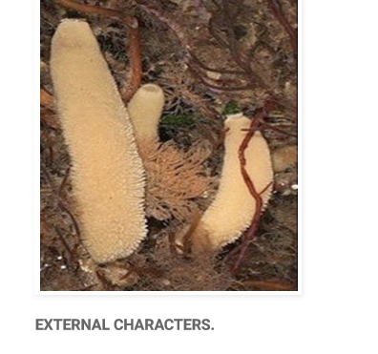  1. SIZE AND SHAPE OF SYCON SPONGE: The colony contains groups of cylinders, which are branched. Each cylinder grows three inches in length. All the branched cylinders are connected to a base. At the apex of the cylinder an opening is present called oseulum. Around this opening monaxon spicules are arranged in a circle, called oscular fringe.  2. Colour : The body shows many colours from grey to brown shade.  INTERNAL STRUCTURE OF SYCON: Sycon is a diplob lastic animal .The body wall is made by two layers  1) Derma 1 layer and  2) Gastral layer.  In between them mesenchyme is present.  A) Dermal layer : This layer contains pinacocytes and porocytes.  1. Pinacocytes : These are simple ﬂat, polygonal cells. These are highly contractile. They cover the entire outer body surface of the sponge. Pinacocytes covering the outer body surf from the dermal epithelium and which cover paragastric cavity and form the gastral epithelium.  2. Potocytes :These are tubular cells distributed among the pinacocytes. They form the openings on the dermal layer.  B) Gastral layer : it shows choanocytes and epithelial cells. Qvanocytes : These are round cells. They show big nucleus A long ﬂagellum s rises from each cell. At base of the ﬂagellum a protoplasmic collar is present. The action of ﬂagellum brings in water. This cell is useful in digestion, respiration and other functions.  C) Mesenchyme : It is present between dermal and gastral layers. It contains amoebocytes. They are many types.  1) Scleroblasts : The amoebocytes secrete skeleton. Scleroblasts are of three types :  1) Calcoblasts . Scleroblasts that secrete calcareous spicules. ii) Silicoblasts . Scleroblasts that secrete silicious spicules iii') Spongioblasts . Scleroblasts that secrete spongin ﬁbres.  2) Chromocytes: Amoebocytes with pigment and give colour to the body.  3) Thesocytes : These cells contain reserve food material.  4) Archeocytes : These are big in size. They give rise to sex cells.  5) Myocytes : These are highly contractile cells. They are arranged circularly around the osculum arid other openings. They guard and regulate the apertures.  6) Gland cells : They are attached to the surface of the sponge. They produce slime.  CANAL SYSTEM IN SYCON SPONGE:  Sycon shows syconoid type of canal system.  a) Dermal ostla : On the body of the sycon dermal ostia are present. They open into incurrent canals  b) In current canals : These are narrow canals. These are covered inside by epethelial cells. They show some openings here and there called prosopyles. c) Radial canal: The body wall is folded. In these foldings radial canals are present at regular intervals.  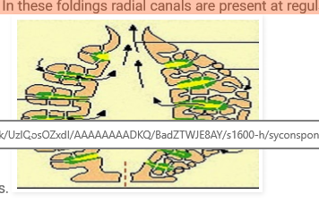  In between the two successive radial canals a tubular space, called incurrent canal, is present. Thus radial canals and incurrent canals are arranged alternately.The radial canals are lined with ﬂagellated cells The ﬂagellar action brings water into the body.  d) Excurrent chambers : The radial canal opens into excurrent chamber through apopyle openings. This chamber is lined by epithelial cells. It opens into spongocoel.  e) Spongocoel : In the centre of the body of sycon a narrow cavity is present called spongocoel. It opens out through osculum.  NUTRITION IN SYCON SPONGE:  a) Food : The food of sycon is small minute bacteria, diatoms, protozoans etc. The food particles come into the sponge along with water current.  b) Digestion : The digestion is intracellular. The food particles are usually captured by the choanocytes. Digestion takes place in the choanocytes. The digested food is passed to other cells. The reserve food is stored in the form of fats, glycogen and Droteins in the thesocyte.  NUTRITION IN SYCON SPONGE:  The undigested marter sent out through osculum along with excurrent water current.  SYCON SPONGE-SPICULES :  In sycon the skeleton contains calcareous spicules. These are of the following types, (i) Large one rayed needle like Monaxon spicules,  (ii) Simple monaxon spicules project from dermal layers on the walls of the radial canals,  (iii) Triaxon spicules are present on the walls of spongocoel.  (iv) Tetraxon spicules are present on the walls of spongocoel.  RESPIRATION : Respiratory organs are absent in sycon. Respiration is by simple diffusion, between the cells of sponge and water.  EXCRETION : In sycon excretory organs are absent. It is done by diffusion. Some people say the excretory wastes will go out of the body through excurrent water.  REPRODUCTION IN SYCON SPONGE: it is carried on by asexual and sexual methods. Budding is the common asexual method.  Sexual reproduction is carried on by the development of sperms and ova. Fertilisation is internal. In the life history Amphiblastula larva is seen .
 | 4. Type study of Coelentrata (Obetia geniculata) | Obelia: General Characters and Life cycle  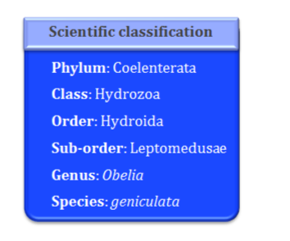  OBELIA GENERAL CHARACTERS  Distribution  It is cosmopolitan in distribution in other words, worldwide distribution except the high- arctic and Antarctic seas. The medusa stage of Obelia species is common in coastal and offshore plankton around the world.  Habit and Habitat  Obelia is sedentary, marine and colonial form. It is found up to the depth of 80 meters. It occurs in both asexual and sexual forms. It grows in intertidal rock pools and at the extreme low water of spring tides.  External Morphology  Obelia is also called as Sea fur. The hydroid colony of Obelia is delicate, semitransparent and whitish to light brown in color. It consists of vertical branching stems are called as hydrocauli and the root like branches are called hydrorhiza. Both are of same thickness. The growth of the colony is sympodial.  Each of the vertical stem or hydrocauli branches in an alternate manner. The ultimate branch terminates in a nutritive zooid called polyp or hydranth. In the older polyps cylindrical reproductive zooids are placed which is known as blastostyle or gonangia. This Obelia colony is dimorphic exhibiting two types of zooids. When the blastostyles develop saucer- shaped bodies called as medusae, the dimorphic colony becomes trimorphic. The following are the three zooids of the Obelia colony,Polyp or hydranth (nutritive zooids): This nutritive zooid of the colony is also known as gastrozooids or trophozooid. It is yellow in color, radial symmetrical and cylindrical in shape. They are specialized for capture, ingestion and digestion of food. Each hydranth is closely similar in structure to that of hydra. It has a sac-like body. The basal end is not closed but connected by a hollow stalk with the hydrocaulus. The body wall composed of ectoderm, mesogloea, and endoderm encloses a simple enteron that opens to outside by the mouth situated at the free end of the hydranth. Mouth is situated at the apex of the hypostome. The ectoderm of the hydranth is thin. The nematocysts are present only on the tentacles. The middle structure less layer, the mesogloea, has nerve net present on its both sides.  The endoderm cells are similar to those of hydra. The nutritive-muscular cells possess agella at their inner ends. The gland cells are large and with granular inclusions. The tubular perisarc surrounding the coenosarc extends around the hydranth to form its conical protective covering known as hydrotheca.  Blastostyle (reproductive zooids): After the hydrocaulus has reached its full development it gives rise to special zooids called blastostyles. They are fewer in number as compared to hydranths in the colony.  The mouth and tentacles are absent in these simplied zooids. They cannot feed hence their enteron is reduced in size. The distal closed end usually forms a attened disc. The perisarc extends over the blastostyle to form a cylindrical or vase-like transparent gonotheca.  The blastostyles are the reproductive zooids as they reproduce asexually to give rise to numerous lateral buds called medusa buds or gonophores. These buds develop into third type of zooids of the colony called medusae. When they are fully formed they are set free and swim away from the colony by escaping through the ruptured distal end or by opening of the lid of the gonotheca.  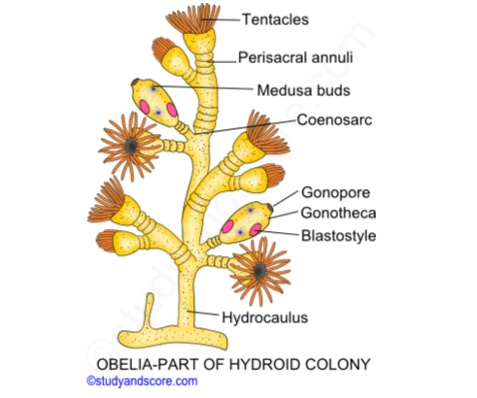  Medusae: These are small, transparent, solitary, free swimming saucer-shaped or bell- shaped zooids. They measure about 6 mm in diameter. These are the reproductive zooids which produce the sex cells.  The inner concave side of the body is known as sub-umbrella and outer convex as exumbrella. A short, hollow, quadrangular projection, the manubrium, hangs down from the middle of the sub umbrella surface. This structure together with the disc or bell-shaped body of the medusa gives it an umbrella-like appearance. The mouth, a square or four sided opening is situated at the tip of the manubrium.  The mouth leads through the cavity of the manubrium into a small gastral cavity or enteric cavity or stomach situated in the central part of the main body of the medusa. From this cavity radiate four narrow radial canals situated at equal distances from each other. These canals run outwards toward the edge of the umbrella and open into a circular canal running around the edge of the umbrella. This system of canal enables the food to be taken in at the mouth and manubrium and digested in the stomach to be distributed through them to the entire medusa.  The edge of the medusa gives off on its inner side a very narrow, rudimentary fold or shelf called the velum. The margin of the umbrella gives off short tentacles which are sixteen in number in the newly born medusa but are numerous in the adult. Ectoderm covers both the surface of the umbrella and the outer surface of the manubrium. The endoderm lines the cavity of the manubrium, ‘stomach’, radial canals and circular canals which together represent the enteron. Endoderm does not extend into the velum.  OBELIA LIFE CYCLE  The primary function of the medusa is sexual reproduction. Obelia is dioecious as each medusa has reproductive organs of only one sex. There is no difference between the male and female medusae. The gonads (testis or ovaries) are four in number and lie on the sub- umbrella, below the radial canals, in the form of knobs. Thus gonads are per-radial in position. They are situated almost at equal distances between the manubrium and the velum. The gonads which arise as diverticula of the radial canals have the same structure as the body wall of medusa. The sex cells start developing very early when the medusa is being formed. These cells originate in the ectoderm of the manubrium, migrate to the endoderm and nally make their way to the gonads. They lie between the ectoderm of the sub-umbrella and the mesogloea.  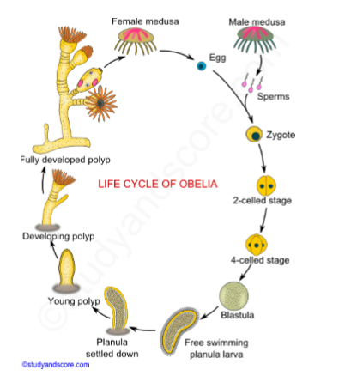  Fertilization: The sperm and ova when fully formed are set free in water by rupture of the outer wall of the gonad. Sometimes the agellated sperms swim about in water and fertilize the ova present in female medusae. The fertilization takes place in water. As medusa is the motile form, it performs two important functions for the colony namely reproduction and dispersal of the gametes.  Cleavage: The fertilized egg undergoes cleavage which is equal and holoblastic (complete). The blastula is a hollow boll consisting of single layer of cells enclosing the blastocoel. This cavity gets completely lled up with cells budded from the wall of the blastula. The embryo is now called stereo gastrula or solid gastrula. The embryo is set free from the egg membrane as a free-swimming larva called the planula. The larva swims about for some time and brings about wide distribution of the species. A cavity soon appears in the endoderm cell mass, which becomes the enteron.  Hydrula: After the free-swimming life the planula larva loses its cilia and settles down on the bottom of the sea, gets attached to the substratum by its broader end and undergoes metamorphosis. The attached or proximal end widens into a disc of attachment. A short distance from the free or proximal end a dilatation is formed. From this portion tentacles arise in a circle as short buds. The narrow portion beyond their origin becomes the hypostome. Soon an aperture, the mouth, is formed at the end of the hypostome. The young hydranth closely resembles a simple polyp like hydra and is called hydrula which undergoes repeated asexual budding to gives rise to complex Obelia colony.  Alternation of generation: Alternation of generation is also known as metagenesis. It is a phenomenon whereby, in the life history of an organism, a diploid asexual phase and a haploid sexual phase regularly alternate with each other.  In Cnidaria, two types of individuals exist namely a polyp and a medusa,  Polyp: The tube like zooid is called polyp. The polyp reproduces asexually It is sessile and attaches to a substrate at the aboral end. It has a cylindrical body called the column. Its mouth is surrounded by food-gathering tentacles.  The body structure of polyp form is simple with simple muscles and nervous system. Velum is absent. Mouth is circular without oral lobes. Also its gastro vascular cavity is simple without radial circular canals. Sensory organs are absent in this form. This form reproduces asexually by budding.  Medusa: The umbrella like zooid is called medusa. The medusa is dioecious and free swimming. Its shape is like an inverted bowl. The tentacles hang from its margins. The mouth opening is centrally located at lower side. The medusa swims by medusa than in a polyp. It gives the medusa a jellylike appearance.  The body structure of medusa form is complicated with well-developed muscles and nervous system. Velum is present around the margins of the umbrella shaped body. Also its gastro vascular cavity is well-developed with radial and circular canals. Sensory organs called as statocysts are present on the margins of the tentacles. These forms reproduce sexually through gametes.  These two forms, polyp and medusa alternate successively where the polyp reproduce asexually to form a large number of medusa, each medusa reproduce sexually by the union of eggs and sperms to form zygote. The zygote grows into larva, which x itself to a substrate and nally form a new polyp.
 | 5. Type study of Plathyhelminthes (Taenia Solium) | Taenia Solium (Pork Tapeworm) Infection and Cysticercosis  Taenia solium infection (taeniasis) is an intestinal infection with adult tapeworms that follows ingestion of contaminated pork. Cysticercosis is infection with larvae of T. solium, which develops after ingestion of ova excreted in human feces. Adult worms may cause mild gastrointestinal symptoms or passage of a motile segment in the stool. Cysticercosis is usually asymptomatic unless larvae invade the central nervous system, resulting in neurocysticercosis, which can cause seizures and various other neurologic signs. Neurocysticercosis may be recognized on brain imaging studies. Fewer than half of patients with neurocysticercosis have adult T. solium in their intestines and thus eggs or proglottids in their stool. Adult worms can be eradicated with praziquantel. Treatment of symptomatic neurocysticercosis is complicated; it includes corticosteroids, antiseizure drugs, and, in some situations, albendazole or praziquantel. Surgery may be required  Taenia solium life cycle  Humans develop intestinal infection with adult worms after ingestion of contaminated pork or may develop cysticercosis after ingestion of T. solium eggs (making humans intermediate hosts).  1. Humans ingest raw or undercooked pork containing cysticerci (larvae).  2. After ingestion, cysts evaginate, attach to the small intestine by their scolex, and mature into adult worms in about 2 months.  3. Adult tapeworms produce proglottids, which become gravid; they detach from the tapeworm and migrate to the anus.  4. Detached proglottids, eggs, or both are passed from the definitive host (human) in feces.  5. Pigs or humans become infected by ingesting embryonated eggs or gravid proglottids (eg, in fecally contaminated food). Autoinfection may occur in humans if proglottids pass from the intestine to the stomach via reverse peristalsis.  6. After eggs are ingested, they hatch in the intestine and release oncospheres, which penetrate the intestinal wall.  7. Oncospheres travel through the bloodstream to striated muscles and to the brain, liver, and other organs, where they develop into cysticerci. Cysticercosis can res  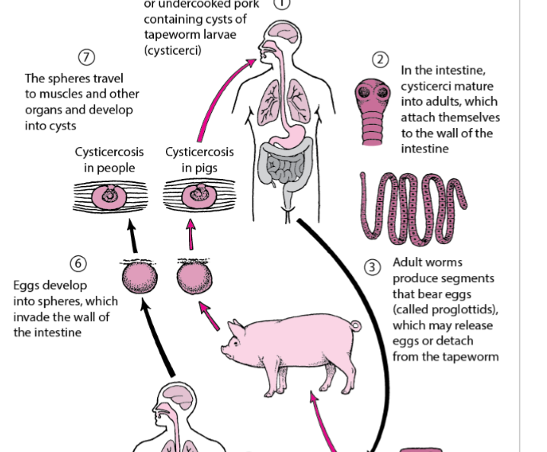  Symptoms and Signs  Intestinal infection  Humans infected with adult T. solium worms are asymptomatic or have mild gastrointestinal complaints. They may see proglottids in their stool. Cysticercosis Viable cysticerci (larval form) in most organs cause minimal or no tissue reaction, but dying cysts in the central nervous system, eye, or spinal cord can release antigens that elicit an intense tissue response. Thus, symptoms often do not appear for years after infection. Infection in the brain (neurocysticercosis) may result in severe symptoms due to mass effect and inflammation induced by degeneration of cysticerci and release of antigens. Depending on the location and number of cysticerci, patients with neurocysticercosis may present with seizures, signs of increased intracranial pressure, hydrocephalus, focal neurologic signs, altered mental status, or aseptic meningitis. Cysticerci may also infect the spinal cord, muscles, subcutaneous tissues, and eyes. Substantial secondary immunity develops after larval infection.  Treatment  For intestinal infection (without neurocysticercosis): Praziquantel or niclosamide (outside the US) For neurocysticercosis: Corticosteroids, antiseizure drugs, and sometimes albendazole or praziquantel and/or surgery  Treatment of intestinal infection  Intestinal infection is treated with praziquantel 5 to 10 mg/kg orally as a single dose to eliminate adult worms. Praziquantel should be used with caution in patients who also have neurocysticercosis (including previously asymptomatic or unrecognized disease) because by killing cysts, praziquantel may trigger an inflammatory response associated with seizures or other symptoms.  Pearls & Pitfalls  T. solium eggs are present in ≤ 50% of stool samples from patients with cysticercosis.Alternatively, a single 2-g dose of niclosamide (not available in the US) is given as 4 tablets (500 mg each) that are chewed one at a time and swallowed with a small amount of water. For children, the dose is 50 mg/kg (maximum 2 g) once. Treatment of neurocysticercosis  Treatment of neurocysticercosis is complicated. Detailed clinical practice guidelines on the Diagnosis and Treatment of Neurocysticercosis were published by the Infectious Diseases Society of America and the American Society of Tropical Medicine and Hygiene in 2018. The initial treatment goals for symptomatic neurocysticercosis are To reduce inflammation associated with degenerating cysticerci documented by MRI To prevent seizures if present or if risk is high To relieve increased intracranial pressure if present Corticosteroids (prednisone up to 60 mg orally once/day or dexamethasone 12 to 24 mg orally once/day) are used to reduce inflammation and increased intracranial pressure. Recipients of prolonged corticosteroid therapy should be evaluated for concurrent latent tuberculosis and strongyloidiasis. Conventional antiseizure drugs are given to patients who have seizures. These drugs can be used prophylactically in patients at high risk of seizures, particularly those who have multiple degenerating lesions with associated inflammation. Neurosurgical intervention may be necessary for patients with increased intracranial pressure or intraventricular cysticerci. Anthelmintic treatment of neurocysticercosis is complicated, and consultation with an expert is recommended. Choice of treatment depends on the location, number, viability, and size of cysticerci; stage of the disease; and clinical manifestations. Prior to anthelmintic treatment, an ophthalmologic examination should be done to exclude the presence of ocular cysticerci. Not all patients respond to treatment, and not all patients must be treated (cysts may already be dead and calcified, or the potential inflammatory response to treatment may be worse than the disease, as in cysticercal encephalitis when patients have a large number of cysts and widespread brain inflammation). When anthelmintic treatment is used, albendazole 7.5 mg/kg orally twice/day for 15 days appears to be more effective than the alternative, praziquantel 16.6 mg/kg orally 3 times a day for 15 days. The combination of albendazole plus praziquantel has been reported to result in a higher rate of radiographic resolution than albendazole alone in patients with more than 2 parenchymal cysts. Albendazole alone or in combination with praziquantel given for ≥ 30 days has been used to treat cysts in the subarachnoid space (racemose cysticercosis), which are less responsive to anthelmintic drugs. Patients receiving prolonged, high dose treatment with albendazole need to be monitored for bone marrow suppression and drug- related hepatitis. Neuroimaging is repeated at 6-month intervals until the findings have resolved. Either prednisone or dexamethasone is started a few day before and continued during the course of anthelminthic administration to reduce the inflammation that occurs in response to dying cysts in the brain. Corticosteroids increase the cerebrospinal fluid (CSF) level of the active metabolite of albendazole but decrease the CSF level of praziquantel. Methotrexate has been used as a corticosteroid-sparing agent in patients requiring more than 2 weeks of anti- inflammatory therapy. Neither albendazole nor praziquantel should be used in patients with ocular or spinal cord cysticerci due to potential adverse effects of the inflammatory response elicited by dying cysts. The presence of intraventricular cysticerci is also a relative contraindication for anthelminthic drugs because the resulting inflammatory response elicited by the dying cysts can cause obstructive hydrocephalus. Surgery may be necessary for obstructive hydrocephalus (due to intraventricular cysticerci including those in the 4th ventricle) or spinal or ocular cysticercosis. Intraventricular cysticerci are removed endoscopically when possible. Ventricular shunts may be needed to reduce increased intracranial pressure. Prevention  Intestinal T. solium infection can be prevented by cooking whole cuts of pork to ≥ 63° C (≥ 145° F) as measured with a food thermometer placed in the thickest part of the meat, then allowing the meat to rest for 3 minutes before carving or consuming. Ground pork should be cooked to ≥ 71° C (≥ 160° F). Ground pork does not require a rest period. Identifying and treating carriers of adult T. solium is an important public health measure in preventing cysticercosis. In the US, transmission has occurred when people who were infected in endemic areas had adult T. solium in their intestines, then contaminated food with their stool. It is very important that food handlers from endemic areas be taught and adhere to good handwashing practices. When traveling to endemic areas with poor sanitation, people should be careful to avoid foods that might be contaminated by human feces and avoid raw and inadequately cooked pork.
UNIT II | 1. Type study of Annelida (Earthworm) | Earthworm  An earthworm is a terrestrial invertebrate that belongs to the order Opisthopora. They exhibit a tube-within-a-tube body plan, are externally segmented with corresponding internal segmentation, and usually have setae on all segments.[1] They occur worldwide where soil, water, and temperature allow.[2] Earthworms are commonly found in soil, eating a wide variety of organic matter.[3] This organic matter includes plant matter, living protozoa, rotifers, nematodes, bacteria, fungi, and other microorganisms.[4] An earthworm's digestive system runs the length of its body.[5] It respires through its skin. It has a double transport system made of coelomic ﬂuid that moves within the ﬂuid-ﬁlled coelom and a simple, closed circulatory system. It has a central and peripheral nervous system. Its central nervous system consists of two ganglia above the mouth, one on either side, connected to a nerve running along its length to motor neurons and sensory cells in each segment. Large numbers of chemoreceptors concentrate near its mouth.Circumferential and longitudinal muscles edging each segment let the worm move. Similar sets of muscles line the gut, and their actions move digesting food toward the worm's anus.  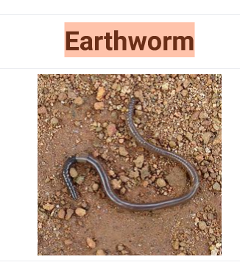  An earthworm with a well-developed clitellum  Scientific classification:  Kingdom: Animalia  Phylum: Annelida  Class: Clitellata  Subclass: Oligochaeta  Order: Opisthopora  Earthworms are hermaphrodites: each carries male and female sex organs. As invertebrates, they lack a true skeleton, but maintain their structure with ﬂuid-ﬁlled coelom chambers that function as a hydrostatic skeleton."Earthworm" is the common name for the largest members of Oligochaeta (which is a class or subclass depending on the author). In classical systems, they were in the order Opisthopora, since the male pores opened posterior to the female pores, although the internal male segments are anterior to the female. Theoretical cladistic studies have placed them in the suborder Lumbricina of the order Haplotaxida, but this may soon change. Folk names for the earthworm include "dew-worm", "rainworm", "nightcrawler", and "angleworm" (from its use as ﬁshing bait). Larger terrestrial earthworms are also called megadriles (translates to "big worms"), opposed to the microdriles ("small worms") in the semiaquatic families Tubiﬁcidae, Lumbricidae, and Enchytraeidae. The megadriles are characterized by a distinct clitellum (more extensive than that of microdriles) and a vascular system with true capillaries.  Anatomy  Form and function  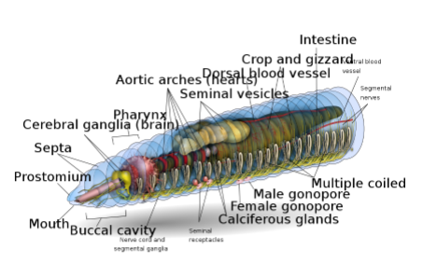  Earth warm head  Depending on the species, an adult earthworm can be from 10 mm (0.39 in) long and 1 mm (0.039 in) wide to 3 m (9.8 ft) long and over 25 mm (0.98 in)wide, but the typical Lumbricus terrestris grows to about 360 mm (14 in) long.[8] Probably the longest worm on conﬁrmed records is Amynthas mekongianus that extends up to 3 m (10 ft) [9] in the mud along the banks of the 4,350 km (2,703 mi) Mekong River in Southeast Asia.  From front to back, the basic shape of the earthworm is a cylindrical tube-in-a-tube, divided into a series of segments (called metamerisms) that compartmentalize the body. Furrows are generally[10] externally visible on the body demarking the segments; dorsal pores and nephridiopores exude a ﬂuid that moistens and protects the worm's surface, allowing it to breathe. Except for the mouth and anal segments, each segment carries bristlelike hairs called lateral setae[11] used to anchor parts of the body during movement;[12] species may have four pairs of setae on each segment or more than eight sometimes forming a complete circle of setae per segment.[11] Special ventral setae are used to anchor mating earthworms by their penetration into the bodies of their mates.[13]  Generally, within a species, the number of segments found is consistent across specimens, and individuals are born with the number of segments they will have throughout their lives. The ﬁrst body segment (segment number 1) features both the earthworm's mouth and, overhanging the mouth, a ﬂeshy lobe called the prostomium, which seals the entrance when the worm is at rest, but is also used to feel and chemically sense the worm's surroundings. Some species of earthworm can even use the prehensile prostomium to grab and drag items such as grasses and leaves into their burrow.  An adult earthworm develops a belt- shaped glandular swelling, called the clitellum, which covers several segments toward the front part of the animal. This is part of the reproductive system and produces egg capsules. The posterior is most commonly cylindrical like the rest of the body, but depending on the species, it may also be quadrangular, octagonal, trapezoidal, or ﬂattened. The last segment is called the periproct; the earthworm's anus, a short vertical slit, is found on this segment.  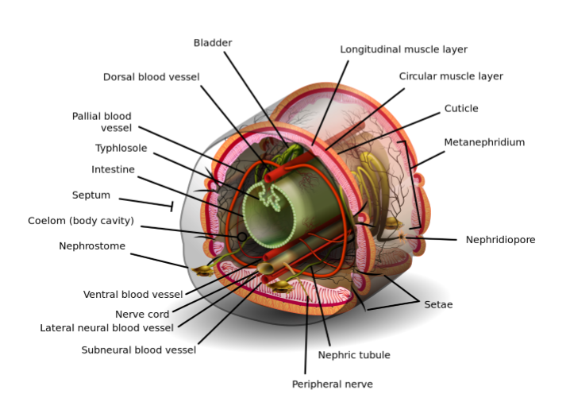  The exterior of an individual segment is a thin cuticle over the skin, commonly pigmented red to brown, which has specialized cells that secrete mucus over the cuticle to keep the body moist and ease movement through the soil. Under the skin is a layer of nerve tissue, and two layers of muscles—a thin outer layer of circular muscle, and a much thicker inner layer of longitudinal muscle.[14] Interior to the muscle layer is a ﬂuid-ﬁlled chamber called a coelom[15] that by its pressurization provides structure to the worm's boneless body. The segments are separated from each other by septa (the plural of "septum")[16] which are perforated transverse walls, allowing the coelomic ﬂuid to pass between segments.[17] A pair of structures called nephrostomes are located at the back of each septum; a nephric tubule leads from each nephrostome through the septum and into the following segment. This tubule then leads to the main body ﬂuid ﬁltering organ, the nephridium or metanephridium, which removes metabolic waste from the coelomic ﬂuid and expels it through pores called nephridiopores on the worm's sides; usually, two nephridia (sometimes more) are found in most segments.[18] At the centre of a worm is the digestive tract, which runs straight through from mouth to anus without coiling, and is ﬂanked above and below by blood vessels (the dorsal blood vessel and the ventral blood vessel as well as a subneural blood vessel) and the ventral nerve cord, and is surrounded in each segment by a pair of pallial blood vessels that connect the dorsal to the subneural blood vessels.  Many earthworms can eject coelomic ﬂuid through pores in the back in response to stress; the Australian Didymogaster sylvaticus (known as the "blue squirter earthworm") can squirt ﬂuid as high as 30 cm (12 in).[19][17]  Nervous system …  Central nervous system  The CNS consists of a bilobed brain (cerebral ganglia, or supra-pharyngeal ganglion), sub-pharyngeal ganglia, circum- pharyngeal connectives and a ventral nerve cord.  Earthworms' brains consist of a pair of pear-shaped cerebral ganglia. These are located in the dorsal side of the alimentary canal in the third segment, in a groove between the buccal cavity and pharynx.  Nervous system  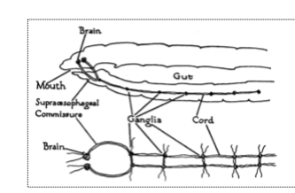  Nervous system of the anterior end of an earthworm  Central nervous system  The CNS consists of a bilobed brain (cerebral ganglia, or supra-pharyngeal ganglion), sub-pharyngeal ganglia, circum- pharyngeal connectives and a ventral nerve cord.  Earthworms' brains consist of a pair of pear-shaped cerebral ganglia. These are located in the dorsal side of the alimentary canal in the third segment, in a groove between the buccal cavity and pharynx.  A pair of circum-pharyngeal connectives from the brain encircle the pharynx and then connect with a pair of sub-pharyngeal ganglia located below the pharynx in the fourth segment. This arrangement means the brain, sub-pharyngeal ganglia and the circum-pharyngeal connectives form a nerve ring around the pharynx.  The ventral nerve cord (formed by nerve cells and nerve ﬁbres) begins at the sub- pharyngeal ganglia and extends below the alimentary canal to the most posterior body segment. The ventral nerve cord has a swelling, or ganglion, in each segment i.e. a segmental ganglion, which occurs from the ﬁfth to the last segment of the body. There is also three giant axons, one medial giant axon (MGA) and two lateral giant axons (LGAs) on the mid-dorsal side of the ventral nerve cord. The MGA is 0.07 mm in diameter and transmits in an anterior-posterior direction at a rate of 32.2 m/s. The LGAs are slightly narrower at 0.05 mm in diameter and transmit in a posterior-anterior direction at 12.6 m/s. The two LGAs are connected at regular intervals along the body and are therefore considered one giant axon.[20][21]  Peripheral nervous system …  Eight to ten nerves arise from the cerebral ganglia to supply the prostomium, buccal chamber and pharynx. Three pairs of nerves arise from the subpharyangeal ganglia to supply the 2nd, 3rd and 4th segment. Three pairs of nerves extend from each segmental ganglion to supply various structures of the segment. The sympathetic nervous system consists of nerve plexuses in the epidermis and alimentary canal. (A plexus is a web of connected nerve cells.) The nerves that run along the body wall pass between the outer circular and inner longitudinal muscle layers of the wall. They give off branches that form the intermuscular plexus and the subepidermal plexus. These nerves connect with the cricopharyngeal connective.  Movement  On the surface, crawling speed varies both within and among individuals. Earthworms crawl faster primarily by taking longer "strides" and a greater frequency of strides. Larger Lumbricus terrestris worms crawl at a greater absolute speed than smaller worms. They achieve this by …taking slightly longer strides but with slightly lower stride frequencies.[22]  Touching an earthworm, which causes a "pressure" response as well as (often) a response to the dehydrating quality of the salt on human skin (toxic to earthworms), stimulates the subepidermal nerve plexus which connects to the intermuscular plexus and causes the longitudinal muscles to contract. This causes the writhing movements observed when a human picks up an earthworm. This behaviour is a reﬂex and does not require the CNS; it occurs even if the nerve cord is removed. Each segment of the earthworm has its own nerve plexus. The plexus of one segment is not connected directly to that of adjacent segments. The nerve cord is required to connect the nervous systems of the segments.[23]  The giant axons carry the fastest signals along the nerve cord. These are emergency signals that initiate reﬂex escape behaviours. The larger dorsal giant axon conducts signals the fastest, from the rear to the front of the animal. If the rear of the worm is touched, a signal is rapidly sent forwards causing the longitudinal muscles in each segment to contract. This causes the worm to shorten very quickly as an attempt to escape from a predator or other potential threat. The two medial giant axons connect with each other and send signals from the front to the rear. Stimulation of these causes the earthworm to very quickly retreat (perhaps contracting into its burrow to escape a bird).  The presence of a nervous system is essential for an animal to be able to experience nociception or pain. However, other physiological capacities are also required such as opioid sensitivity and central modulation of responses by analgesics.[24] Enkephalin and α-endorphin-like substances have been found in earthworms. Injections of naloxone (an opioid antagonist) inhibit the escape responses of earthworms. This indicates that opioid substances play a role in sensory modulation, similar to that found in many vertebrates.[25]  Sensory reception  Photosensitivity  Earthworms do not have eyes (although some worms do), however, they do have specialized photosensitive cells called "light cells of Hess". These photoreceptor … …cells have a central intracellular cavity (phaosome) ﬁlled with microvilli. As well as the microvilli, there are several sensory cilia in the phagosome which are structurally independent of the microvilli.[26] The photoreceptors are distributed in most parts of the epidermis but are more concentrated on the back and sides of the worm. A relatively small number occurs on the ventral surface of the 1st segment. They are most numerous in the prostomium and reduce in density in the ﬁrst three segments; they are very few in number past the third segment.[23]  Epidermal receptor (Sense organ) …  These receptors are abundant and distributed all over the epidermis. Each receptor shows a slightly elevated cuticle which covers a group of tall, slender and columnar receptor cells. These cells bear small hairlike processes at their outer ends and their inner ends are connected with nerve ﬁbres. The epidermal receptors are tactile in function. They are also concerned with changes in temperature and respond to chemical stimuli. Earthworms are extremely sensitive to touch and mechanical vibration.  Buccal receptor (Sense organ) …  These receptors are located only in the epithelium of the buccal chamber. These receptors are gustatory and olfactory (related to taste and smell). They also respond to chemical stimuli. (Chemoreceptor)  Digestive system  The gut of the earthworm is a straight tube which extends from the worm's mouth to its anus. It is differentiated into an alimentary canal and associated glands which are embedded in the wall of the alimentary canal itself. The alimentary canal consists of a mouth, buccal cavity …(generally running through the ﬁrst one or two segments of the earthworm), pharynx (running generally about four segments in length), oesophagus, crop, gizzard (usually) and intestine.[27]Food enters at the mouth. The pharynx acts as a suction pump; its muscular walls draw in food. In the pharynx, the pharyngeal glands secrete mucus. Food moves into the esophagus, where calcium (from the blood and ingested from previous meals) is pumped in to maintain proper blood calcium levels in the blood and food pH. From there the food passes into the crop and gizzard. In the gizzard,strong muscular contractions grind the food with the help of mineral particles ingested along with the food. Once through the gizzard, food continues through the intestine for digestion. The intestine secretes pepsin to digest proteins, amylase to digest polysaccharides, cellulase to digest cellulose, and lipase to digest fats.[6] Earthworms use, in addition to the digestive proteins, a class of surface active compounds called drilodefensins, which help digest plant material.[28] Instead of being coiled like a mammalian intestine, in an earthworm's intestine a large mid-dorsal, tongue-like fold is present, called typhlosole which increases surface area to increase nutrient absorption by having many folds running along its length. The intestine has its own pair of muscle layers like the body, but in reverse order—an inner circular layer within an outer longitudinal layer.[29]  Circulatory system  Earthworms have a dual circulatory system in which both the coelomic ﬂuid and a closed circulatory system carry the food, waste, and respiratory gases. The closed circulatory system has ﬁve main blood vessels: the dorsal (top) vessel, …which runs above the digestive tract; the ventral (bottom) vessel, which runs below the digestive tract; the subneural vessel, which runs below the ventral nerve cord; and two lateroneural vessels on either side of the nerve cord.[30]  The dorsal vessel is mainly a collecting structure in the intestinal region. It receives a pair commissural and dorsal intestines in each segment. The ventral vessel branches off to a pair of ventro- tegumentaries and ventro-intestinals in each segment. The subneural vessel also gives out a pair of commissurals running along the posterior surface of the septum.  The pumping action on the dorsal vessel moves the blood forward, while the other four longitudinal vessels carry the blood rearward. In segments seven through eleven, a pair of aortic arches ring the coelom and acts as hearts, pumping the blood to the ventral vessel that acts as the aorta. The blood consists of ameboid cells and haemoglobin dissolved in the plasma. The second circulatory system derives from the cells of the digestive system that line the coelom. As the digestive cells become full, they release non-living cells of fat into the ﬂuid-ﬁlled coelom, where they ﬂoat freely but can pass through the walls separating each segment, moving food to other parts and assist in wound healing.[31]  Excretory system  The excretory system contains a pair of nephridia in every segment, except for the ﬁrst three and the last ones.[32] The three types of nephridia are: integumentary, septal, and pharyngeal. The integumentary nephridia lie attached to the inner side of the body wall in all segments except the ﬁrst two. The septal nephridia are attached to both sides of the septa behind the 15th segment. The pharyngeal nephridia are attached to the fourth, ﬁfth and sixth …segments.[32] The waste in the coelom ﬂuid from a forward segment is drawn in by the beating of cilia of the nephrostome. From there it is carried through the septum (wall) via a tube which forms a series of loops entwined by blood capillaries that also transfer waste into the tubule of the nephrostome. The excretory wastes are then ﬁnally discharged through a pore on the worm's side.[33]  Respiration  Earthworms have no special respiratory organs. Gases are exchanged through the moist skin and capillaries, where the …oxygen is picked up by the haemoglobin dissolved in the blood plasma and carbon dioxide is released. Water, as well as salts, can also be moved through the skin by active transport.  At birth, earthworms emerge small but fully formed, lacking only their sex structures which develop in about 60 to 90 days. They attain full size in about one year. Scientists predict that the average lifespan under ﬁeld conditions is four to eight years, while most garden varieties live only one to two years.  Reproduction  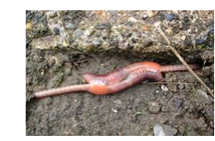  Earthworm copulation  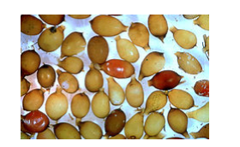  Earthworm cocoons from L. terrestris  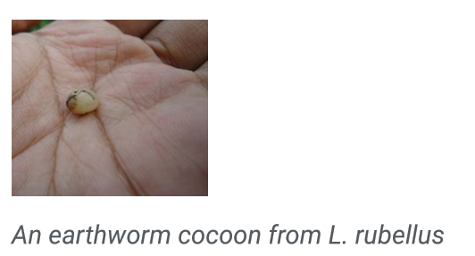  Several common earthworm species are mostly parthenogenetic, meaning that growth and development of embryos happens without fertilization. Among lumbricid earthworms, parthenogenesis arose from sexual relatives many times.[34] Parthenogenesis in some Aporrectodea trapezoides lineages arose 6.4 to 1.1 million years ago from sexual ancestors.[35] A few species exhibit An earthworm cocoon from L. rubellus pseudogamous parthogenesis, meaning that mating is necessary to stimulate reproduction, even though no male genetic material passes to the offspring.[36]  Earthworm mating occurs on the surface, most often at night. Earthworms are hermaphrodites; that is, they have both male and female sexual organs. The sexual organs are located in segments 9 to 15. Earthworms have one or two pairs of testes contained within sacs. The two or four pairs of seminal vesicles produce, store and release the sperm via the male pores. Ovaries and oviducts in segment 13 release eggs via female pores on segment 14, while sperm is expelled from segment 15. One or more pairs of spermathecae are present in segments 9 and 10 (depending on the species) which are internal sacs that receive and store sperm from the other worm during copulation. As a result, segment 15 of one worm exudes sperm into segments 9 and 10 with its storage vesicles of its mate. Some species use external spermatophores for sperm transfer.  In Hormogaster samnitica and Hormogaster elisae transcriptome DNA libraries were sequenced and two sex pheromones, Attractin and Temptin, were detected in all tissue samples of both species.[37] Sex pheromones are probably important in earthworms because they live in an environment where chemical signaling may play a crucial role in attracting a partner and in facilitating outcrossing. Outcrossing would provide the beneﬁt of masking the expression of deleterious recessive mutations in progeny[38] (see Complementation).  Copulation and reproduction are separate processes in earthworms. The mating pair overlap front ends ventrally and each exchanges sperm with the other. The clitellum becomes very reddish to pinkish in colour. Sometime after copulation, long after the worms have separated, the clitellum (behind the spermathecae) secretes material which forms a ring around the worm. The worm then backs out of the ring, and as it does so, it injects its own eggs and the other worm's sperm into it. Thus each worm becomes the genetic father of some of their offspring and the genetic mother of the rest. As the worm slips out of the ring, the ends of the cocoon seal to form a vaguely onion- shaped incubator (cocoon) in which the embryonic worms develop. Hence fertilization is external. The cocoon is then deposited in the soil.After three weeks about 2 to 20 young ones hatch with an average of 4. Development is direct i.e.without formation of any larva.  Locomotion  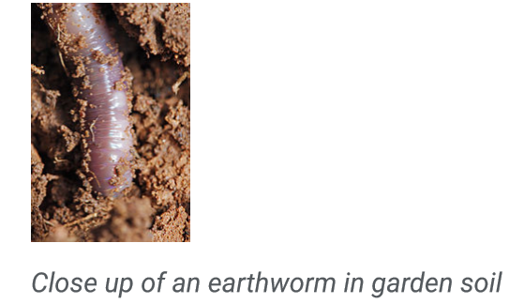  Earthworms travel underground by the means of waves of muscular contractions which alternately shorten and lengthen the body (peristalsis). The shortened part is anchored to the surrounding soil by tiny clawlike bristles (setae) set along its segmented length. In all the body segments except the ﬁrst, last and clitellum, there is a ring of S-shaped setae embedded in the epidermal pit of each segment (perichaetine). The whole burrowing process is aided by the secretion of lubricating mucus. As a result of their movement through their lubricated tunnels, worms can make gurgling noises underground when disturbed. Earthworms move through soil by expanding crevices with force; when forces are measured according to body weight, hatchlings can push 500 times their own body weight whereas large adults can push only 10 times their own body weight.[39]  Regeneration  Earthworms have the ability to regenerate lost segments, but this ability varies between species and depends on the extent of the damage. Stephenson (1930) devoted a chapter of his monograph to this topic, while G.E. Gates spent 20 years studying regeneration in a variety of species, but "because little interest was shown", Gates (1972) published only a few …of his ﬁndings that, nevertheless, show it is theoretically possible to grow two whole worms from a bisected specimen in certain species.  Gates's reports included:  Eisenia fetida (Savigny, 1826) with head regeneration, in an anterior direction, possible at each intersegmental level back to and including 23/24, while tails were regenerated at any levels behind 20/21, i.e., two worms may grow from one.[40] Lumbricus terrestris (Linnaeus, 1758) replacing anterior segments from as far back as 13/14 and 16/17 but tail regeneration was never found. Perionyx excavatus (Perrier, 1872) readily regenerated lost parts of the body, in an anterior direction from as far back as 17/18, and in a posterior direction as far forward as 20/21. Lampito mauritii (Kinberg, 1867) with regeneration in anterior direction at all levels back to 25/26 and tail regeneration from 30/31; head regeneration was sometimes believed to be caused by internal amputation resulting from Sarcophaga sp. larval infestation.  Criodrilus lacuum (Hoffmeister, 1845) also has prodigious regenerative capacity with 'head' regeneration from as far back as 40/41.[41] An unidentiﬁed Tasmanian earthworm shown growing a replacement head has been reported.[42] Within the world of taxonomy, the stable 'Classical System' of Michaelsen (1900) and Stephenson (1930) was gradually eroded by the controversy over how to classify earthworms, such that Fender and McKey-Fender (1990) went so far as to Taxonomy and distribution say, "The family-level classiﬁcation of the megascolecid earthworms is in chaos."[43] Over the years, many scientists have developed their own classiﬁcation systems for earthworms, which led to confusion, and these systems have been and still continue to be revised and updated. The classiﬁcation system used here which was developed by Blakemore (2000), is a modern reversion to the Classical System that is historically proven and widely accepted.[44]  Categorization of a megadrile earthworm into one of its taxonomic families under suborders Lumbricina and Moniligastrida is based on such features as the makeup of the clitellum, the location and disposition of the sex features (pores, prostatic glands, etc.), number of gizzards, and body shape.[44] Currently, over 6,000 species of terrestrial earthworms are named, as provided in a species name database,[45] but the number of synonyms is unknown.  The families, with their known distributions or origins:[44]  Acanthodrilidae – (Gondwanan or Pangaean?)  Ailoscolecidae – the Pyrenees and the southeast USA Almidae – tropical equatorial (South America, Africa, Indo-Asia) Benhamiinae – Ethiopian, Neotropical (a possible subfamily of Octochaetidae) Criodrilidae – southwestern Palaearctic: Europe, Middle East, Russia and Siberia to Paciﬁc coast; Japan (Biwadrilus); mainly aquatic Diplocardiinae/-idae – Gondwanan or Laurasian? (a subfamily of Acanthodrilidae) Enchytraeidae – cosmopolitan but uncommon in tropics (usually classed with Microdriles) Eudrilidae – Tropical Africa south of the Sahara Exxidae – Neotropical: Central America and the Caribbean Glossoscolecidae – Neotropical: Central and South America, Caribbean Haplotaxidae – cosmopolitan distribution (usually classed with Microdriles) Hormogastridae – Mediterranean Kynotidae – Malagasian: Madagascar Lumbricidae – Holarctic: North America, Europe, Middle East, Central Asia to Japan Lutodrilidae – Louisiana the southeast USA Megascolecidae – (Pangaean?) Microchaetidae – Terrestrial in Africa especially South African grasslands Moniligastridae – Oriental and Indian subregion Ocnerodrilidae – Neotropics, Africa; India Octochaetidae – Australasian, Indian, Oriental, Ethiopian, Neotropical Octochaetinae – Australasian, Indian, Oriental (subfamily if Benhamiinae is accepted)  Sparganophilidae – Nearctic, Neotropical: North and Central America Tumakidae – Colombia, South America As an invasive species  From a total of around 7,000 species, only about 150 species are widely distributed around the world. These are the peregrine or cosmopolitan earthworms.[46]
 | 2. Type study of Arthropoda (Prawn) | Study Notes on Prawn  In this article we will discuss about Prawn:- 1. Habit and Habitat of Prawn 2. External Structures of Prawn 3. Locomotion 4. Digestive System 5. Respiratory System 6. Circulatory System 7. Excretory System 8. Physiology of Green Glands 9. Nervous System 10. Reproductive System 11. Breeding and Life History  1. Habit and Habitat of Prawn:  The prawn is common in rivers, ponds and other fresh-water areas. It is nocturnal, bottom-dweller and lives within underwat er crevices and aquatic vegetation’s. It takes all kinds of food specially decaying leaves. It is a good swimmer but is also capable of crawling on the surface and at the time of danger can jump backwardly. It may attain a length up to seventy-ﬁve centimetres.  2. External Structures of Prawn:  The body of Prawn is elongated, hemispherical and slightly tapering at the posterior end (Fig. 18.2). The fresh specimen is slightly bluish in colour. The entire outer surface of the body is covered by hard exoskeleton. The body is distinctly divided into two parts— cephalothorax and abdomen. Both these parts bear on their ventral surfaces paired appendages, which are specialised for differe nt functions.Each appendage is biramous, i.e., two branched, and in spite of their modi- ﬁcations are built up on the same general plan:  - Lower, double-jointed protopodite containing proximal coxa and distal basis and In addition to the app endages, the two halves of the body bear several other structures.  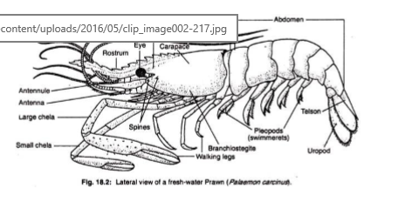  Cephalothorax:  Cephalothorax is the broad, un- segmented and cylindrical anterior part. It is formed by the fusion of head and thorax. In fact, during the development eye and the ﬁrst segment disappears during the process of transformation.A continuous shield-like exoskeletal covering, called cara pace, encloses the cephalothorax. On both the ventrolateral sides, the carapace-hangs freely over the gill-chamber as gill-cover or branchiostegite. The branchiostegite is raised and lowered by a thin membrane, branchiostegal membrane. Ventrally, the carapace is covered by several hard sternal plates. Following structures are present on the cephalothoracic region:  (1) Rostrum:  On the dorsal and median surface, the carapace is drawn into a long serrated projection towards the anterior end. This is defensive in function.  (2) Eye:  Near the base of the rostrum and on each side of the carapace is placed an eye. Each eye is black and hemispherical and made up of several visual elements. It is thus called compound eye and it is mounted on a movable and jointed stalk. It is responsible for detecting light.  (3) Spines:  These are small pointed struct ures, present in pairs on each lateral side of the carapace and posterior to each eye. The anterior pair is known as antennal spines and the short posterior pair is the hepatic spines.  (4) Appendages:  Thirteen pairs of append ages are present on the ventral side of prawn. The close apposition of these appendages speaks about the fusion of cephalothoracic segments.The ﬁrst ﬁve pairs, i.e. First ant enna or Antennule, Second antenna, Mand ible, First maxilla or Maxillula and Seco nd maxilla are known as cephalic append- ages. The remaining eight pairs are called thoracic appendages or periopods, which include three pairs of Maxillipeds and ﬁve pairs of walking legs.  - First antenna:  First antenna is also known as antennule (Fig. 18.3A). It is placed near the base of the eye stalk. Its protopodite carries an additional segment, a spiny precoxa. The basis is longer than coxa and probably its exo and endopodites are modiﬁ ed as feelers or ﬂagella.  The outer feeler has two branches and the smaller branch carries olfactory setae, probably for determ ining smell. The precoxa carries the bal ancing organ, called statocyst and the coxa is beset with many sensory hairs.  (b) Second antenna:  It is situated immed iately after the ﬁrst antenna. The coxa cont ains a specialised organ, called green gland, or antennal squama or scale with setae along its inner margin (Fig. 18.3B). The scale serves as a balancer during swimming. The endopodite has bec ome a long many- jointed ﬂagellum and carries numrous tactile setae.  (c) Mandible:  It is placed on the outer side of the mouth and is responsible for crushing the food. In its protopodite, the coxa is modiﬁed to form as spoon-shaped proximal apophysis and solid distal part called head (Fig. 18.3C).The head contains stout molar process with ﬁve to six yellow teeth and thin incisor process with three closely set white teeth. The basis portion of protopodite and the endopodite form a three- jointed mandibular palp, which remains in front of the head of the mandible and carries sensory setae. The exopodite is absent.  (d) First maxilla or Maxillula:  This crown-shaped smallest appendag Two to these plates (formed by coxa and basis) are projected inwards and are called jaws or gnathobases or endites. The remaining plate is endopodite and is dir ected outwards. The exopodite is absent. The ﬁrst maxilla is responsible for pushing the food inside the mouth.  (e) Second maxilla:  It is fan-shaped (Fig. 18.3E) and placed immediately after the ﬁrst maxilla. The coxa is much reduced and the basis is bifurcated and directed inwards to form endites or jaws. The exopodife is large, fan-shaped and known as scaphognathite or batar.The endopodite is small and placed between the basis and exopodite. The second maxilla serves double functions— jaws are for food-getting and the scaphognathite is for producing constant water current within the gill chambers.  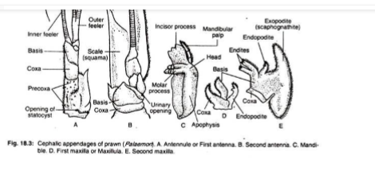  (f) First maxilliped:  The coxa and basis of the protopodite are ﬂattened to become jaws and bear stiff setae on their inner mar gins (Fig. 18.4A). In addition to short endopodite and long exopodite, the coxa bears a bilobed epipodite. The exo and endopodite parts of coxa together with basis help in the in- pushing of food. The epipodites help in respiration.  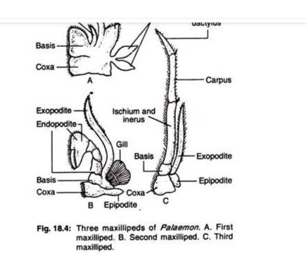  (g) Second maxilliped:  Here the short coxa carries on its outer margin a small epipodite and a gill (Fig. 18.4B). The inner margin is lined with numerous setae. The exopodite is long and un-jointed but the endopodite is made up of ﬁve segments— ischium, merus; carpus, propodusand dactylus. The last two segments are curved back- wards to form a knife-like structure.  (h) Third maxilliped:  This appendage is leg-like (Fig. 18.4C) and its coxa carries a thin epipodite on the outer side. The exopodite is thin and un-carpus and the distal segment is formed by the fusion of propodus with dactylus.  (i) Walking legs:  There are ﬁve pairs of walking legs for crawling. Each leg has a short protopodite with distinct coxa and basis and a prominent ﬁve segmented endopodite (Fig. 18.5). These endopodite segments are ischium, merus, carpus, propodus, and dactylus.  The epi- and exopodites are absent. The ﬁrst and second legs possess pincers formed by the attachm ent of dactylus on propodus and are called chelate legs, while the rest are known as non-chelate legs. The second walking leg being the largest is known as large chela and the ﬁrst walking leg is called small chela.  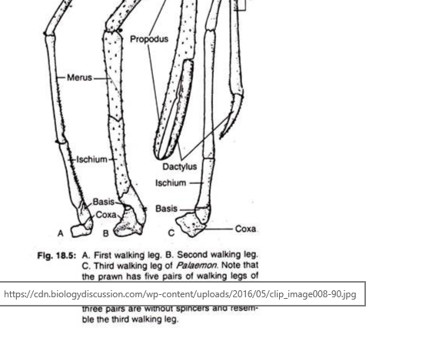  (5) Different apertures in cephalothorax:  (a) Mouth:  The mouth is a slit-like unp aired and median aperture on the ventral side of the cephalothorax and is situated in between third and fourth segments. It is encircled by mandibles, maxillae and ﬁrst maxillipeds. It is present as a minute opening on a raised papilla near the base of each second antenna. It serves as an outlet of excretory duct from the excretory organ, green gland.  (c) Gonopores:  The position of these paired openings depends upon the sex of the individual. In males, the gonopores are seen on the inner sides of the coxae of ﬁfth walking legs and in females these are in similar positions on the third walking legs.  (d) Statocyst openings:  Tine statocysts or the balancing organs of prawn communicate with the exterior through minute pores. There are two statocysts situated one on the base of each ﬁrst antenna.  Abdomen:  The abdomen is composed of six distinct segments and a posterior-most triangular telson. Each abdominal segment is laterally compressed and is bounded by a imbricately ar ranged sclerites are united with each other by thin un-calciﬁed arthroidal membrane. Each sclerite consists of a ventral plate-like sternum and a dorsal arch-shaped tergum (Fig. 18.6).  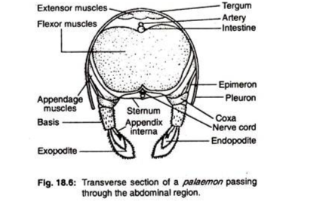  The tergum suspends freely on the lateral sides as pleuron. The pleuron is connected with the appendage of the corre sponding side by a small plate-like epimeron.  The imbricate arrangement of the sclerites and its hinge-like joints (marked by orange spots) permit free vertical movements of the abdomen. Each abdominal segment carries a pair of appendages on its ventral sides. These appendages are called pleopods and the Crafthought|Sponsored These Are The Most Daring Dresses Ever Worn At The ACM Awards Read Next Story  last pair is modiﬁed and known as uropods.  (a) Pleopods or Swimmerets:  One pair of pleopods is present in each of the ﬁrst ﬁve abdominal segments. In each pleopod the protopodite has a longer basis than the coxa (Fig. 18.7A-C). The exopodite is longer than the endopodite. Both the exo and endopodites bear tactile setae but the former is larger.  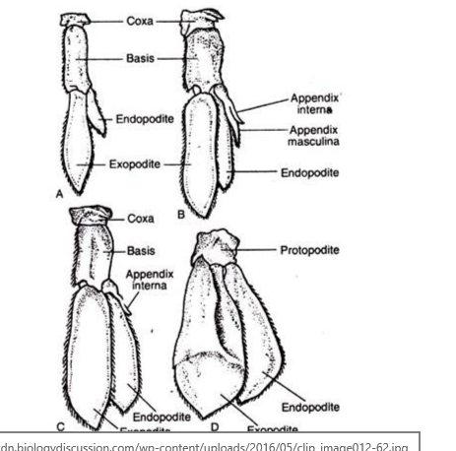  sides of the endopodites of 2nd, 3rd, 4th and 5th pleopods. These processes of both the sides in females unite to form a basket for carrying eggs. The second pleopods of the male prawn have an additional process which is known as appendix masculina. The pleopods are primarily meant for swimming.  (b) Uropod:  One pair of uropods is present in the last segment, one on each side of the telson (Fig. 18.7D). The protopodite is one segmented but the exo- and endopodites are large and fan-shaped. The exopodite is divided by a ﬁne suture but the endopodite is not sutured. The tactile setae are arranged at the margin of both the exo- and endop odites. The uropods are used for changing direction and also for leaping backwards.  Only one aperture called anus is present near the base of the telson on its ventral side. This is the opening of alimentary canal for the purpose of egestion.  3. Locomotion of Prawn: The prawn moves in three different ways —crawling, swimming and darting. AtCrafthought |Sponsored These Are The Most Daring Dresses Ever Worn At The ACM Awards Read Next Story  the time of crawling the animal straightens its body and rests over ﬁve pairs of walking legs. The legs are moved in harmony and the feelers of the antennae are directed forward to survey the environment. The swimmerets move like paddle during swimming and look like oars.  The third type of locomotion, darting, occurs to evade danger. During this type of movement, the animal curves its abdomen under the cephalothorax and exerts pressure on the surface by the expanded uropod’s and telson. This gives a backward thrust, which shifts the body to a considerable distance in backward direction.  4. Digestive System of Prawn: The digestive system of Prawn consists of (A) Ali mentary canal and (B) Digestive glands (Fig. 18.8).  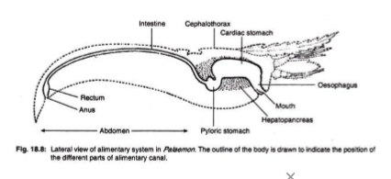  1. Fore gut:  It is internally lined by thick cuticle and consists of following parts:  (a) Mouth:  It is a broad opening on the ventral side of the cephalothorax between the third and fourth segments. It is bordered anteriorly by shield-like labrum, posteriorly by two-lobed labium and laterally by the inc isor processes of the mandibles.  (b) Buccal cavity:  A small anterio-posteriorly ﬂattened chamber between the mouth and oesopha gus. It has an irregularly folded lining of cuticle.  (c) Oesophagus:  It runs vertically upwards as a broad tube from the buccal cavity and leads to the stomach. The inner lining is muscular and has one anterior, two lateral and one posterior folds.  Crafthought|Sponsored  These Are The Most Daring Dresses Ever Worn At The ACM Awards Read Next Story  (d) Stomach:  This is the longest part of the fore gut which is placed longitudinally within the cephalothorax.  It is divided into two parts:  (i) Cardiac stomach:  It is large, spacious and bag-like anterior part of the stomach. Its inner cuticular wall is provided with ridges havi ng minute bristles. Following plates support its wall—circular plate in the anterior part, lanceolate plate on the dorsal side of the posterior part and a shield-shaped hastate plate in the mid-ventral region (Fig. 18.9). The posterior part of the hastate plate is depressed and reaches up to the cardio-pyloric opening.  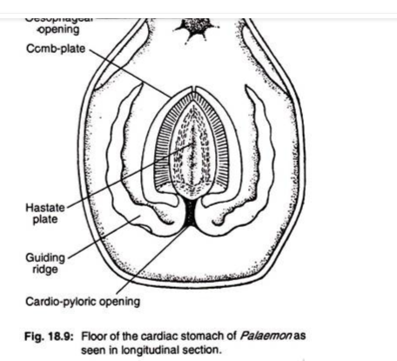  The upper part is slightly convex and gradua lly slopes towards the two lateral sides from a distinct median ridge in the middle. Both the upper and posterior surfaces have delicate setae. On each lateral side of the hastate plate lies an elongated lateral groove. A cuticular supporting rod and a ridged plate of similar nature, bound the inner and outer sides respectively of each lateral groove.  The inner side of each ridged plate is provided with rows of comb-like setae, which are known as comb-plate. The bristles of the comb-plate partially cover Crafthought|Sponsored These Are The Most Daring Dresses Ever Worn At The ACM Awards Read Next Story  the lateral side of the hastate plate. The comb-plates of two sides unite at the anterior end but remain free at the posterior end just near the cardio- pyloric opening.The inner wall of the card iac stomach on the side of each comb-plate is folded to form a longitudinal channel, called the guiding ridge. The two guiding ridges posteriorly form the border of the cardio-pyloric opening.  (ii) Pyloric stomach:  The cardiac stomach opens within th6 next part, pyloric stomach through a narrow, X-shaped cardio-pyloric opening. The opening is guarded by one anterior, one posterior and two lateral valves. The anterior valve is the posterior extension of hastate plate, poster ior one is the fold of stomach wall and the two lateral valves are the projections of the guiding ridges.  The pyloric stomach is much smaller and narrower than cardiac stomach. Its lateral muscular wall is incompletely di- vided by folds into a small dorsal chamber and large ventral chamber. The ventral chamber receives the duct from Crafthought|Sponsored  These Are The Most Daring Dresses Ever Worn At The ACM Awards Read Next Story the digestive gland, hepatopancreas and is divided into two late ral compartments.The ﬂoor of the ventral chamber has a rectangular ﬁlter plate havi ng alternate ridges and grooves. This ﬁlter plate together with the bristles on the lateral wall of ventral chamber, acts as pyloric ﬁlt ering apparatus. This ﬁlter permits only liquid food to enter into the intestine.  2. Mid gut:  It is the narrow and elong ated part of the’ intestine, which begins from the dorsal chamber of pyloric stomach and runs along the mid-dorsal line up to the sixth abdominal segment. Its internal epithel ial lining at the posterior part is folded. Thus the space within the tube is reduced.  3. Hind gut:  It is also lined by thick cuticle and consists of following parts:  (a) Rectum:  It is the swollen muscular region of the last part of intestine having number as internal folds. Crafthought|Sponsored These Are The Most Daring Dresses Ever Worn At The ACM Awards Read Next Story  (b) Anus:  This is the aperture through which the alimentary canal opens to the exterior. It is a ventrally placed longitudinal slit-like opening, present near the base of the telson on a raised papilla.  B. Digestive gland:  Only one digestive gland, hepatopancreas, is present. It is an orange-yellow coloured, loosely arranged bilobed organ which encirc les completely the pyloric stomach, part of the intestine and partly the cardiac stomach. One hepatopancreatic duct originates from each lobe independently and opens separ ately within the pyloric stomach, immedi ately after the pyloric ﬁlter plate.  The hepatop ancreas in its role as digestive gland serves as liver, pancreas and intestine of higher animals. In addition, it absorbs digested food and can store it for future use. Thus, this organ serves double functions—digestion and storage.  Mechanism of Nutrition:  Crafthought|Sponsored  These Are The Most Daring Dresses Ever Worn At The ACM Awards Read Next Story The process of nutrition involves three stages—ingestion, digestion and egestion.  Ingestion:  Prawn is omnivorous, i.e., eats all kinds of foods. It feeds actively at dusk and in the morning on algae, decaying vegetables and small insects. Food is pro - cured by the chelate legs and brought near the mouth cavity by following appendages— maxillipeds, maxillulae and maxillae.Man dibles help to fragment the food into smaller bits and the molar processes of the mandib les inside the buccal cavity crush the food. Entrance of food within the cardiac stomach is assisted by the peristaltic motion of the oesophageal wall.  Digestion:  Within the cardiac stomach the food is churned by the action of cuticular plates on the inner wall, ﬁner particles of food ﬁltered by the complete come within lateral grooves from where it is guided into the ventral chamber of pyloric stomach.  Crafthought|Sponsored  These Are The Most Daring Dresses Ever Worn At The ACM Awards Read Next Story  Digestion takes place within the pyloric stom ach by the action of digestive juices which come from the hepatopancreas. All the enz ymes for the breakdown of carbohydrate, protein and lipid are present in the juice.The digested liquid food is strained by the ﬁlteri ng apparatus in the ventral chamber of pyloric stomach and enters within dorsal chamber and then to the hepatopancreas. The residual part of the food passes within the mid gut. After certain amount of absorpt ion the residual matter enters within dorsal chamber and then to the hepatopancreas. The residual part of the food passes within the hind gut.  Egestion:  From intestine the residual part of the food enters within the rectum and is temporarily stored there for some-time. Finally it is ejected through the anus.  5. Respiratory System of Prawn: Prawn respires in the aquatic medium and it carries three sets of organs for the purpose—lining of the branchiostegite, epipodites and gills. All these organs are enclosed within a special chamber on Crafthought|Sponsored These Are The Most Daring Dresses Ever Worn At The ACM Awards Read Next Story  each side of the cephalothorax, which is called gill-chamber.  The gill-chamber is covered by the lateral extension of carapace, called gill- cover or branchiostegite. Each gill-chamber is thus open ventrally, anteriorly and posteriorly.  A. Lining of the branchiostegite:  The richly vascularised membrane of the branchiostegite serves as respiratory surface, through which gaseous exchange takes place.  B. Epipodites:  These are small highly vascularised leaf- like membranous structures, one on the coxal segment of each maxilliped. These epipodites being present in the anter ior part of the gill-chamber carry out respi- ratory functions.  C. Gills:  Among the three sets of respir atory organs, the gills are regarded as prim ary respiratory organs. On each lateral side of the cephalothorax and beneath the second gill.  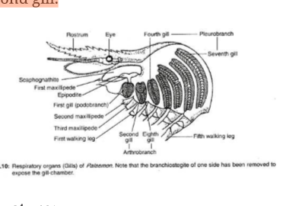  Structure:  The gills are crescent-shaped and their sizes increase gradually from anter ior to posterior direction. Each gill consists of a slender axis or base on which double rows of rhomboidal leaf-like gill-plates are arranged like the pages of a book.  According to their position and mode of attachment, the gills are of three types:  (i) Podobranch—attached with the coxa of the second maxilliped.  (ii) Arthrobranch—at tached with the arthroidal membrane of third maxilliped.  (iii) Pleurobranch—attached with the outer border of the thorax and over theCrafthought |Sponsored These Are The Most Daring Dresses Ever Worn At The ACM Awards Read Next Story  articulating surface of the walking legs.  In prawn, the ﬁrst gill is podobranch, second and eighth gills are arthrobranchs and rem aining ﬁve gills are pleurobranches.  Histology:  Histological structure of the gill shows that gill base has following layers— the outermost cuticle, inner epidermis and innermost connective tissue mass. Each gill- plate is formed by monolayer of cells, sand- witched between two layers of cuticle. The cellular layer includes two alternately arranged cell types— pigmented and transparent.  Blood supply:  Two lateral and one median longitudinal blood channels pass througho ut the length of gill-base. The two lateral channels are interconnected by numerous transverse channels.  From each lateral channel a slender marginal channel is given to each plate. After covering the entire margin of the plate, the marginal channel opens within the median channel. The gill receives  Crafthought|Sponsored  These Are The Most Daring Dresses Ever Worn At The ACM Awards Read Next Story deoxygenated blood through afferent branchial channels.Each branch of afferent channels opens within the transverse channels. From transverse channels the blood passes to the lateral longitudinal channels and is distribu ted subsequently within the gill- plates through the marginal channels. After oxida tion, the blood from marginal channel ret urns to the median channel and then to the efferent branchial vessels, which convey it to the heart.  The course of circulation of blood through the gill is given below:  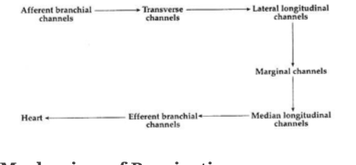  Mechanism of Respiration:  The scaphognathites of maxillae and exopodites of maxillipeds are responsible for forcing the water to rush inside the gill- chamber through posterior and lateral sides. This water passes out through the anterior end. epipodites are bathed and gaseous ex- change occurs through these areas when dissolved oxygen is taken in and carbon dioxide passes from the body to the exterior.  6. Circulatory System of Prawn: The blood circulation in prawn is open type, i.e., blood ﬂows through the body spaces. Such spaces are called haemocoels. The cir culatory system includes—blood, heart, true blood vessels and haemocoelomic spaces.  A. Blood:  Blood includes both the circul ating ﬂuid and the body ﬂuid. The cellular part of the blood includes only amoeboid leucocytes. The liquid part, plasma, contains a copper-containing respiratory pigment haemocyanin in dissolved state. This pigm ent is responsible for the blue colouration of the blood. The blood can coagulate very rapidly.  B. Heart:  It is more or less a triangular organ with inner spongy cavity. It is placed beneath the carapace and above the gonads.Crafthought |Sponsored These Are The Most Daring Dresses Ever Worn At The ACM Awards Read Next Story  Heart is united with the pyloric stomach by a cardio-pyloric strand. The anterior end of the heart, called the apex is pointed and the broad end base is directed posteriorly.  The entire structure is enclosed within a haemocoelomic space, called pericardial sinus, the wall of which serves as pericardium. Two lateral and one median longitudinally ﬁbrous tissue strands connect the heart with the body wall and thus ﬁx it to its position inside the pericar dium.The wall of the heart is pierced by ﬁve pairs of slit-like openings, called ostia. There are two pairs on the lateral sides, one pair in the ventral, one pair in dorsal and one pair at the posterior end of the heart. These ostia are contractile and work as valves to permit only ﬂow of blood from pericardial sinus to the heart.  C. True blood vessels:  These are the vessels which possess deﬁnite walls. As all of them originate from the heart to supply blood to different parts of the body, they are better called arteries. From the heart of prawn six large vessels originate.  Crafthought|Sponsored  These Are The Most Daring Dresses Ever Worn At The ACM Awards Read Next Story  They are:  (i) single ophthalmic artery,  (ii) paired antennary arteries and  (iii) paired hepatopancreatic arteries— all originate from the anterior end and  (iv) a single mid-posterior artery emerges from the posterior end (Fig.  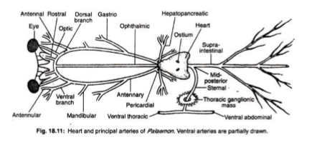  (i) Ophthalmic artery:  The single opht halmic or cephalic artery originates from the apex of the heart and runs anteriorly along the mid-dorsal line up to the base of the rostrum and unites with the branches of two antennary arteries.  (ii) Atennary artery:  Each antennary ar tery originates from the heart and from the sides of the ophthalmic artery. It runs anteriorlyCrafthought |Sponsored These Are The Most Daring Dresses Ever Worn At The ACM Awards Read Next Story  along the outer border of the mandibular muscle.  Each antennary artery sends the following branches on its own side:  (a) Pericardial branch to supply blood to the pericardial wall,  (b) Gastric branch to supply blood to the cardiac stomach,  (c) Mandibular artery to the muscle of the mandible. Each antennary artery then splits into,  (d) A ventral, and  (e) A dorsal branch.  The ventral branch supplies vessels to the ﬁrst and second antennae. The dorsal branch sends an optic artery to the eye and then the two dorsal branches of the two antennaries unite with the median ophthalmic artery to run within the rostrum as paired rostral arteries.  (iii) Hepatopancreatic artery:  The hepatopancreatic or hepatic artery of each side originates from the posterio- median end of the heart and runs  Crafthought|Sponsored  These Are The Most Daring Dresses Ever Worn At The ACM Awards Read Next Story  transversely to enter within the hepatopancreas.  (iv) Mid-posterior artery:  The midposterior artery immediately after originating from the posterio- median end of the heart divides into:  (a) Supra-intestinal artery and  (b) Sternal artery.  The supra-intestinal which is also known as dorsal abdominal artery runs posteriorly along the mid-dorsal line up to the hind gut. It supplies the alimentary canal and the muscles on the dorsal sides.  The sternal artery runs transversely towards the ventral side. It pierces the thoracic ganglion mass and bifurcates into an anteriorly dir ected ventral thoracic and a posteriorly di rected ventral abdominal arteries.  The ventral thoracic artery supplies blood to the differe nt parts on the ventral side of the cephalothorax and ventral abdominal sends branches to the ventral side of the abdomen  All the arteries ultimately break up into ﬁner branches and open within the haemo coelomic spaces. Thus the Circulatory system of prawn lacks network of capillaries.  D. Haemocoelomic spaces:  Small haem ocoelomic spaces are called lacunae. These lacunae open into larger spaces, called sin uses. The passages connecting lacunae and sinus or two sinuses are known as haemoc oelomic channels.  Blood after ﬂowing through different small haemocoelomic spaces or lacunae is collected in a pair of common elongated space, called ventral sinus. These are placed beneath the hepatopancreas and continued up to certain length within the abdomen. The two ventral sinuses are interconnected by several small slender channels.From the ventral sinus six afferent branchial channel take the deoxygenated blood to the gills. First afferent branchial channel supplies blood to the podobranch and arthrobranchs while the remaining ﬁve vessels supply to the ﬁve pleurobranchs.From gills oxygenated blood is collected by six pairs of efferent branchial channels and is ﬁnally drained into dorsal or pericar dial sinus.  Mechanism of blood ﬂow:  The heart contracts to drive the oxygenated blood to the different parts of the body through arteri es (Fig. 18.12). These arteries instead of forming capillary network open directly within haemocoelomic spaces. From differ ent haemocoelomic lacune deoxygenated blood is collected within paired ventral si nuses.  From these large spaces, blood is sent for oxidation to the respiratory organs through the afferent branchial channels. From gills the blood returns to the pericardial sinus through efferent branchial channels.  When the pericardial sinus is full its wall starts to contract and forces the blood to enter within the heart through ostia. When heart contracts the lip-like borders of the ostia close and thus blood is permitted to travel only through arteries.  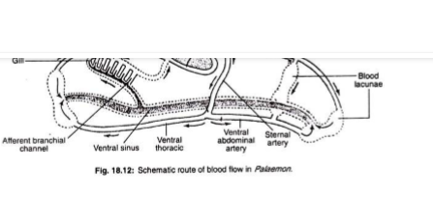  7. Excretory System of Prawn:  Excretory organs of Prawn are known as green glands or antennal glands (Fig. 18.13). They are called green glands for their colour and antennal gland for the location at the base of the second antennae. The green colour is seen in Astacus. These are paired white or gans. Each organ remains within the coxa of each second antenna.  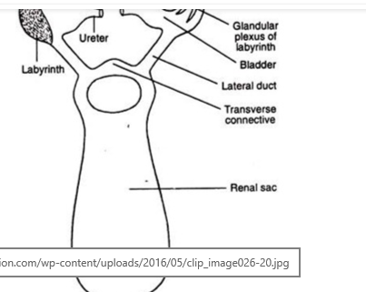  The organ consists of following parts:  (A) End sac:  This small bean-shaped part contains a blood lacuna. Its wall is two- layered, the inner layer is of epithelial cells having excretory function and the outer thick connective tissue layer has minute lacunae. Radially arranged partitions, called septa, project from the wall within central cavity.  (B) Labyrinth:  Present outside the end sac and contains many narrow, branched and coiledCrafthought openi ng but opens within the bladder through several apertures. A single epithelial cell layer having excretory function lines each tubule.  (C) Bladder:  It is a thin-walled sac with an epithelial lining. It communicates with the exterior through a small ureter.  (D) Excretory opening:  It is present on the base of each second antenna. Both the green glands are connected with a common large thin- walled transparent and centrally placed sac, called the renal sac. It is present between the cardiac stomach and the carapace and it communicates with the bladder of each green gland by a separate lateral duct. The two lateral ducts are interc onnected by a transverse connective.  8. Physiology of Green Glands of Prawn: The green glands perform two important functions:  1. Elimination of nitrogenous waste products and  2. Maintains the osmotic equilibrium.  1. Elimination of nitrogenous waste products:  End sac and the labyrinth are the two regions responsible for extracting urine from the blood. The most nitrogenous products include ammonia, a major excretory product in all crustaceans (the ammonia compounds are excreted by end sac in only aquatic crustaceans), and also urea and uric acid.The excretory products are conveyed by the excretory ducts of the labyrinth from the surrounding blood of the haemocoel.Ultra ﬁltration of the blood takes place across the wall of the end sac. The labyrinth walls are folded and glandular which are considered as the site of selective reabsorption. The primary urine is modiﬁed when it passes through the parts of the excretory system. The urine remains temporarily stored within the bladder and is periodically expelled through renal pore.  2. Maintains the osmotic equilibrium: Crafthought|Sponsored These Are The Most Daring Dresses Ever Worn At The ACM Awards Read Next Story  The excess water which enters the body is separated from the body ﬂuid by the green glands to maintain osmotic equilibrium and volume regulation of the body ﬂuid is achieved.  In addition to green glands, gills and integumental covering are also responsible for excretion. The exoskeleton at the time of its periodic replacement carries a large quan tity of excretory products.  9. Nervous System of Prawn: Nervous system resembles the annelidan pattern but shows considerable advancement.  It is divisible into:  (A) Central nervous system,  (B) Peripheral nervous system and  (C) Autonomic nervous system.  It also includes several sense organs to permit the entry of different messages from outside.  A. Central nervous system:  The central nervous system runs from  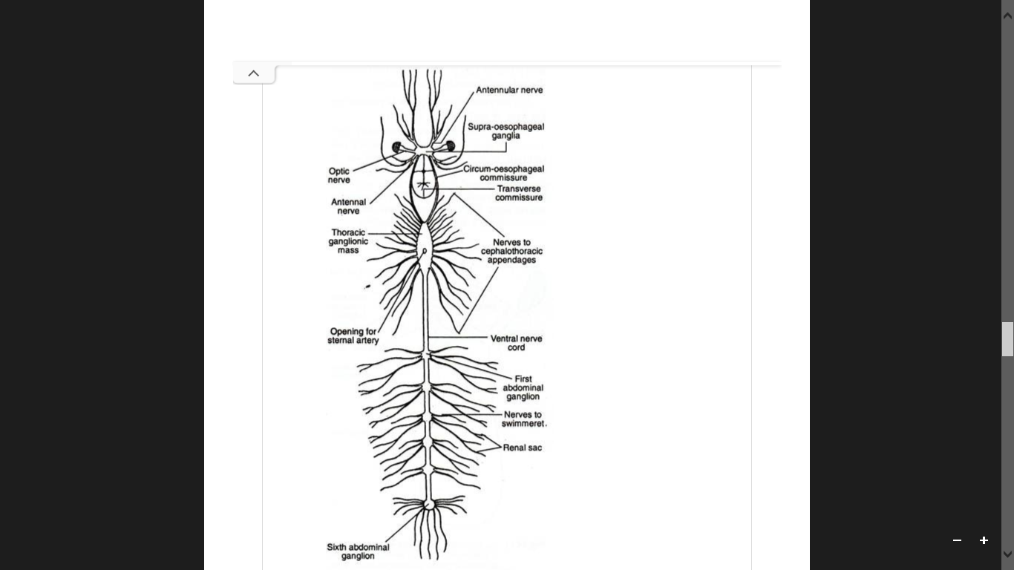  2. Circumoesophageal connectives:  These are a paired cord, each of which begins from the supraoesophageal ganglion of one side and runs posteriorly along the ventrol ateral wall of the cephalothoracic cavity. A small ganglion is present in each commis sure to supply nerve to the mandibles.  The two cords are connected by a thin nerve, called transverse loop, which is present imme diately after the oesophagus. The two conn ectives ultimately unite at the ﬂoor of the thoracic cavity with a large ganglion, called the thoracic ganglionic mass.  3. Thoracic ganglionic mass:  A large ventral elongated mass is formed by the fusion of eleven pairs of ganglia. Two circumoesophageal connectives are united with it at the anterior end. This ganglionic mass is pierced by the sternal artery. It sends eleven pairs of peripheral nerves.  4. Ventral nerve cord:  From the posterior end of the thoracic ganglionic mass originates ventral nerve cord which runs up to the posterior-most segment. The cord appears to be single but in reality it is formed by the fusion of two separate cords. The ventral nerve cord along its course bears a ganglion in each segment. The last ganglion or 6th ganglion is the largest of all the abdominal ganglia and known as stellate ganglion.  B. Peripheral nervous system:  The per ipheral nerves are given off from the differe nt parts of the central nervous system. Each peripheral nerve contains two kinds of ﬁb res—motor and sensory. The motor ﬁbres carry instructions from the central nervous system to different parts and the sensory ﬁbres are meant for bringing messages from different corners of the body.  Following per ipheral nerves are seen in prawn:  1. Optic nerve:  From each lobe of brain, an optic nerve enters within the eye to innerv ate the retinal layer.  2. Antennular nerve:  From each lobe of brain an antennular nerve is given within the ﬁrst antenna or antennule to supply statocyst and various other structures present in the ﬁrst antenna.  3. Antennary nerve:  From the posterior side of each lobe of brain, antennary nerve originates and runs posteriorly to take a quick turn towards the anterior dissection to supply the various parts within second ant enna including green gland.  4. Cephalothoracic nerves:  Eleven pairs of cephalothoracic nerves originate from the thoracic ganglionic mass to supply different muscles and appendages in that region.  5. Abdominal nerves:  From each abdomi nal ganglion two ‘pairs of peripheral nerves are given off to the corresponding segments to supply muscles and appendages. The stellate ganglion in addition to these two pairs sends several more branches to telson, rectum and other adjoining structures. Crafthought|Sponsored These Are The Most Daring Dresses Ever Worn At The ACM Awards Read Next Story  C. Autonomic nervous system:  It inc ludes a few minute ganglia and slender nerves which are present over the cardiac stomach to supply involuntary parts of the body.
 | 3. Type study of Mollusca (Freshwater mussel) | Freshwater pearl mussel  The freshwater pearl mussel (Margaritifera margaritifera) is an endangered species of freshwater mussel, an aquatic bivalve mollusc in the family Margaritiferidae.  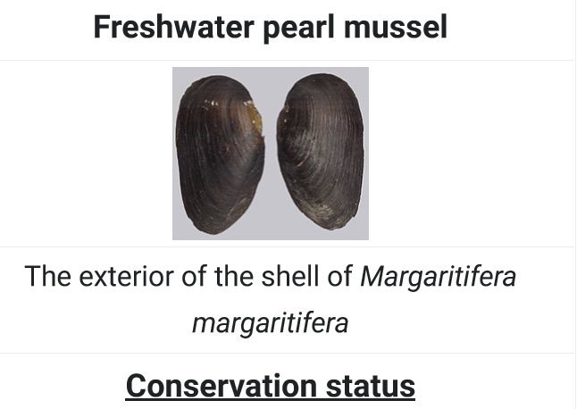  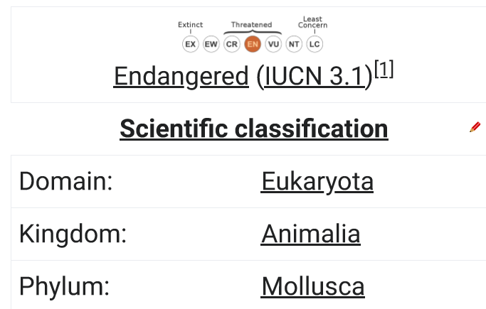  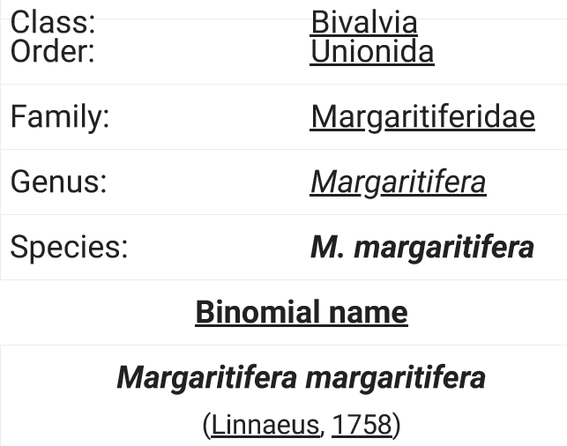  Although the name "freshwater pearl mussel" is often used for this species, other freshwater mussel species can also create pearls and some can also be used as a source of mother of pearl. Most cultured pearls today come from in Asia, or Amblema species in North America, both members of the related family Unionidae; pearls are also found within species in the genus Unio.  The interior of the shell of Margaritifera margaritifera has thick nacre (the inner mother of pearl layer of the shell). This species is capable of making ﬁne-quality pearls, and was historically exploited in the search for pearls from wild sources. In recent times, the Russian malacologist recent times, the Russian malacologist Valeriy Zyuganov received worldwide reputation after he discovered that the pearl mussel exhibited negligible senescence and he determined that it had a maximum lifespan of 210–250 years.[2][3] The data of V.V. Zyuganov have been conﬁrmed by Finnish malacologists[4] and gained general acceptance  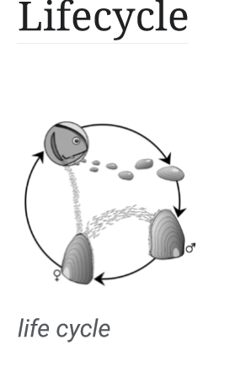  Capable of living for up to 130 years,[31] the freshwater pearl mussel begins life as a tiny larva, measuring just 0.6 to 0.7 millimetres long, which is ejected into the water from an adult mussel in a mass of one to four million other larvae. This remarkable event takes place over just one to two days, sometime between July and September.[6] The larvae, known as glochidia, resemble tiny mussels, but their minute shells are held open until they snap shut on a suitable host. The host of freshwater pearl mussel larvae are juvenile ﬁsh from the salmonid family, which includes the Atlantic salmon and sea trout.[6] The chances of a larva encountering a suitable ﬁsh are very low,[11] and thus nearly all are swept away and die; only a few are inhaled by an Atlantic salmon or sea trout, where they snap shut onto the ﬁsh's gills.[6]  Attached to the gills of a ﬁsh, the glochidia live and grow in this oxygen-rich environment until the following May or June, when they drop off. The juvenile must land on clean gravely or sandy substrates if it is to successfully grow.[6] Attached to the substrate, juvenile freshwater pearl mussels typically burrow themselves completely into the sand or gravel, while adults are generally found  with a third of their shell exposed.[6] Should they become dislodged, freshwater pearl mussels can rebury themselves, and are also capable of moving slowly across sandy sediments, using their large, muscular foot.[6]  The freshwater pearl mussel grows extremely slowly,[11] inhaling water through exposed siphons, and ﬁltering out tiny organic particles on which it feeds.[6] It is thought that in areas where this species was once abundant, this ﬁlter feeding acted to clarify the water, beneﬁting other species which inhabited the rivers and streams.[6] Maturity is reached at an age of 10 to 15 years,[6] followed by a reproductive period of over 75 years in which about 200 million larvae can be produced.[11] In early summer each year, around June and July, male freshwater pearl mussels release sperm into the water, where they are inhaled by female mussels. Inside the female, the fertilized eggs develop in a pouch on the gills for several weeks, until temperature or other environmental cues trigger the female to release the larvae  Threats and conservation  Once the most abundant bivalve mollusc in ancient rivers around the world, numbers of the freshwater pearl mussel are now declining in all countries and this species is nearly extinct in many areas.[9] The causes of this decline are not fully understood, but alteration and degradation  Threats and conservation of its freshwater habitat undoubtedly plays a central role.[9] The negative impacts humans have on rivers and streams come from a wide range of activities such as river regulation, drainage, sewage disposal, dredging, and water pollution, including the introduction of excess nutrients.[9] Anything that affects the abundance of the ﬁsh hosts will also affect the freshwater pearl mussel; for example, the introduction of exotic ﬁsh species, such as the rainbow trout, reduce the number of native ﬁsh hosts.[9] Introduced species are also directly affecting the freshwater pearl mussel; the invasion of the zebra mussel (Dreissenapolymorpha), which has been spread to new locations by being transported on the bottom of boats or in ballast waters, has impacted freshwater pearl mussel populations in all countries it has invaded.[9]  The freshwater pearl mussel, which is completely protected in all European countries,[32][33] has been the focus of a signiﬁcant amount of conservation efforts.[34] Measures have included the transfer of adult mussels to areas where it had gone extinct,[34][35] the culture of juvenile mussels, and the release of juvenile trout, which have been infected with glochidia, into small rivers, but mainly the freshwater pearl mussel has beneﬁted from habitat restoration projects in some areas.[35] Due to the essential role salmonid ﬁsh play in the life of the freshwater pearl mussel, the conservation of salmon and trout is also central in the survival of this endangered freshwater mussel.[9]
 | 4. Type of Echinodermata (Sea star) | Starﬁsh  Starﬁsh or sea stars are star-shaped echinoderms belonging to the class Asteroidea. Common usage frequently ﬁnds these names being also applied to ophiuroids, which are correctly referred to as brittle stars or basket stars. Starﬁsh are also known as Asteroids due to being in the class Asteroidea. About 1,500 species of starﬁsh occur on the seabed in all the world's oceans, from the tropics to frigid polar waters. They are found from the intertidal zone down to abyssal depths, 6,000 m (20,000 ft) below the surface.  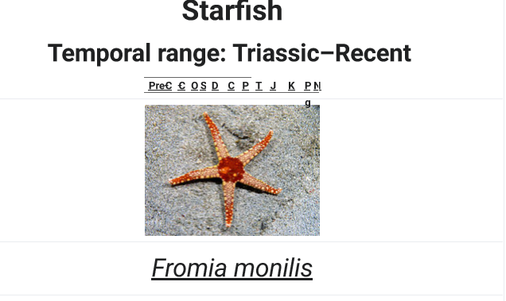  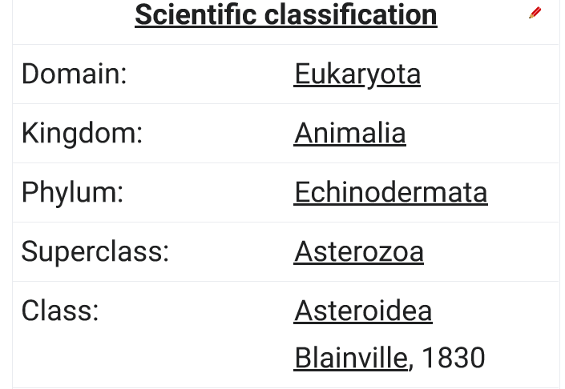  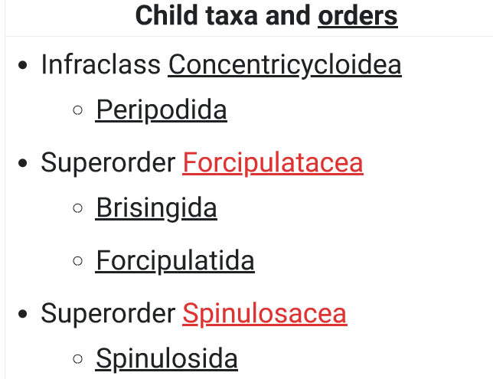  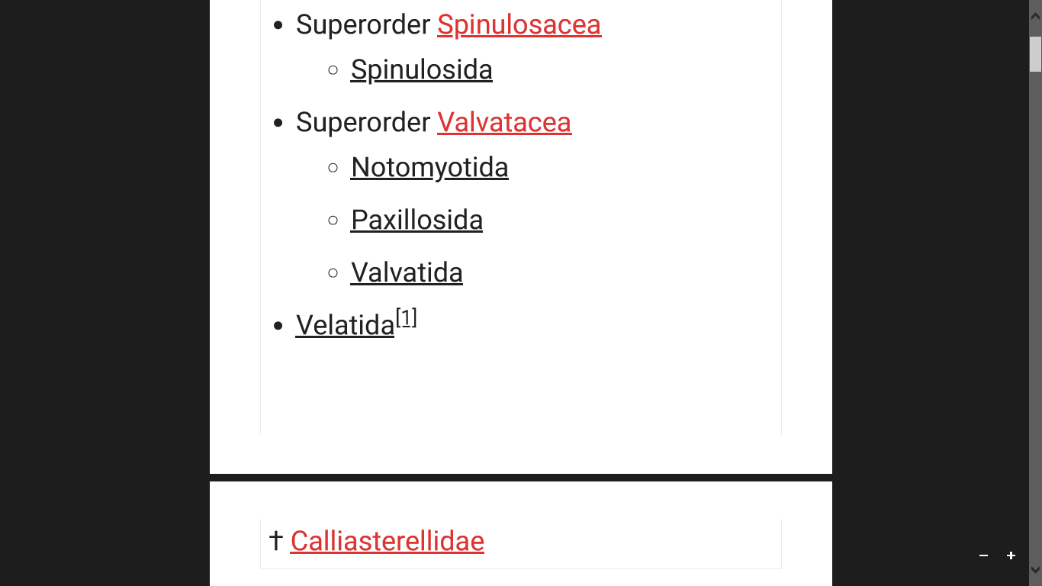  Starﬁsh are marine invertebrates. They typically have a central disc and usually ﬁve arms, though some species have a larger number of arms. The aboral or upper surface may be smooth, granular or spiny, and is covered with overlapping plates. Many species are brightly coloured in various shades of red or orange, while others are blue, grey or brown. Starﬁsh have tube feet operated by a hydraulic system and a mouth at the centre of the oral or lower surface. They are opportunistic feeders and are mostly  † Calliasterellidae  predators on benthic invertebrates. Several species have specialized feeding behaviours including eversion of their stomachs and suspension feeding. They have complex life cycles and can reproduce both sexually and asexually. Most can regenerate damaged parts or lost arms and they can shed arms as a means of defense. The Asteroidea occupy several signiﬁcant ecological roles. Starﬁsh, such as the ochre sea star (Pisaster ochraceus) and the reef sea star (Stichaster australis), have become widely known as examples of the keystone species concept in ecology. The tropical crown-of-thorns starﬁsh (Acanthaster  planci) is a voracious predator of coral throughout the Indo-Paciﬁc region, and the northern Paciﬁc sea star is considered to be one of the world's 100 worst invasive species.  The fossil record for starﬁsh is ancient, dating back to the Ordovician around 450 million years ago, but it is rather sparse, as starﬁsh tend to disintegrate after death. Only the ossicles and spines of the animal are likely to be preserved, making remains hard to locate. With their appealing symmetrical shape, starﬁsh have played a part in literature, legend, design and popular culture. They are sometimes collected as curios, used in design or as logos, and in some cultures, despite possible toxicity, they are eaten.  Most starﬁsh have ﬁve arms that radiate from a central disc, but the number varies with the group. Some species have six or seven arms and others have 10–15  Body wall  The body wall consists of a thin cuticle, an epidermis consisting of a single layer of cells, a thick dermis formed of connective tissue and a thin coelomic myoepithelial layer, which provides the longitudinal and circular musculature. The dermis contains an endoskeleton of calcium carbonate components known as ossicles. These are of Acanthaster planciPedicellaria and papulae of Asterias forbesi  honeycombed structures composed of calcite microcrystals arranged in a lattice.[5] They vary in form, with some bearing external granules, tubercles and spines, but most are tabular plates that ﬁt neatly together in a tessellated manner and form the main covering of the aboral surface.[6] Some are specialised structures such as the madreporite (the entrance to the water vascular system), pedicellariae and paxillae.[5] Pedicellariae are compound ossicles with forceps-like jaws. They remove debris from the body surface and wave around on ﬂexible stalks in response to physical or chemical stimuli while continually making biting movements. They often form clusters surrounding spines.[7][8] Paxillae are umbrella-like structures found on starﬁsh that live buried in sediment. The edges of adjacent paxillae meet to form a false cuticle with a water cavity beneath in which the madreporite and delicate gill structures are protected. All the ossicles, including those projecting externally, are covered by the epidermal layer.[5]  Several groups of starﬁsh, including Valvatida and Forcipulatida, possess pedicellariae.[7] In Forcipulatida, such as Asterias and Pisaster, they occur in pompom-like tufts at the base of each spine, whereas in the Goniasteridae, such as Hippasteria phrygiana, the pedicellariae are scattered over the body surface. Some are thought to assist in defence, while others aid in feeding or in the removal of organisms attempting to settle on the starﬁsh's surface.[9] Some species like Labidiaster annulatus, Rathbunaster californicus and Novodinia antillensis use their large pedicellariae to capture small ﬁsh and crustaceans.[10]  There may also be papulae, thin-walled protrusions of the body cavity that reach through the body wall and extend into the surrounding water. These serve respiratory function.[11] The structures are supported by collagen ﬁbres set at right angles to each other and arranged in a three-dimensional web with the ossicles and papulae in the interstices. This arrangement enables both easy ﬂexion of the arms by the starﬁsh and the rapid onset of stiffness and rigidity required for actions performed under stress.[12]  Water vascular system  The water vascular system of the starﬁsh is a hydraulic system made up of a network of ﬂuid-ﬁlled canals and is concerned with locomotion, adhesion, food manipulation and gas exchange. Water enters the system through the madreporite, a porous, often conspicuous, sieve-like ossicle on the aboral surface. It is linked through a stone canal, often lined with calcareous material, to a ring canal around the mouth opening. A set of radial canals leads off this; one radial canal runs along the ambulacral groove in each arm.Arm tip of Leptasterias polaris showing tube feet and eyespot  There are short lateral canals branching off alternately to either side of the radial canal, each ending in an ampulla. These bulb-shaped organs are joined to tube feet (podia) on the exterior of the animal by short linking canals that pass through ossicles in the ambulacral groove. There are usually two rows of tube feet but in some species, the lateral canals are alternately long and short and there appear to be four rows. The interior of the whole canal system is lined with cilia.[13]  When longitudinal muscles in the amullae contract, valves in the lateral canals close and water is forced into the tube feet. These extend to contact the substrate. Although the tube feet resemble suction cups in appearance, the gripping action is a function of adhesive chemicals rather than suction.[14] Other chemicals and relaxation of the ampullae allow for release from the substrate. The tube feet latch on to surfaces and move in a wave, with one arm section attaching to the surface as another releases.[15][16] Some starﬁsh turn up the tips of their arms while moving which gives maximum exposure of the sensory tube feet and the eyespot to external stimuli.[17]  Having descended from bilateral organisms, starﬁsh may move in a bilateral fashion, particularly when hunting or in danger. When crawling, certain arms act as the leading arms, while others trail behind.[3][18][8] Most starﬁsh cannot move quickly, a typical speed being that of the leather star (Dermasterias imbricata), which can manage just 15 cm (6 in) in a minute.[19] Some burrowing species from the genera Astropecten and Luidia have points rather than suckers on their long tube feet and are capable of much more rapid motion, "gliding" across the ocean ﬂoor. The sand star (Luidia foliolata) can travel at a speed of 2.8 m (9 ft 2 in) minute.[20] When a starﬁsh ﬁnds itself upside down, two adjacent arms are bent backwards to provide support, the opposite arm is used to stamp the ground while the two remaining arms are raised on either side; ﬁnally the stamping arm is released as the starﬁsh turns itself over and recovers its normal stance.[18]  Apart from their function in locomotion, the tube feet act as accessory gills. The water vascular system serves to transport oxygen from, and carbon dioxide to, the tube feet and also nutrients from the gut to the muscles involved in locomotion. Fluid movement is bidirectional and  initiated by cilia.[13] Gas exchange also takes place through other gills known as papulae, which are thin-walled bulges on the aboral surface of the disc and arms. Oxygen is transferred from these to the coelomic ﬂuid, which acts as the transport medium for gasses. Oxygen dissolved in the water is distributed through the body mainly by the ﬂuid in the main body cavity; the circulatory system may also play a minor role.[21]  Digestive system and excretion  Aboral view of partially dissected starﬁsh: 1. Pyloric stomach 2. Intestine and anus 3. Rectal sac 4. Stone canal 5. Madreporite 6. Pyloric caecum 7. Digestive glands 8. Cardiac stomach 9. Gonad 10. Radial canal 11. Ambulacral ridge  The gut of a starﬁsh occupies most of the disc and extends into the arms. The mouth is located in the centre of the oral surface, where it is surrounded by a tough peristomial membrane and closed with a sphincter. The mouth opens through a short oesophagus into a stomach divided by a constriction into a larger, eversible cardiac portion and a smaller pyloric portion. The cardiac stomach is glandular and pouched, and is supported by ligaments attached to ossicles in the arms so it can be pulled back into position after it has been everted. The pyloric stomach has two extensions into each arm: the  pyloric caeca. These are elongated, branched hollow tubes that are lined by a series of glands, which secrete digestive enzymes and absorb nutrients from the food. A short intestine and rectum run from the pyloric stomach to open at a small anus at the apex of the aboral surface of the disc.[22]  Primitive starﬁsh, such as Astropecten and Luidia, swallow their prey whole, and start to digest it in their cardiac stomachs. Shell valves and other inedible materials are ejected through their mouths. The semi- digested ﬂuid is passed into their pyloric stomachs and caeca where digestion  continues and absorption ensues.[22] In more advanced species of starﬁsh, the cardiac stomach can be everted from the organism's body to engulf and digest food. When the prey is a clam or other bivalve, the starﬁsh pulls with its tube feet to separate the two valves slightly, and inserts a small section of its stomach, which releases enzymes to digest the prey. The stomach and the partially digested prey are later retracted into the disc. Here the food is passed on to the pyloric stomach, which always remains inside the disc.[23] The retraction and contraction of the cardiac stomach is activated by a neuropeptide known as NGFFYamide.[24]  Because of this ability to digest food outside the body, starﬁsh can hunt prey much larger than their mouths. Their diets include clams and oysters, arthropods, small ﬁsh and gastropod molluscs. Some starﬁsh are not pure carnivores, supplementing their diets with algae or organic detritus. Some of these species are grazers, but others trap food particles from the water in sticky mucus strands that are swept towards the mouth along ciliated grooves.[22]  The main nitrogenous waste product is ammonia. Starﬁsh have no distinct excretory organs; waste ammonia is  removed by diffusion through the tube feet and papulae.[21] The body ﬂuid contains phagocytic cells called coelomocytes, which are also found within the hemal and water vascular systems. These cells engulf waste material, and eventually migrate to the tips of the papulae, where a portion of body wall is nipped off and ejected into the surrounding water. Some waste may also be excreted by the pyloric glands and voided with the faeces.[21]  Starﬁsh do not appear to have any mechanisms for osmoregulation, and keep their body ﬂuids at the same salt concentration as the surrounding water.  Although some species can tolerate relatively low salinity, the lack of an osmoregulation system probably explains why starﬁsh are not found in fresh water or even in many estuarine environments.[21]  Sensory and nervous systems  Although starﬁsh do not have many well- deﬁned sense organs, they are sensitive to touch, light, temperature, orientation and the status of the water around them. The tube feet, spines and pedicellariae are sensitive to touch. The tube feet, especially those at the tips of the rays, are  also sensitive to chemicals, enabling the starﬁsh to detect odour sources such as food.[23] There are eyespots at the ends of the arms, each one made of 80–200 simple ocelli. These are composed of pigmented epithelial cells that respond to light and are covered by a thick, transparent cuticle that both protects the ocelli and acts to focus light. Many starﬁsh also possess individual photoreceptor cells in other parts of their bodies and respond to light even when their eyespots are covered. Whether they advance or retreat depends on the species.[25]  While a starﬁsh lacks a centralized brain, it has a complex nervous system with a nerve ring around the mouth and a radial nerve running along the ambulacral region of each arm parallel to the radial canal. The peripheral nerve system consists of two nerve nets: a sensory system in the epidermis and a motor system in the lining of the coelomic cavity. Neurons passing through the dermis connect the two.[25] The ring nerves and radial nerves have sensory and motor components and coordinate the starﬁsh's balance and directional systems.[11] The sensory component receives input from the sensory organs while the motor nerves  control the tube feet and musculature. The starﬁsh does not have the capacity to plan its actions. If one arm detects an attractive odour, it becomes dominant and temporarily over-rides the other arms to initiate movement towards the prey. The mechanism for this is not fully understood.[25]  Circulatory system  The body cavity contains the circulatory or haemal system. The vessels form three rings: one around the mouth (the hyponeural haemal ring), another around the digestive system (the gastric ring) and the third near the aboral surface (the genital ring). The heart beats about six times a minute and is at the apex of a vertical channel (the axial vessel) that connects the three rings. At the base of each arm are paired gonads; a lateral vessel extends from the genital ring past the gonads to the tip of the arm. This vessel has a blind end and there is no continuous circulation of the ﬂuid within it. This liquid does not contain a pigment and has little or no respiratory function but is probably used to transport nutrients around the body.[26]  Secondary metabolites  Starﬁsh produce a large number of secondary metabolites in the form of lipids, including steroidal derivatives of cholesterol, and fatty acid amides of sphingosine. The steroids are mostly saponins, known as asterosaponins, and their sulphated derivatives. They vary between species and are typically formed from up to six sugar molecules (usually glucose and galactose) connected by up to three glycosidic chains. Long-chain fatty acid amides of sphingosine occur frequently and some of them have known pharmacological activity. Various  ceramides are also known from starﬁsh and a small number of alkaloids have also been identiﬁed. The functions of these chemicals in the starﬁsh have not been fully investigated but most have roles in defence and communication. Some are feeding deterrents used by the starﬁsh to discourage predation. Others are antifoulants and supplement the pedicellariae to prevent other organisms from settling on the starﬁsh's aboral surface. Some are alarm pheromones and escape-eliciting chemicals, the release of which trigger responses in conspeciﬁc starﬁsh but often produce escape responses in potential prey.[27] Research into the eﬃcacy of these compounds for possible pharmacological or industrial use occurs worldwide.[  Sexual reproduction  Life cycle  Most species of starﬁsh are gonochorous, there being separate male and female individuals. These are usually not distinguishable externally as the gonads cannot be seen, but their sex is apparent when they spawn. Some species are simultaneous hermaphrodites, producing eggs and sperm at the same time and in a  Life cycle  few of these, the same gonad, called an ovotestis, produces both eggs and sperm.[29] Other starﬁsh are sequential hermaphrodites. Protandrous individuals of species like Asterina gibbosa start life as males before changing sex into females as they grow older. In some species such as Nepanthia belcheri, a large female can split in half and the resulting offspring are males. When these grow large enough they change back into females.[30]  Each starﬁsh arm contains two gonads that release gametes through openings called gonoducts, located on the central  disc between the arms. Fertilization is generally external but in a few species, internal fertilization takes place. In most species, the buoyant eggs and sperm are simply released into the water (free spawning) and the resulting embryos and larvae live as part of the plankton. In others, the eggs may be stuck to the undersides of rocks.[31] In certain species of starﬁsh, the females brood their eggs – either by simply enveloping them[31] or by holding them in specialised structures. Brooding may be done in pockets on the starﬁsh's aboral surface,[32][33] inside the pyloric stomach (Leptasterias tenera)[34] or even in the interior of the gonads themselves.[29] Those starﬁsh that brood their eggs by "sitting" on them usually assume a humped posture with their discs raised off the substrate.[35] Pteraster militaris broods a few of its young and disperses the remaining eggs, that are too numerous to ﬁt into its pouch.[32] In these brooding species, the eggs are relatively large, and supplied with yolk, and they generally develop directly into miniature starﬁsh without an intervening larval stage.[29] The developing young are called lecithotrophic because they obtain their nutrition from the yolk as opposed to "planktotrophic" larvae that feed in the water column. In Parvulastra parvivipara,an intragonadal brooder, the young starﬁsh obtain nutrients by eating other eggs and embryos in the brood pouch.[36] Brooding is especially common in polar and deep- sea species that live in environments unfavourable for larval development[33] and in smaller species that produce just a few eggs.[37][38]  In the tropics, a plentiful supply of phytoplankton is continuously available for starﬁsh larvae to feed on. Spawning takes place at any time of year, each species having its own characteristic breeding season.[39] In temperate regions, the spring and summer brings an increase in  food supplies. The ﬁrst individual of a species to spawn may release a pheromone that serves to attract other starﬁsh to aggregate and to release their gametes synchronously.[40] In other species, a male and female may come together and form a pair.[41][42] This behaviour is called pseudocopulation[43] and the male climbs on top, placing his arms between those of the female. When she releases eggs into the water, he is induced to spawn.[40] Starﬁsh may use environmental signals to coordinate the time of spawning (day length to indicate the correct time of the year,[41] dawn or dusk to indicate the correct time of day),and chemical signals to indicate their readiness to breed. In some species, mature females produce chemicals to attract sperm in the sea water.[4  Larval development  Three kinds of bilaterally symmetric starﬁsh larvae (from left to right) scaphularia larva, bipinnaria larva, brachiolaria larva, all of Asterias sp. Painted by Ernst Haeckel  Most starﬁsh embryos hatch at the blastula stage. The original ball of cells develops a lateral pouch, the archenteron. The entrance to this is known as the blastopore and it will later develop into the anus—together with chordates, echinoderms are deuterostomes, meaning the second (deutero) invagination becomes the mouth (stome); members of all other phyla are protostomes, and their ﬁrst invagination becomes the mouth. Another invagination of the surface will fuse with the tip of the archenteron as the mouth while the interior section will become the gut. At the same time, a band of cilia develops on the exterior. This  enlarges and extends around the surface and eventually onto two developing arm- like outgrowths. At this stage the larva is known as a bipinnaria. The cilia are used for locomotion and feeding, their rhythmic beat wafting phytoplankton towards the mouth.[7]  The next stage in development is a brachiolaria larva and involves the growth of three short, additional arms. These are at the anterior end, surround a sucker and have adhesive cells at their tips. Both bipinnaria and brachiolaria larvae are bilaterally symmetrical. When fully developed, the brachiolaria settles on the  seabed and attaches itself with a short stalk formed from the ventral arms and sucker. Metamorphosis now takes place with a radical rearrangement of tissues. The left side of the larval body becomes the oral surface of the juvenile and the right side the aboral surface. Part of the gut is retained, but the mouth and anus move to new positions. Some of the body cavities degenerate but others become the water vascular system and the visceral coelom. The starﬁsh is now pentaradially symmetrical. It casts off its stalk and becomes a free-living juvenile starﬁsh about 1 mm (0.04 in) in diameter. Starﬁsh of the order Paxillosida have no  brachiolaria stage, with the bipinnaria larvae settling on the seabed and developing directly into juveniles.[7]  Asexual reproduction  Some species of starﬁsh are able to reproduce asexually as adults either by ﬁssion of their central discs[45] or by autotomy of one or more of their arms.  "Comet" of Linckia guildingi, showing starﬁsh body regrowing from a single arm  Which of these processes occurs depends on the genus. Among starﬁsh that are able to regenerate their whole body from a single arm, some can do so even from fragments just 1 cm (0.4 in) long.[46] Single arms that regenerate a whole individual are called comet forms. The division of the starﬁsh, either across its disc or at the base of the arm, is usually accompanied by a weakness in the structure that provides a fracture zone.[47]  The larvae of several species of starﬁsh can reproduce asexually before they reach maturity.[48] They do this by autotomising some parts of their bodies or by  budding.[49] When such a larva senses that food is plentiful, it takes the path of asexual reproduction rather than normal development.[50] Though this costs it time and energy and delays maturity, it allows a single larva to give rise to multiple adults when the conditions are appropriate.[49]  Regeneration  Sunﬂower seastar regenerating missing arms  Some species of starﬁsh have the ability to regenerate lost arms and can regrow an entire new limb given time.[46] A few can regrow a complete new disc from a single arm, while others need at least part of the central disc to be attached to the detached part.[21] Regrowth can take several months or years,[46] and starﬁsh are vulnerable to infections during the early stages after the loss of an arm. A separated limb lives off stored nutrients until it regrows a disc and mouth and is able to feed again.[46] Other than fragmentation carried out for the purpose of reproduction, the division of the body may happen inadvertently due to part being detached by a predator, or part  may be actively shed by the starﬁsh in an escape response.[21] The loss of parts of the body is achieved by the rapid softening of a special type of connective tissue in response to nervous signals. This type of tissue is called catch connective tissue and is found in most echinoderms.[51] An autotomy-promoting factor has been identiﬁed which, when injected into another starﬁsh, causes rapid shedding of arms.[52]  Lifespan  The lifespan of a starﬁsh varies considerably between species, generally  being longer in larger forms and in those with planktonic larvae. For example, Leptasterias hexactis broods a small number of large-yolked eggs. It has an adult weight of 20 g (0.7 oz), reaches sexual maturity in two years and lives for about ten years.[7] Pisaster ochraceus releases a large number of eggs into the sea each year and has an adult weight of up to 800 g (28 oz). It reaches maturity in ﬁve years and has a maximum recorded lifespan of 34 years.[7]

UNIT III | 1. Characters of chordate | Characteristics of Chordata  Animals in the phylum Chordata share four key features that appear at some stage during their development (often, only during embryogenesis) (:  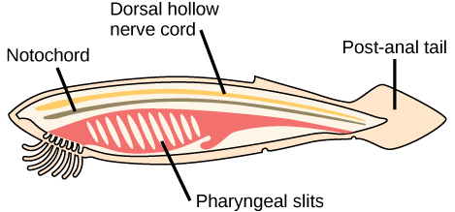Figure 29.1A.129.1A.1: Defining characteristics of chordates: In chordates, four common features appear at some point during development: a notochord, a dorsal hollow nerve cord, pharyngeal slits, and a post-anal tail.  - a notochord  - a dorsal hollow nerve cord  - pharyngeal slits  - post-anal tail  Notochord  The chordates are named for the notochord: a flexible, rod-shaped structure that is found in the embryonic stage of all chordates and also in the adult stage of some chordate species. It is located between the digestive tube and the nerve cord, providing skeletal support through the length of the body. In some chordates, the notochord acts as the primary axial support of the body throughout the animal’s lifetime.  In vertebrates, the notochord is present during embryonic development, at which time it induces the development of the neural tube which serves as a support for the developing embryonic body. The notochord, however, is replaced by the vertebral column (spine) in most adult vertebrates.  Dorsal Hollow Nerve Cord  The dorsal hollow nerve cord derives from ectoderm that rolls into a hollow tube during development. In chordates, it is located dorsally (at the top of the animal) to the notochord. In contrast to the chordates, other animal phyla are characterized by solid nerve cords that are located either ventrally or laterally. The nerve cord found in most chordate embryos develops into the brain and spinal cord, which comprise the central nervous system.  Pharyngeal Slits  Pharyngeal slits are openings in the pharynx (the region just posterior to the mouth) that extend to the outside environment. In organisms that live in aquatic environments, pharyngeal slits allow for the exit of water that enters the mouth during feeding. Some invertebrate chordates use the pharyngeal slits to filter food out of the water that enters the mouth. In vertebrate fishes, the pharyngeal slits develop into gill arches, the bony or cartilaginous gill supports.  In most terrestrial animals, including mammals and birds, pharyngeal slits are present only during embryonic development. In these animals, the pharyngeal slits develop into the jaw and inner ear bones.  Post-anal Tail  The post-anal tail is a posterior elongation of the body, extending beyond the anus. The tail contains skeletal elements and muscles, which provide a source of locomotion in aquatic species. In some terrestrial vertebrates, the tail also helps with balance, courting, and signaling when danger is near. In humans and other apes, the post-anal tail is present during embryonic development, but is vestigial as an adult.
 | 2. Amphioxus digestive system, reparatory system | The enterostome is also called a mouth. Since the enterostome leads into an endoderm-lined pharynx and not into an ordinary ectoderm-lined vestibule or stomodaeum, it cannot correspond to the mouth of chordates. Hence, the front opening into the vestibule is a true mouth.  (i) Muller Organ:  The epithelium (ectoderm) of the oral hood is projected to form six to eight pairs of finger-like folds, each having a ciliated groove borded by ciliated ridge. These folds are collectively known as wheel organ or Muller’s organ or rotatory organ. Outer of these, the mid-dorsal groove is the largest and ends in a pit or depression in the roof of buccal cavity. This is called Hatscheks groove and Hatscheks pit respectively. Both are ciliated and glandular, and secretes mucus.  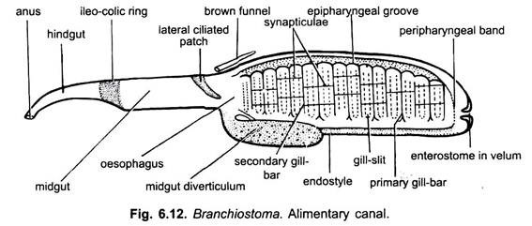  (ii) Velum and Enterostome:  At the posterior end of the buccal cavity is present a circular, membranous velum. It is centrally perforated by the enterostome which leads into pharynx. The velum has circular muscles which act as sphincter for opening and closing the enterostome. The edges of the velum bear 12 or more slender, ciliated velar tentacles which normally project backwards forming a strainer.  3. Pharynx:  The pharynx is a large, laterally compressed sac occupying nearly one-half anterior part of the body. It is suspended in the atrial cavity which encloses it from all sides except the dorsal.  (i) Pharyngeal Wall and Gill-Slits:  The lateral walls of the pharynx are perforated by more than 150 pairs of gill-clefts which bear no gills. The gill-clefts are metameric, vertical apertures when first formed in the larva, but each gets divided into two. New gill-clefts are added with age at the posterior end of the pharynx; hence, their number varies in different specimens. Between the gill-clefts the wall of the pharynx is known as gill-bars or gill-lamellae.  The pharyngeal gill-bars are of two types- primary gill-bars and secondary gill-bars or tongue-bars. They alternate regularly and differ in their structure and mode of development. A primary gill-bar is formed of the tissue between two successive gill-clefts after they have perforated to the exterior.  It is composed of the wall of the pharynx and the body wall of the larva. The secondary gill-bars arise as down growths of the dorsal wall of larval gill-clefts, the wall grows downwards dividing the original gill-cleft into two halves vertically.  Both primary and secondary gill-bars are covered on their external or outer surface by sparsely ciliated ectodermal or atrial epithelium, but on their inner, anterior and posterior surfaces by endodermal pharyngeal epithelium which is heavily ciliated.  The cilia on the anterior and posterior endodermal surfaces of gill-bars are long and called the lateral cilia which propel water, and the cilia on the inner endodermal surface of each gill- bar form a long but narrow tract of frontal cilia which propel mucus. In the middle each gill- bar has a mesodermic core of connective tissue, blood vessels and gill-rods.  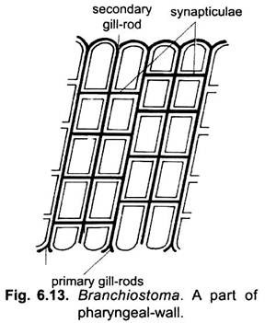  The gill-bars are supported internally by gelatinous skeletal gill-rods. All gill-rods are united dorsally, but ventrally their free ends are forked in the primary gill-bars, and unforked or simple in the secondary gill-bars. The primary gill-bars are connected to each other by transverse junctions called synapticula which also contain gelatinous rods and blood vessels. The synapticula develop only after the gill-clefts are completed, they make the pharynx look like a basket, somewhat like the branchial sac of urochordates.  The primary gill-bars contain a narrow coelomic canal running throughout the length of each and communicating dorsally and ventrally with other corresponding coelomic spaces, they also have three blood vessels in each, running lengthwise. The secondary gill-bars with simple gill-rods have no coelom and only two blood vessels run through each of them.  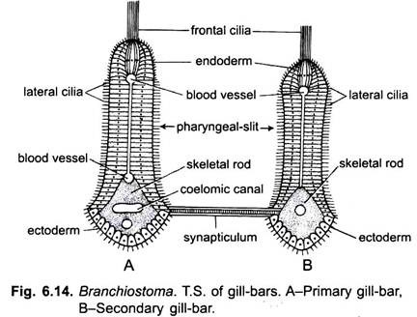  (ii) Epipharyngeal Groove:  Besides the ciliated gill-bars, there are other ciliated tracts in the pharynx. Running mid-dorsally is a ciliated epipharyngeal groove which leads into the opening of oesophagus at the posterior end of the pharynx.  (iii) Endostyle:  In the mid-ventral wall of the pharynx is a shallow groove called endostyle. The endostyle is lined with four longitudinal tracts of glandular epithelial cells which secrete mucus. These tracts are separated by ciliated epithelial cells of which the median row of cells bears very long cilia. The endostyle is supported below by the two gelatinous skeletal plates.  Beneath these is present the subendostylar coelomic canal enclosing the ventral aorta. A similar endostyle is found in urochordates and in the ammocoete larva of lampreys, but the larval endostyle is lost during metamorphosis of lamprey, it contributes to the formation of a thyroid gland in the adult. Like thyroid gland of vertebrates, it also concentrates radioactive iodine.  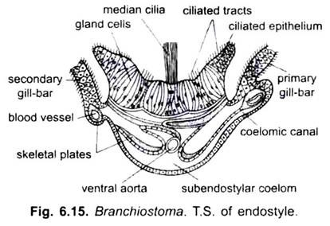  (iv) Peripharyngeal Bands:  The epipharyngeal groove and endostyle are joined to each other anteriorly by two narrow ciliated peripharyngeal bands. Each running on the lateral side wall of the pharynx behind the velum and demarcates a narrow anterior prebranchial region of the pharynx from the proper large posterior pharynx. It is devoid of cilia and gill-slits.  4. Oesophagus:  The pharynx opens posteriorly into a straight narrow ciliated oesophagus followed by a wide midgut or intestine.  5. Intestine:  Intestine is a long tube suspended in the atrium by the dorsal mesentery arising from the dorsal body wall. It is continued into a narrow hindgut opening by an anus lying slightly to the left where the caudal tin begins. Arising ventrally from the junction of oesophagus and midgut is a blind pouch called midgut diverticulum which extends in front on the right of the pharynx. The entire gut is suspended from the dorsal body wall by a dorsal mesentery. The gut has a lining of epithelial cells and a thin covering of smooth muscles.  The gut has several internal ciliated tracts in its lining, there is a crescent-shaped lateral tract of cilia in the midgut which directs food into the midgut diverticulum; there is a dorsal tract in the midgut; between the midgut and the hindgut is a large ciliated ileo-colonic or ileocolic ring which chums food. In the hindgut is another dorsal tract of cilia.  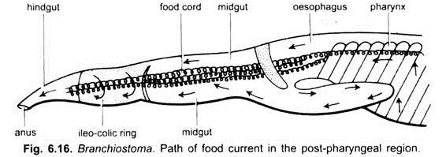  Digestive Glands:  The midgut diverticulum is often called liver or hepatic caecum, but it does not resemble a liver in structure or function, though its blood vessels are somewhat like those found in the liver of vertebrates. The midgut diverticulum is a digestive gland and is comparable to a vertebrate pancreas.  Physiology of Digestion:  Food:  Branchiostoma feeds on protozoans, diatoms, algae, desmids and other organic particles suspended in sea water.  Feeding:  Branchiostoma is a ciliary feeder. Action of cilia of the pharynx causes a current of water containing food. The current of water enters the mouth and goes to the pharynx from where it passes through gill-clefts into an atrial cavity, and then it goes out through an aperture of the atrial cavity called atriopore. In feeding the oral hood is extended and oral cirri are turned inwards, they prevent sand from entering the mouth.  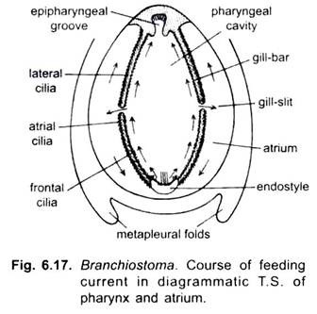  Rotary movements of cilia of wheel organ direct water towards the pharynx, but some food particles fall out of the water current, they are mixed with mucus secreted by groove of Hatschek and passed back into the pharynx. When the main water current passes through the enterostome into the pharynx, mainly due to lateral cilia of gill-bars, the suspended food particles fall on the gill-bars where they get entangled in mucus secreted mainly by the endostyle and to some extent by the pharyngeal epithehum.  Mucus secreted by endostyle is transferred to the lateral wall of the pharynx by its lateral rows of cilia; the median row of long endostylar cilia keeps supplying mucus to the lateral rows of cilia of the endostyle. These cilia lash outwards throwing the muccus on the lateral wall of pharynx.  The frontal cilia of gill- bars beat along the length of the bars in such a way that they propel mucus from the lateral to the mid- dorsal side of the pharynx. In this way a stream of mucus with food particles passes from the lower- side into epipharyngeal groove. The cilia of epipharyngeal groove beat backwards moving the cord of mucus and food into the oesophagus.  The peripharyngeal bands also collect and pass to the epipharyngeal groove any food particles which fall out of the water current at the extreme anterior end of the pharynx (where no gill-clefts are present). Food and mucus are not transferred from the endostyle into the peri-pharyngeal bands, as is often stated.  The cord of food and mucus passes down the gut by action of cilia. It is moved from the oesophagus into the midgut where a lateral tract of cilia directs it into the midgut diverticulum, from here the cord is returned again into the midgut. The iliocolic or iliocolonic ring rotates the cord of food causing the food and enzymes to mix, and then the cord of food is moved into the hindgut.  Digestion:  Digestive enzymes are secreted by the epithelial cells of the gut and midgut diverticulum. They are mixed with food as it passes along. Digestion starts in the midgut and is continued in the hind-gut.  Besides this extracellular digestion, intracellular digestion also occurs in which food particles are taken into the epithelial cells of the hindgut and digested there. Some papillae on the floor of the atrium contain phagocytic cells which engulf food particles which may pass into the atrial cavity. Absorption of digested food takes place mostly in the hindgut and to lesser extent in the midgut.  Sub-Phylum – Cephalochordata  Morphology:  The body is elongated, fish like, semi-transparent, laterally compressed and pointed at both ends. It measures about 5-7 compound in length, the colour of the body is dark red and reddish brown.  The body of the amphioxus is divided into two parts: The trunk and tail. The head is absent. The paired fins are absent, but unpaired fins such as a dorsal fin, running along the whole length, a caudal fin, around the tailed a ventral fin, are present.  The dorsal fin is supported by a series of fin rays. But these are not similar to fin rays of fishes. The trunk bears three openings: the mouth atripore and anus. The anterior end of trunk is pointed called rostrum. The mouth lies below the rostrum. The mouth leads into oral hood formed by dorsal and lateral projections of the body. The edge of the oral hood is provided with 10 to 11 pairs of oral cirri or tentacles. The cirri helps in filter feeding and draw water current towards pharynx.  The oral hood encloses a cup shaped buccal cavity called vestibule. The atripore is a small mid-ventral aperture situated in front of the ventral fin. The anus lies at the base of caudal fin on the ventral side. From the posterior part of the oral hood two lateral membranous metapleural folds run up to the atriopore.
 | 3. Circulation, excretion and reproduction | சுருக்கம்  ஆம்பியோக்ஸஸின் சுற்றோட்ட அமைப்பின் உருவ அமைப்பை தெளிவுபடுத்துவதற்காக, ஒளி மற்றும் எலக்ட்ரான் நுண்ணோக்கியின் நவீன நுட்பங்களைப் பயன்படுத்தி இரத்த நாளங்கள் ஆராயப்பட்டன.  ஆம்பியோக்ஸஸில் புழக்கத்தின் முறை வென்ட்ரலாகவும் பின்னோக்கி முதுகெலும்பாகவும் உள்ளது. கூடுதலாக, பொதுவாக அதிக சோர்டேட்டுகளின் இரத்தத்துடன் தொடர்புடைய சுழற்சி சடலங்கள் இல்லை.  ஆம்பியோக்ஸஸின் சுற்றோட்ட அமைப்பு நன்கு வரையறுக்கப்பட்ட சுருக்கக் குழாய்கள் மற்றும் வாஸ்குலர் இடைவெளிகள் அல்லது ஒரு இணைப்பு திசு மேட்ரிக்ஸில் உள்ள சைனஸ்கள் ஆகியவற்றைக் கொண்டுள்ளது. சுருக்கக் கப்பல்கள் ஒரு அடித்தள லேமினாவில் ஒரு இடைவிடாத எண்டோடெலியல் புறணியைக் கொண்டுள்ளன, மேலும் அவை ஒரு எளிய அடுக்கு சுருக்க மயோபிதெலியல் செல்கள் மூலம் மூடப்பட்டுள்ளன. பெரிய மற்றும் சிறிய அஃபெரென்ட் மற்றும் எஃபெரென்ட் பாத்திரங்கள் மற்றும் இரத்த சைனஸ்கள் உள்ளிட்ட வாஸ்குலர் மரம் முழுவதும் இடைவிடாத எண்டோடெலியல் லைனிங் ஏற்படுகிறது. இது அதிக விலங்குகளுக்கு முரணானது, அங்கு எண்டோடெலியம் எல்லை அடுக்கின் உள் மேற்பரப்பில் அதிகமாகவோ அல்லது குறைவாகவோ தொடர்ச்சியான புறணி உருவாக்குகிறது.  ஆம்பியோக்ஸஸின் எண்டோடெலியல் செல்கள், உயர் கோர்டேட்டுகளின் நுண்குழாய்களில் உள்ள எண்டோடெலியல் செல்கள் போன்றவை, பெரும்பாலும் பாசல் லேமினாவிலிருந்து வடிகட்டுதலின் எச்சங்களை அகற்றுவதன் மூலம் சுற்றோட்ட அமைப்பின் உடலியல் துறையில் ஒரு பங்கை வகிக்கின்றன, இதன் மூலம் பொருட்கள் பரிமாற்றம் மற்றும் சுற்றியுள்ள திசுக்களில் இருந்து.  Fine structure of the excretory system of Amphioxus (Branchiostoma floridae) and its response to osmotic stress  - Peter C. Moller¹ &  - Richard A. Ellis¹  Cell and Tissue Research volume 148, pages1–9(1974)Cite this article  - 185 Accesses  - 9 Citations  - Metrics details  Summary  The excretory organs of Amphioxus occur as segmentally arranged structures throughout the pharyngeal region and may be divided into three components: the solenocytes, the renal tubule, and the renal glomerulus.  The solenocytes possess foot processes that rest upon the coelomic surface of the ligamentum denticulatum. The tubular apparatus of the solenocytes consists of ten triangular rods surrounding a central flagellum. The distal end of the tubular apparatus enters branches of the renal tubule. The renal tubule eventually opens into the atrial cavity of Amphioxus.  The renal glomerulus is a sinus within the connective tissue of the ligamentum dentieculatum where it connects elements of the branchial circulation with the dorsal aorta. The renal glomerulus, like other blood vessels of Amphioxus, lacks an endothelial lining.  If Amphioxus is adapted to artificial sea water at different concentrations there is no change in kidney morphology suggesting that Amphioxus is either is osmotic with its environment or is osmoregulating with other organs.  REPRODUCTION IN AMPHIOXUS  By BS Media  Thursday, 06 July 2017 16:35 Read 4053 times  Medically reviewed by a board-certified member  Amphioxus is a Cephalochordate animal. Its Life history in the early stages shows resemblance with ascidians. HATSCHE’K WILSON. CONKLIN’ worked on the part of embryogenesis of Amphioxus. ‘CONKLINS’ work in more accurate and is recent.  Amphioxus is a unisexual animal. But sexual dimorphism is absent. Amphioxus shows 26 pairs of Gonads. They are present from 25th myotomal segments to 51. These Gonads have no ducts. When mature the overlapping tissue of the Gonad will rupture and the gametes are Iibereted into atrium of Amphioxus. They will come out into the water through the atriopore.  AMPHIOXUS - ORGANISATION OF THE GAMETES  SPERMATOZOAN IN AMPHIOXUS: The mature male sex cell called Sermatozoan. It is 15 to 20 in length. It shows three regions.  1. Head, 2. Middle piece and 3. Tail .  On the head acrosome is present. Head shows a big nucleus. Around the nucleus thin sheet of Cytoplasm is present. It is called Manchetty. The middle piece is small with mitochondrial matrix called nebenkeron. The tail is long and shows movements.  EGG OR OVUM IN AMPHIOXUS: The mature female sex cell is ovum. It is small and 0.12 mm in diameter. It is a microlecithal egg. The cytoplasm around the nucleus will show yolk. In the peripheral cytoplasm yolk is absent. It is granular and is called carticoplasm. The plasma membrane surrounds the cytoplasm. Around this is a mucopolysaccharide membrane is present. It is called vitelline membrance. In between these two layers perivitelline space is present. The nucleus is present towards the animal pole, where as the opposite pole is called vegetal pole. The vegetal pole becomes posterio dorsal side of the embryo. The Animal pole becomes antero-ventral side of the embryo. Hence a gradient polarity is established in the egg.  FERTILISATION IN AMPHIOXUS: As soon as the egg comes in contact with water the vitelline membrane wilI separate from the plasma membrane.  The egg is surrounded by a number of sperms. One sperm will make its entry through the contents of the egg from the vegetal pole. At this time a number of changes take place in the corticoplasm. Now membranes are formed which unite with vitelline membrane It is called Fertilisation  So that no other sperm can enter into the egg. The head and middle piece of the sperm will enter into ooplasm of the egg. The egg nucleus undergoes second maturation division. Second polar body is pushed into the pervitilline space . The sperm nucleus and middle piece will show 180° twist and move towards the egg nucleus. Both the nuclei will unite. Thus a zygote nucleus is formed.
 | 4. Shark – Digestion, Respiration | Sharks are a group of elasmobranch fish characterized by a cartilaginous skeleton, five to seven gill slits on the sides of the head, and pectoral fins that are not fused to the head. Modern sharks are classified within the clade Selachimorpha (or Selachii) and are the sister group to the rays. However, the term "shark" has also been used for extinct members of the subclass Elasmobranchii outside the Selachimorpha, such as Cladoselache and Xenacanthus, as well as other Chondrichthyes such as the holocephalid eugenedontidans.  How Sharks Breathe  Sharks don't have lungs, but they do have to breathe oxygen to survive. Instead of breathing air, though, sharks get oxygen from the water that surrounds them. The concentration of oxygen in water is much lower than in air, so animals like sharks have developed ways to harvest as much oxygen as they can. The breathing process for sharks begins and ends with their gills, which they use to both extract oxygen from water and rid their bodies of carbon dioxide.  Here's the quick version of how it works, according to Sharkopedia:  - As water passes over the gills, small capillaries allow oxygen to enter the bloodstream.  - The oxygenated blood is then pumped throughout the shark’s body.  - The blood then enters the heart and is pumped to the gills, where carbon dioxide is released and the process begins again.  Most sharks get water to flow over their gills by swimming and moving through water, while some sharks will hold water in their cheeks and pump it over their gills—allowing them to breathe while resting on the ocean bottom.  The High and Low  Oxygen levels vary depending on depth: higher at the surface of the ocean and lower in deeper water.  Some sharks, especially bigger and more active sharks, require more oxygen than others, and some sharks are actually able to adapt to low oxygen conditions. "While all sharks (and their relatives) require a certain amount of oxygen to survive—and higher levels are better—some species can tolerate low levels of oxygen for prolonged periods of time," says Rachel Skubel, Ph.D., student at the Abess Center for Ecosystem Science and Policy and researcher at the Shark Research & Conservation Program at University of Miami. For example, the epaulette shark is regularly exposed to low or no oxygen in its shallow tidal habitat and tolerates it by lowering its energy (and thus oxygen, which produces energy) demand. There are instances of other sharks, such as the shortfin mako, that make deep dives into low-oxygen areas, likely in search of food, says Skubel. But sharks that are able to use these tactics (i.e., energy production in the absence of oxygen) have to recover from these efforts—just like humans would recover from running fast sprints!  Declining Oxygen in Our Oceans  Still, sharks depend on oxygen-rich water to keep them alive, along with all marine life. Declining oxygen levels in the world's oceans are a threat for sea creatures and the habitats in which they exist. A study published last year shows that oxygen levels have been declining for more than 20 years—faster than anticipated. Areas with low levels of oxygen are expanding, causing fish, shrimp and other organisms to flee or die, and their feeding habits to change.  What does it mean for sharks?  "Low oxygen can reduce abundance of prey species," explains Skubel. "If there is less food available, sharks might move to other areas (if they can)." She also points out that a change in the depth of oxygen minimum zones could impact sharks. "The higher-oxygen surface waters are important for active species of sharks and their prey, so a reduction in 'vertical habitat' could restrict their access not only to food, but also to cooler deeper waters to regulate their body temperature."  Warming Waters  Oxygen naturally fluctuates in marine waters, but the decline in oxygen levels is happening faster than predicted. Warmer oceans may be to blame. Scientists point to carbon pollution and climate change as a likely driver of this trend. Carbon pollution—carbon dioxide and other gases emitted from cars, factories, electricity production and agriculture—is one of the biggest contributors to climate change. These gases get trapped near the earth's surface creating warmer temperatures. As carbon pollution warms the earth, oxygen in the oceans drops because warmer water holds less oxygen.  What's more, the oceans naturally absorb carbon dioxide (which actually helps stabilize the earth's climate). But as carbon pollution increases, it increases the acidity of seawater (called ocean acidification). Skubel points out there is potential for acidification to alter a shark's sense of smell and ability to track prey. A 2015 study from the University of Adelaide showed "warmer waters and ocean acidification will have major detrimental effects on sharks' ability to meet their energy demands, with the effects likely to cascade through entire ecosystems."  On Dry Land  Of course, climate change doesn’t just affect the oxygen sharks rely on—it also threatens the air humans breathe. The same warmer temperatures that are concerning for sharks and marine life underwater increase dangers for humans, too, contributing to high-ozone days and wildfires with their pervasive smoke. The added smog and soot increases health risks such as asthma attacks, heart disease and even early death. That's why it's so important to reduce the carbon pollution that causes climate change. Land or water, it impacts all life on this planet.  So, what can you do? Right now, you can join the fight for healthy air. Lifesaving clean air and climate protections are under attack. For example, transportation is the nation's number one source of carbon pollution, but the Trump Administration has signaled that they plan to roll back cleaner cars standards. These standards are strongly supported by the public and they're working to reduce carbon pollution. Other policy issues include a proposal to censor science, riders that give breaks to industrial polluters and threats to the Clean Air Act. You can help us speak up, spread the word and take action for healthy air by signing and sharing our petitions and letters to policymakers.  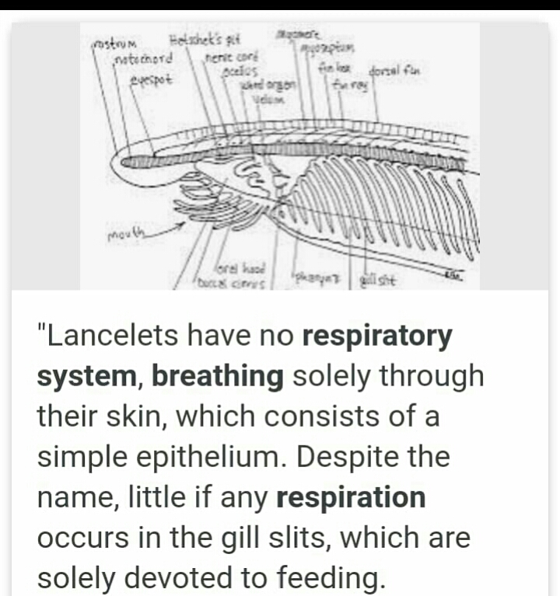
 | 5. Circulation, Excretion, Reproduction | What is excretion?  Excretion is a biological process by which metabolic waste products and toxic materials are removed from the body of an organism. It's an essential and imprtant part in life, because it gets rid of all the poisons and etc.  Sharks excrete through the same place where they have sexual intercourse through. They do not have separate opening form excreting and reproduction.The urogenital system is made up of the uinary and reproductive systems. The purpose of the urinary system is to purify the body of its Nitrogenous waste. Both the male and female urinary system work similarly.  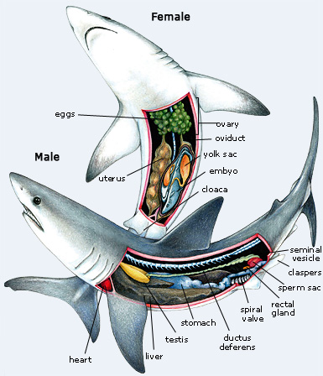  Reproduction  Sharks are sexually dimorphic. That is, there are visual differences between males and females. Males, like the one seen in this picture, have pelvic claspers which are modified pelvic fins used for sperm delivery.  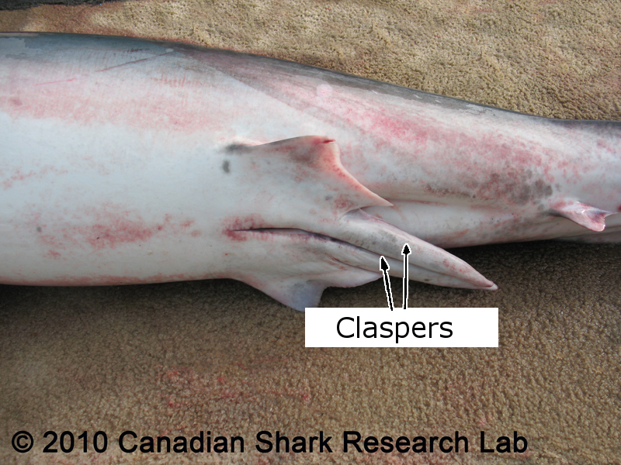  Male claspers  Claspers are rolls of cartilage that become stiffened with calcium in the adult. The presence or absence of these claspers make it very easy to differentiate males from females. Males also have paired testes, however the right one is always more developed than the left, which may be smaller or absent altogether.  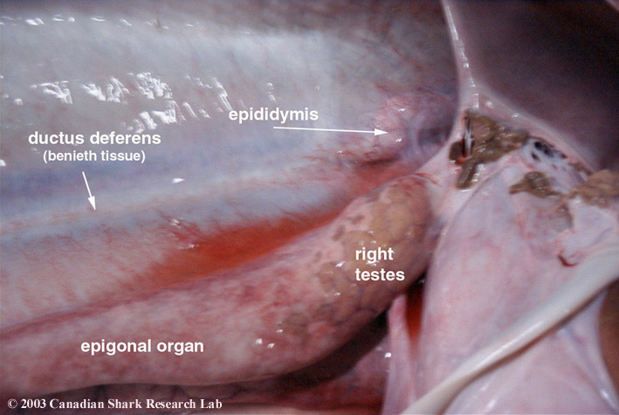  A close up view of the right testes of a porbeagle.  The testes are internal and are located in the anterior end of the body cavity within the epigonal organ. The urinary and reproductive tracts join together to form the urogenital sinus. From there the sperm is eventually released into the groove of the claspers and is then delivered to the female during copulation.  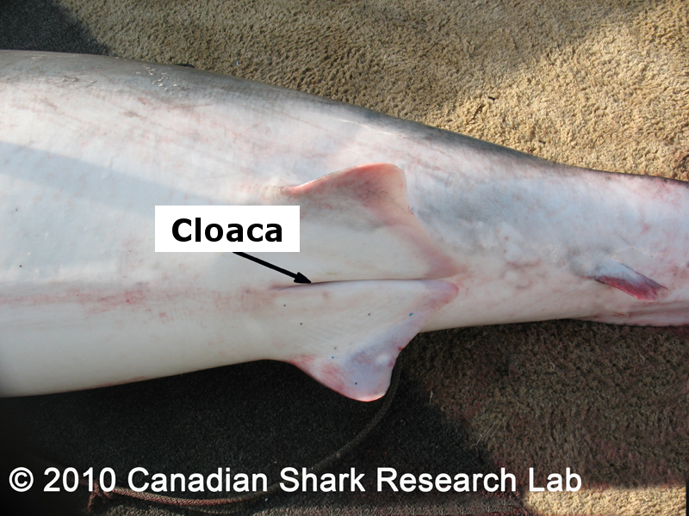  Cloaca of a female  Females do not have claspers. Instead they have a cloacal opening (as do the males) between the pelvic fins. The internal ovaries are found anteriorly in the body cavity and are paired, but as was the case with the male testes the left side is often reduced. Indeed, the left ovary often releases very few or no eggs.  Compare the reproductive organs of mature female blue and porbeagle sharks (Note: these are high resolution images, so images will take somewhat longer to display). Click here for internal images of the spiny dogfish.  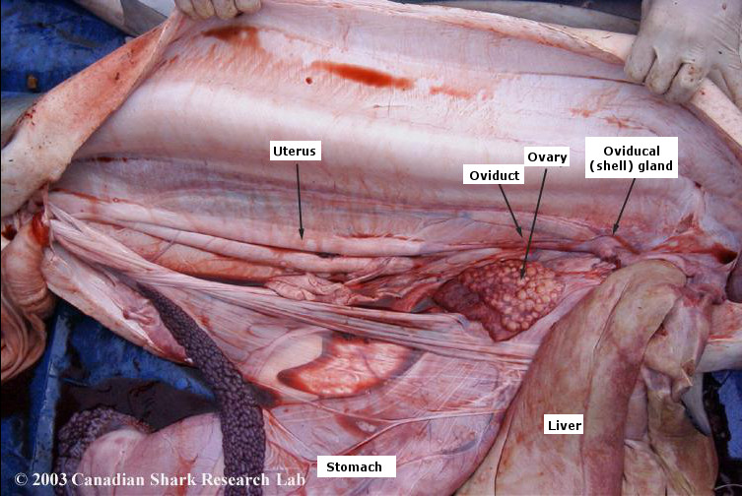  Internal anatomy of a mature female blue shark.  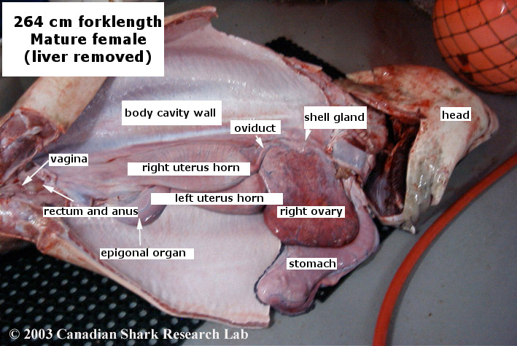  Internal anatomy of a mature female porbeagle shark.  Once eggs are released and fertilized, a horny shell or membrane is secreted around each one as they pass through the oviducal gland or shell gland. Some sharks produce a shell that is tough and can protect the young. In other species the membrane is slight or vestigial and the young develop and hatch within the uterus of the female. The eggs and egg cases produced by different species are highly variable. Eggs can be up to 60 or 70 mm in diameter and encased in shells up to 300 mm long. Shapes vary from spindle to purse-like with tendrils and hooks.  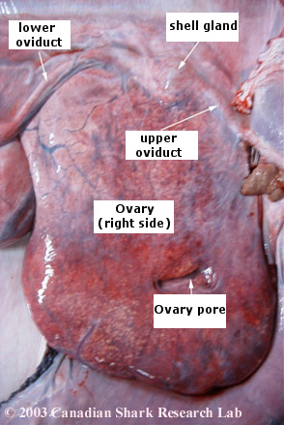  A close up view of the right ovary of a porbeagle  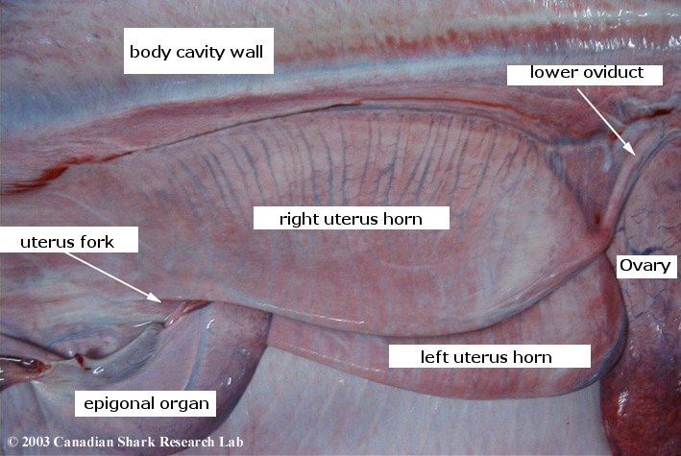  A close up view of the uterus of a porbeagle.  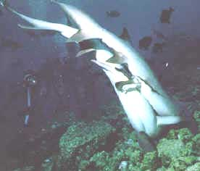  Photo modified from Sharks, Editor John D. Stevens. 1987. Facts on File Inc. New York, NY.  During copulation sharks meet face to face. As seen in this picture the male inserts one of his claspers into the cloaca of the female. Sperm contained within sperm packets called spermatophores are delivered to the female via a groove in the clasper. The spermatophores are forcefully ejected by contracting organs known as siphon sacs which use seawater currents to carry the spermatophores.  Another marked difference between the male and female sharks of some species is the thickness of their skin. The skin on a female blue shark is nearly twice as thick as that of males. It is believed that this is because of the viciousness of mating. Males will often bite females during face to face copulation leaving them with wounds. Without the extra thickness of the skin females could be severely injured.  The photos below show bite marks on the left pectoral fin of a female porbeagle and on female blue sharks.  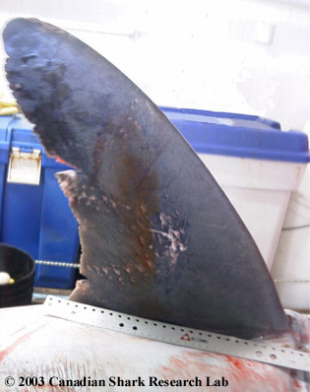  Mating scars on female porbeagle pectoral fin.  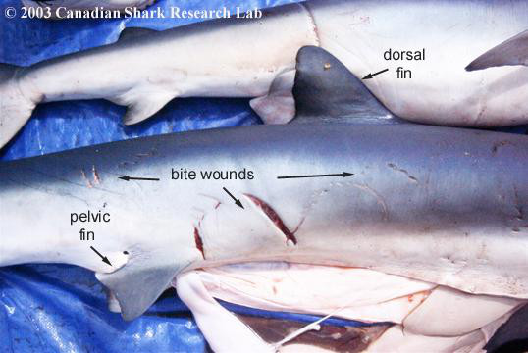  Mating scars on a female blue shark  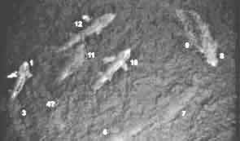  Aerial view of basking sharks in a mating circle  Mating behaviour in sharks can be very complex and evidence suggests that there is some degree of mate selection within certain species. Sexes often segregate, and only come together to mate. Occasionally congregations form in mating behaviour. For instance, basking sharks have been seen forming mating circles like the one seen in this picture. The exact purpose of this behaviour is not known however it is clear that it related to mating.  There are three modes of reproduction within the sharks. In general most sharks bear live young, however there are some sharks who lay eggs. The most advanced form of development is called viviparity. This is when the female provides nourishment for the embryos as they develop inside of her. The nourishment can be delivered as a secretion called uterine milk or through a placental connection.  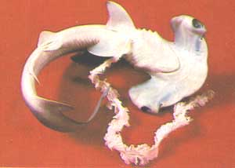  Hammerhead in viviparous development stage. Photo modified from Eve Bunting, The Sea World Book of Sharks. 1979. Halcourt Brace Jovanovich Publishers. Orlando, Florida.  The hammerhead shown in this picture is an example of viviparous development. The placental connection to this fetus would have been connected to the uterine wall of the mother.  The most common form of development is referred to as ovoviviparity. This is similar to viviparity because the eggs are fertilized, hatch and develop within the body of the female. However the embryos do not receive any direct nourishment from the mother other than the initial investment of the egg production. In some species, the young can receive nutrients by devouring newly ovulated eggs or smaller, less developed embryos or siblings. This is known as oophagy.  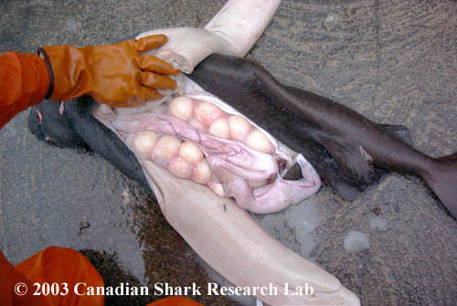  Portuguese Shark Eggs  Examples of ovoviviparous development. In this example of a portuguese shark, the developing ova can be clearly seen within the ovaries. The eggs will eventually move into the uteri where they will hatch, developing into an embryo nourished by large amounts of yolk. Further examples of various embryo stages of ovoviviparous development can be seen in the spiny dogfish and porbeagle sharks.  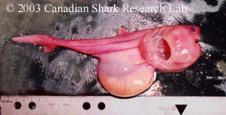  Porbeagle embryo. Note the yolk stomach which looks like a distended belly under the embryo.  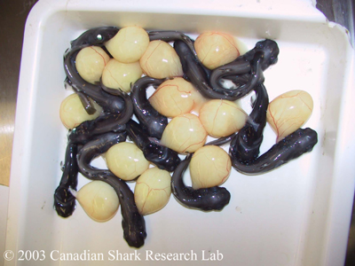  Black dogfish embryos (Courtesy of Einar Àsgeirsson and Ingibjörg Jónsdóttir, Iceland).  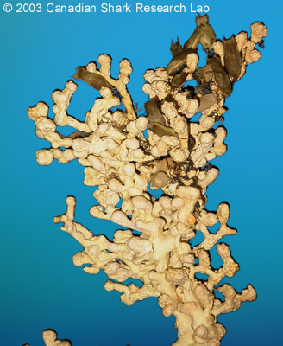  Catshark egg cases on coral.  The final type of development is known as oviparity. In oviparous reproduction, sharks lay eggs in the form of egg cases, which they attach to algae or corals. The egg cases of at least one species are designed to be pushed into the sediment. Once the eggs are secure the female then leaves and the eggs receive no subsequent protection or nourishment.  A number of small dark eggs can be seen in the upper parts of the coral in this picture. Small tendrils attached to the egg case are used to fasten it to corals and algae. Without the protection of the mother,the embryo is then able to develop and hatch with some level of protection from predators.  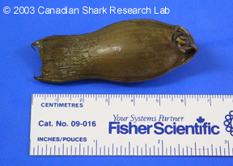  The egg case of a deepsea cat shark (as seen above).  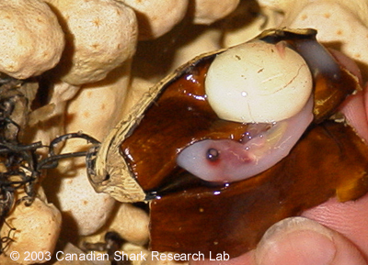  A deepsea cat shark embryo within the egg case. Notice the large yolk sac which nourishes it while developing inside the egg case.
UNIT IV | Morphology and digestive system of Frog | Frogs - Morphology And Anatomy  Frogs are carnivorous tailless amphibians which are widely found in India. A diverse variety of frogs can be found all over the world; among them, the Indian frogs are called Rana tigrina. They are vertebrates, coming under the class Amphibia (phylum Chordata). Frogs are cold-blooded animals (poikilotherms) whose body temperature varies according to their environment, hence, they need to protect themselves from extreme heat and cold for maintaining optimum body temperature. Thus, they follow aestivation and hibernation during the summer and winter seasons respectively. Another characteristic feature of frogs is that they camouflage i.e., they can change their skin colour according to their surroundings.  Morphology of Frogs  Though larvae have tails, adult frogs are tailless. An adult frog has a stout body which is differentiated into head and trunk. Other external features are a pair of nostrils, protruding eyes, a membranous tympanum (ear), slippery/warty moist skin and webbed limbs.  Frogs generally have a slippery moist and highly permeable skin through which they absorb water and respire. Thus, the moist skin acts as a respiratory organ in frogs. Also, the skin is glandular in nature, which produces mucus and toxic substances to warn them of their predators. The colour of the skin can vary from brown and green to vivid colours as per secretions.  The locomotion of frogs takes place with the help of their forelimbs and hind limbs. Frogs are unisexual i.e., they show sexual dimorphism. A male frog is distinguished from a female frog by the presence of vocal sacs and a copulatory pad on forelimbs. A female frog lacks these body features.  Anatomy  The body plan of frogs consists of well-developed structures which help them in their physiological activities. The body cavity accommodates all the organ systems such as digestive, respiratory, circulatory, excretory, nervous and reproductive systems, whose functions are almost similar to human body systems.  Digestive system  The alimentary canal together with the accessory organs makes up the digestive system of the frog. Since frogs are carnivorous they have short intestine. The alimentary canal begins at the mouth (buccal or oral cavity), passes through the pharynx, oesophagus or food pipe, stomach, small intestines, large intestines, rectum and finally ending at the cloaca. The food particles get digested gradually as they travel through various compartments of the alimentary canal.  Respiratory system  The amphibian has two modes of respiration – cutaneous respiration and pulmonary respiration. In an aquatic ecosystem, the skin is the respiratory organs where the diffusion of dissolved oxygen takes place. This is called cutaneous respiration. While on land, they use both skin and lungs for respiration. During pulmonary respiration, air entering through nostrils passes to the lungs via the buccal cavity. But during summer and winter sleep, they use only skin for respiration.  Circulatory system  Frogs have a well-developed muscular heart with three chambers- two atria and one ventricle. Blood and lymph help in the transportation of food, air and other substances throughout the body via the network of blood vessels. The blood is composed of plasma and blood cells (RBC, WBC, and platelets).  Excretory system  The frog is a ureotelic animal whose major excretory product is urea. They have a distinguishable excretory system composed of a pair of kidneys, ureters, cloaca and urinary bladder. The kidneys have the structural unit called nephron which filters the blood and excretes out the waste.  Coordination system  The nervous system and the endocrine system together perform the control and coordination in frogs. The endocrine system is composed of the endocrine glands such as pituitary, thyroid, parathyroid, thymus, pineal body, pancreatic islets, adrenals, and gonads. The secretions of these glands called hormones are responsible for metamorphism and other regulatory functions.  The nervous system is divided into CNS and PNS. The brain is distinguished as forebrain, midbrain, and hindbrain which control different parts of the body. The brain is enclosed in the cranium and the vertebral column protects the spinal cord.  Reproductive system  Both male and female frogs have their own reproductive system where gametes for reproduction are produced. Male frog has testes which produce sperms and eject it through the cloaca. In a female frog, a pair of ovaries produce ovum and pass it to oviduct which opens into the cloaca. The cloaca is a common pathway for excretion and reproduction. At a time, 2500 to 3000 eggs are laid which are fertilized externally.  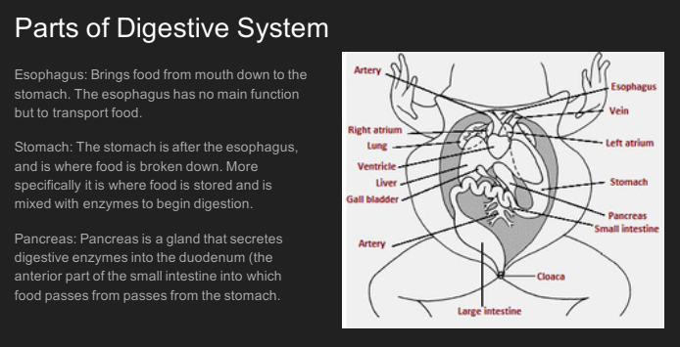  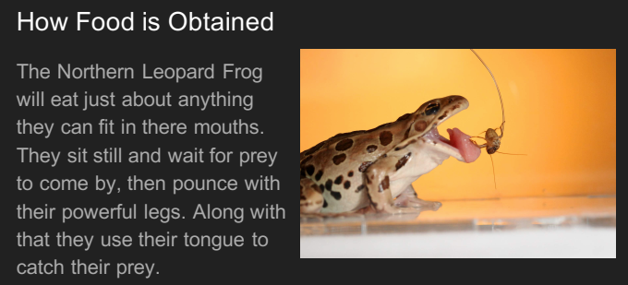  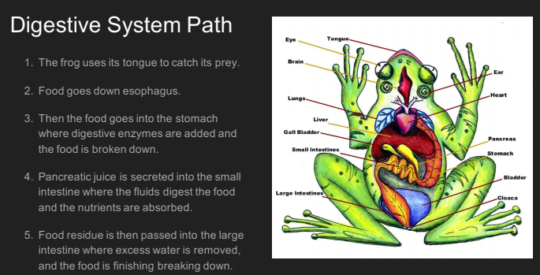  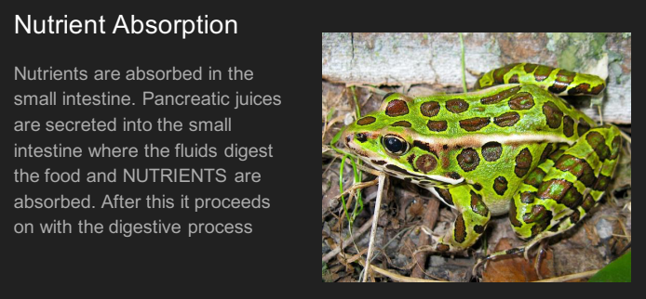  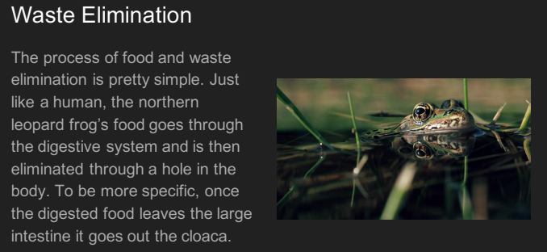
 | Respirative system and circulatory system of frog | Respiration in a Frog vs. a Tadpole  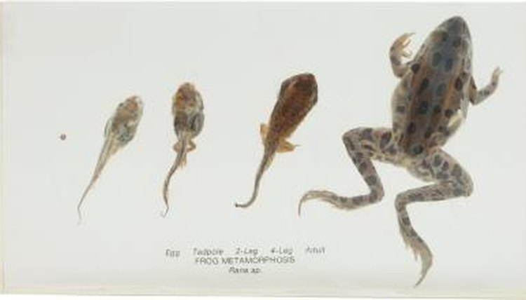  Hemera Technologies/PhotoObjects.net/Getty Images  Tadpoles hatch from frogs' eggs and can only survive in water. As they undergo metamorphosis to become adult frogs they change in many ways, losing their swimming tails and developing legs. Both need to take in oxygen from their environment, and the way they respire also changes as they develop. Tadpoles use gills, while mature frogs have three types of respiration  Animal Circulatory System  By: BD Editors  Reviewed by: BD Editors  Last Updated: April 24, 2019  Many animals have a closed circulatory system, where the blood is maintained in vessels and pumped by a heart. Some organisms, such as many mollusks, have an open system, where the blood washes over and around tissues. Animals with a closed circulatory system tend to have higher blood pressure. The blood is also able to travel further than in an open system. These animals may have a one-, two-, three-, or four-chambered heart.  Frog Fish Earthworm  Open or closed circulatory system Closed Closed Closed  Number of circuits for circulation Three One One  Chambers in the heart Three Two One  Number of hearts in body One One Five  Frog Circulation  Frogs are amphibians and have a closed circulatory system. Unless there is an abnormal mutation present, frogs only have one heart to pump blood throughout the body.  A frog has a three-chambered heart. The chambers include two atria and a ventricle. The right atrium receives deoxygenated blood from the veins. Oxygenated and deoxygenated blood have a tendency to mix within the ventricle that is responsible for pumping blood. The left atrium receives oxygenated blood from both the lungs and the skin.  Frogs have three circuits for their circulation, unlike humans who only have two. Like humans, however, frogs have a systemic circuit, which pumps oxygenated blood throughout the body. The pulmonary circuit moves blood to the lungs to pick up oxygen. Frogs also have a pulmocutaneous circuit, where deoxygenated blood is transported to the skin to pick up oxygen and undergo gas exchange.  The below image shows a diagram of a frog’s heart with its three chambers.  Fish Circulation  Like frogs, fish have a closed circulatory system. Fish also typically only have one heart within their bodies, unless they have a mutation that causes two to develop—this is rare, however  A fish has a two-chambered heart. The chambers are a single atrium and a ventricle. The atrium receives blood from the veins, and the ventricle pumps blood to the gills for gas exchange, similar to the ventricle in frogs. The blood moves from the gills throughout the rest of the fish’s body. This single circuit is known as systemic circulation. Having only this circuit for blood limits the oxygen that the fish’s body can transport, limiting the fish’s metabolic potential.  Earthworm Circulation  Earthworms are a bit different from fish and frogs, as well as many other animals. They have a closed circulatory system, but they don’t have a true heart. Instead, earthworms have five aortic arches, which are vessels that function similarly to a heart, pumping blood to the dorsal and ventral blood vessels.  The dorsal blood vessels supply blood to the front portion of the earthworm’s body, while the ventral blood vessels bring blood to the back portion of the earthworm. These vessels move blood in a continuous circuit.  Earthworms don’t have lungs to pick up oxygen. Instead, gas exchange occurs across the skin, similarly to what can happen in amphibians. Oxygen diffuses into the body, while carbon dioxide diffuses across the earthworm’s skin and into the surrounding environment.
 | Excretory system of frog | Overview  The excretory system involves the removal of additional or unnecessary material or waste from the body. Frogs are amphibians which are cold-blooded and born as tadpoles, then develop into adults that live out of water. Often, frogs live in damp areas such as creeks or ponds but can also live in trees. The frog has developed an excretory system that combines with the reproductive system, this is also known as a urogenital system because the two systems make one. The excretory system of a frog consists of a kidney pair, a pair of ureters, a urinary bladder, and a cloaca. The excretory system of the frog starts with taking in liquid waste from the kidneys—which remove wastes and extra water to become urine—which then is collected in the urinary bladder through ureters. The urinary bladder is present ventral to the rectum and both open into the cloaca. Both of these waste materials leave the body through the cloaca and the cloacal vent. For males, both ureters act as a urogenital duct which opens into the cloaca while in females, the ureters and the oviduct open separately into the cloaca. When frogs lack a water source, or are faced with a dry period, water can be reabsorbed from urine in the bladder to rehydrate the frog. When frogs are on land, they can also reabsorb water into the blood which helps to replace water loss from evaporation through the skin. The excretory system of amphibians, such as frogs, is advantageous to their specific niche.  ﻿﻿  Excretory System of a Frog:  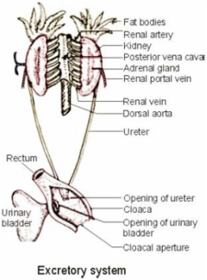  Common Organ: Kidney  The flattened bean-like structures located on the posterior of the body cavity, near the spine, are the kidneys. The main function of the amphibian kidney is to filter Nitrogen wastes from the blood which is diluted with water to make urine. The frog kidneys excrete excess water but also have adapted to conserve water rather than eliminating it when they spend time on land. Frogs can adjust to the different water amounts that it is exposed to by adjusting the rate of filtration at the glomerulus, which is located at the beginning of the nephrostome in the kidney. Nephridium are structurally very similar to that of a human nephron, but they are often funnel shaped and do not have a deep loop of Henle. The nephrostome push the water, metabolic wastes, unnecessary hormones and other substances into the metanephridium (a type of excretory gland). Frogs and other amphibians normally have a single large glomerulus that is the first stage of filtration. When blood flow through the glomerulus is limited, a renal portal system carries away materials that were reabsorbed through the tubules. When frogs are tadpoles or if they are aquatic frogs and have an abundance of water, they produce ammonia and if they do not a lot of access to water they can produce uric acid. However, most adult frogs produce urea, a loss toxic product than ammonia that requires more energy.
 | Reproductive system of frog | Reproductive system of frog  The frog is a unisexual animal with easy sexual dimorphism. Females are smaller than males of the same age. The abdomen of male frog is small and thin. Vocal cords are present in a male.  Male reproductive system  ^{source:drawitneat.blogspot.com}fig:Male reproductive system  The male reproductive system of frog consists of following organs;  Testes: It is one paired, yellowish colour, oval shaped which is encircled by peritoneum (mesorchium ) and are attached to the dorsal wall of the kidney. Each testis consists coiled structures called seminiferous tubules that are connected each other by connective tissues. It consists of interstitial cells whose secretion enable to show secondary sexual characters. Each tubule is externally covered by membrane prepared and internally by germinal epithelium. The epithelial lining of seminiferous tubules consists of germinal cells, which produce spermatozoa.  Sperm is formed of head, neck and tail. The head is thick nd enlarged structure with acrosomes in its top which contains the same sized nucleus. Neck joins head and tail parts which consist of centrosome and mitochondria. The tail is a thread like structure and helps in wriggling movements of sperm.  Vasa efferentia: It is a group of 10- 12 ducts that arise from testis and opens into Bidder's canal. Internally it is covered by epithelium and externally by connective tissues. At last, it opens collectively into a network of ducts known as rete testis.  Seminal vesicle: Each urinogenital duct expands to form seminal vesicle where the sperms are stored until they are ejected out during copulation. It contains fructose which nourishes the sperm and its internal structure is same as of vas differential.  ^{source;biology4isc.weebly.com}fig:T.S of testis^{source:biology4isc.weebly.com}fig:Structure of Sperm  Urino-genital ducts: Also called ureter or collecting duct runs below the kidneys. The sperms pass out through this duct along with urine.  Sperm formation  Spermatogenesis is defined as the formation of sperm in the genital epithelium. It consists of four stages,  Multiplication phase: Genital epithelium cell is divided by mitotic division into numerous cells called spermatogonia. The chromosomes number remains the same as 24.  Growth phase: The spermatogonia enlarge in their size by absorbing nutrients and are called as primary spermatocytes. The chromosomes number remains the same.  Maturation phase: Here, primary spermatocyte forms two cell by meiotic division. Here the chromosome number reduces to half and comes to 4. These cells are further divided and each primary spermatocyte is converted into four secondary spermatocytes.  Metamorphosis: This stage is the stage of formation of sperm, mitochondria and centriole forms head, Golgi complex gives rise to acrosome and centriole forms tail and its sheath is formed from mitochondria.  Female reproductive organ  It consists of following parts  Ovary: Paired yellowish black coloured structure covered by a membrane of peritoneum known as mesovarium. This is full of eggs during breeding season.  Ovaries are small structures consisting three layers, outer theca external, middle germinal epithelium and inner theca internal which consist blood cells, muscle cells, nerves cells and germinal epithelium. From germinal epithelium, single epithelium enlarges and forms the egg. The ova terminates from the abdominal cavity and comes out which is known as ovulation.  ^{source:www.kullabs.com}fig:Female Reproductive System of Frog  Oviduct: It is a long coiled duct with the thick wall that is not connected with kidneys. It is divided into three parts.  Oviduct funnel: wide opened structure, located in the anterior part of body cavity near lungs and oesophagus. The ciliated wide opening is known as the ostium.  Middle region: coiled part with thin body wall in some area and thick in the remaining area. It consists some glands which secrete albumen that hardens ova.  Uterus: It is the middle part near the cloaca which is wide, thin-walled structure and forms uterus.  After the ovulation, the cilia of the oviducal funnel draws the coelomic fluid with ova which moves into the middle region with the help of cilia. Here, ova is encircled by albumen and later it comes into the uterus.  ^{source:www.meritnation.com}fig:T.S of Ovary  Egg formation  Eggs are formed from the germinal epithelium. They become mature after passing through the following stages,  Multiplication phase: Genital epithelium divides into numerous cells called oogonia by mitotic division.  Growth phase: After absorbing nutrients, these cells become large which are called primary oocytes. Here, chromosome number is 22.  Maturation phase: In the first meiotic cell division each cell is divided into a large secondary oocyte and smaller known as first polar bodies. The first polar bodies disintegrate. The second meiotic division produces the ovum proper and the second polar body. Two vitelline membranes bound the egg, which is encircled by albumen. A nucleus is seen in the middle part that is surrounded by protoplasm. Each egg has two colours, white is due to yolk that lies downward and black part is of less weight that lies on the surface of the water. These are also called vegetal and animal pole respectively.  Things to remember  - The croaking is a mating call produced by the sexually mature male frog to attract sexually mature female for copulation.  - Ovisac is the swollen art of oviduct near the cloacae which stores and hardens the ova by its albumenous secretion before copulation.  - Seminal vesicles stores and nourishes the sperms before copulation.  - Testes are encircled by peritoneum which is known as mesorchium.  - Sperm formation in the genital epithelium is known as spermatogenesis.  - It includes every relationship which established among the people.  - There can be more than one community in a society. Community smaller than society.  - It is a network of social relationships which cannot see or touched.  - common interests and common objectives are not necessary for society.
 | Calotes – Type study of calotes | The alimentary canal starts from the mouth. The mouth is a transverse terminal aperture provided with jaws. The jaws are provided with teeth. The teeth are sharp, small, pointed and recurved backwards. They are actually simple cones (haplodont) having an enamel cap and an interior ortho-dentine.  The ortho-dentine encloses a large pulp cavity. The style of attachment of teeth is identified as pleurodont, i.e., the teeth are lodged to the outer wall of the alveolar groove (Fig. 8.8B). All the teeth are similar in size and shape, i.e., they are of homodontous type. But the teeth differ markedly in size in different regions of the jaws.  The mouth leads into the buccal cavity which is large and compressed dorsoventrally. At the posterior part of the roof of buccal cavity, there are two openings for the internal nares. The floor of the cavity houses a median and muscular tongue. The tongue is protrusible and the apex of the tongue is slightly bifurcated. The buccal cavity passes to the stomach through pharynx and oesophagus.  The stomach is elongated, sac-like and placed more or less vertically. The stomach is divisible into a cardiac and a pyloric portion. The pyloric part of the stomach is followed by small intestine which is narrow tubular and coiled.  The small intestine may again be divided into a U-shaped duodenum and a long much coiled ileum. The small intestine is followed by a large intestine (or rectum) which is small, sac-like and opens into the cloaca. At the junction of ileum and rectum a small projection, called coeliac caecum, is present.  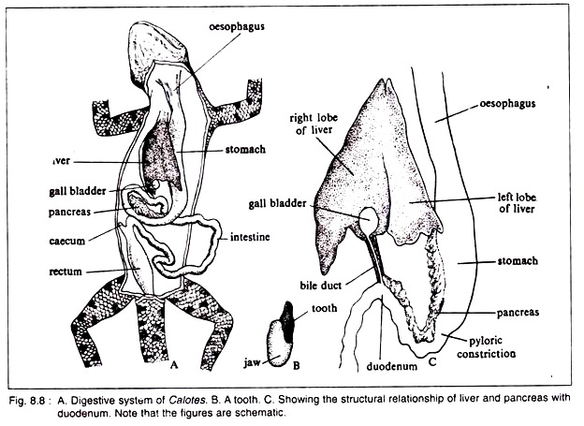  The colon is absent. The cloaca opens to the exterior by the anus (or vent). The whole of the alimentary canal is kept in position by folds of peritoneum. The stomach is attached with the body wall by the mesogaster, the ileum by the mesentery and the rectum by the mesorectum.  Digestive glands:  Small unicellular salivary and mucous glands are present in the buccal cavity. These glands are few in number. The most important of the digestive glands is the liver which is massive and situated dorsal to the stomach. The liver is divided into left and right lobes. Both the lobes are united anteriorly (Fig. 8.8C). The upper margin of the liver and the apex of the ventricle are connected by gubernaculum cordis.  The liver secretes bile. The bile remains stored in the gall-bladder. The gall-bladder is a small and roundish sac which is situated on the outer margin of the right lobe of liver. The gall-bladder acts as a reservoir of the bile. The inner wall of the stomach is beset with a large number of unicellular parietal glands and gastric glands which secrete hydrochloric acid and digestive enzymes respectively.  Another important digestive gland in the pancreas. It is a flat and elongated structure. The colour is white. It opens into the beginning of the duodenum. The secretion of pancreas is called pancreatic juice. The juice is alkaline in nature and contains digestive enzymes.  These enzymes are trypsin, amylopsin and lipase. The spleen is a small rounded glandular structure situated in the mesentery below the stomach. It is morphologically connected with the digestive tract, but has got no digestive role. The spleen stores the erythrocytes and also destroys them, when necessary.  The food of Calotes consists mainly of small living insects. Ingestion is done with the help of the tip of the tongue and the insect is taken inside alive. The sticky mucous secretion helps to catch the prey. True digestion occurs in the stomach where HCI and pepsin react on the food matter.  HCI makes the medium acidic and kills bacteria while pepsin reacts with the protein part of the food and breaks it into peptone and proteoses.  In the next phase, digestion occurs in the duodenum. In the duodenum, bile neutralizes the acidic half-digested chyme and emulsifies the fat part of the food. Now pancreatic juice comes into play. Being alkaline in nature it makes the medium strongly alkaline.  Digestive enzyme, trypsin (present in pancreatic juice) reacts with protein and proteoses and converts them into soluble amino acids. Amylopsin reacts with carbohydrate which transforms into glucose and lipase reacts on fat converting it to fatty acid and glycerol.  The mixture of food containing simpler and soluble products and undigested food materials passes into the intestine. The lining cells of the intestine take up the soluble products while undigested food particles are stored in the rectum from where these are voided periodically.  Type # 2. Respiratory System:  Calotes is a true lung breather. Structurally the respiratory organs do not show any great improvement over the amphibians but functionally the lungs have become more efficient.  Respiratory structures:  The respiratory structures include a pair of nostrils (or external nares) situated a little ahead of the eyes. The nostrils lead to nasal passages which open into the roof of the buccal cavity. The glottis opens into the larynx which is box-shaped and is made up of a pair of arytenoids and single cricoid (forming the base) cartilages.  The larynx opens into the trachea which is narrow, tubular and beset with complete cartilaginous tracheal rings. The trachea is bifurcated into two and forms a pair of narrow passages, called bronchi. Each bronchus enters into a lung.  The lungs are elongated sac-like structures. The right lung is slightly larger than the left one. Internally each lung is incompletely divided into small chambers by the development of many incomplete septa (Fig. 8.9).  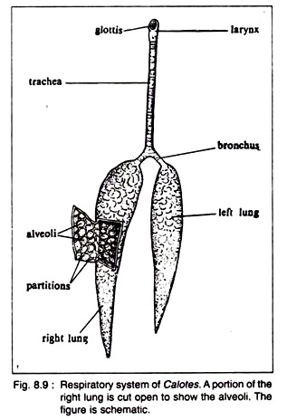  These chambers are called alveoli. The alveoli are the actual areas where exchange of gases occurs. In the distal part of the lung, such chambers are almost absent. This non- partitioned posterior part of the lung is considered as reservoir for the residual air. It constitutes about one-third part of the whole lung. The wall of the lung is made of squamous epithelium.  Mechanism of respiration:  The chemical mechanism of respiration is basically similar in all vertebrates, but the physical mechanism varies in many forms. The physical mechanism is divided into two steps. The steps are: inspiration and expiration.  Inspiration is caused by the movement of the intercostal muscles which raise the ribs and by increasing the volume of thorax reduce lung pressure and cause an inflow of air inside the lungs. Expiration is caused by lowering the ribs through the contraction of intercostal muscles and decreasing thoracic volume. By expiration carbon-dioxide and moisture are removed.  Type # 3. Circulatory System:  Transportation of various substances within an organism is conducted by the circulatory system. The circulatory system consists of cardiovascular system and lymphatic system.  The cardiovascular system includes:  (a) The heart which is an efficient machine to propel,  (b) The fluid vehicle, the blood into the pipelines of (c) arteries and (d) veins.  Structure of Heart:  The heart of Calotes lies in the pleuroperitoneal cavity and occupies a position which is midway between the fore-limbs though the ventricle extends slightly beyond the level of the axillae. Thus the position of the heart is rather forward and such a disposition indicates a lower grade of organisation because such condition is observed in Sphenodon.  The heart is covered by a thin and transparent pericardial membrane. The space between the heart and pericardium is filled with pericardial fluid. The heart is triangular in shape. The auricular region is wider than the ventricular region (Fig. 8.10A).  Sinus venosus:  The heart is made up of five chambers. The sinus venosus is reduced and is disposed transversely and dorsal to the lower half of the auricles. It is thin-walled and is formed by the confluence of the venae cavae. The right half of the sinus venosus is larger than its left counterpart and is formed by the confluence of right anterior vena cava (precaval vein) and posterior vena cava (postcaval vein).  The left portion of the sinus venosus is composed mainly by the left anterior vena cava. A constriction marks off the right and left parts of sinus venosus (Fig. 8.10 B). The sinus venosus opens into the right auricle near the region of the constriction by a semicircular sinuauricular aperture.  The aperture is provided with sinuauricular valves. The valves develop from the upper and lower margins of the aperture and the free end of the valves which is slightly frilled projects into the lumen of the right auricle.  Auricle:  The right auricle is larger than the left auricle and appears darker than the left auricle. The wall of the right auricle is thick and its inner lining is thrown into a number of musculi pectinati which are projected within the lumen.  The left auricle is smaller than the right auricle and it receives a common pulmonary vein. The pulmonary aperture is circular in outline and is located on its dorsal wall close to the inter-auricular septum. The aperture is not provided with valves.  Internally the left and right auricles are separated by a thin, muscular and non-perforated inter-auricular septum. The septum extends posteriorly for a short distance within the ventricle and bears at its posterior tip the auriculoventricular valves.  Ventricle:  The ventricle is muscular, spongy and triangular in appearance. Its apex is directed caudad and bears a thin and white cord of tissue, called gubernaculum cordis. It penetrates the pericardium and reaches the upper margin of liver. The thick-walled ventricle (Fig. 8.10 C) is provided internally with an inter-ventricular septum which divides it incompletely into left and right halves.  This partition has become complete in crocodiles except for an aperture, called foramen of Panizza. The foramen of Panizza is a communicating aperture between the left and right systemic arches just at the point of crossing after their emergence from the ventricle.  The inner cavity of the ventricle has been arbitrarily divided into three regions, namely, cavum pulmonale situated in the right side, cavum arteriosum (or the left hand portion) by a muscular ridge. The ridge arises from the right ventral wall of the ventricle and runs dorsal obliquely. Higher up, it becomes horizontally inclined.  It then runs obliquely again and takes a vertical course. It cuts off the aforesaid cavities. The left and right auriculoventricular apertures lie very close together being separated by the prolongation of the inter-auricular septum. The free lateral edge of the septum bears the auriculoventricular valves.  In the middle of the ventricle and close to the line of demarcation between the auricles and ventricle, there are three apertures from which the aortic arches arise. The inner wall of the ventricle is provided with thick interlacing muscles, called columnae carnae. There are bunches of thread-like muscle fibres, called chordae tendineae, by which the valves remain attached to the columnae carnae.  Valve:  The different compartments of the heart are intercommunicated by apertures having swing door-like flaps, called the valves. These valves control the passage of blood and direct the flow in one direction.  The valves present in the heart of Calotes are:  (a) A pair of leaf-like valves in the sinuauricular aperture.  (b) Sphincter muscle acting as valve in the opening of pulmonary vein into the left auricle,  (c) A pair of leaf-like valves formed by the bifurcation of the inter-auricular septum in the auriculoventricular aperture,  (d) Three semilunar valves in each orifice from which the arterial arches arise.  The walls of the heart are provided with three histological layers common to all blood vessels,, i.e., tunica intima, tunica media and tunica adventitia from inner to the outside. Of these three layers, the tunica media is peculiar in having specialised cardiac muscles showing striations and branching’s. The heart is supplied with the cardiac branch of 10th cranial nerve.  Mechanism of circulation through heart:  In Calotes, the circulatory circuit is double. There are pulmonary or lesser circulation and systemic or greater circulation. Pulmonary circulation is conducted by the pulmonary arteries which carry deoxygenated blood to the lungs. In the lungs, the blood becomes oxygenated and returns to the left auricle by the pulmonary vein.  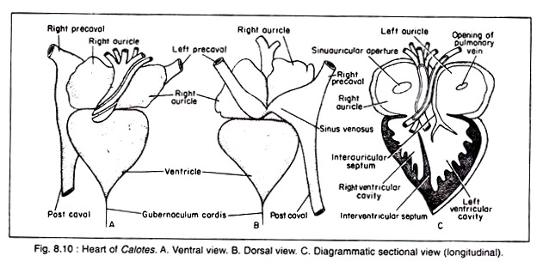  The left auricle pours its content into the ventricle through the auriculoventricular aperture. In the greater circulation, deoxygenated blood returns to the sinus venosus by two precaval and one postcaval veins. The sinus venosus opens into the right auricle. The right auricle empties its content into the ventricle.  The ventricle sends blood for circulation into the different parts of the body through the systemic and pulmonary arches. The entry and exit of blood in the ventricle are so beautifully arranged that a major quantity of oxygenated blood is always forwarded to the brain region.  As the ventricle is incompletely divided, admixture of oxygenated and deoxygenated blood occurs thrice in Calotes once in the cavum venosum, once in the dorsal aorta and another in the left ductus caroticus.  Thus, though the ventricle in Calotes is morphologically incompletely divided, there is a tendency for the physiological separation of the two types of blood, at least in two auricles completely and in the ventricle partially. From this point, the heart of Calotes is biologically more advanced than that of Bufo.  Blood:  Blood of Calotes is red in colour and is made up of plasma and blood cells. The red blood corpuscles are biconvex, elliptical in outline and each bears an elliptical nucleus. The white blood corpuscles are irregular in outline, non-pigmented and each bears a spherical nucleus.  Arterial System:  Of the six pairs of arterial arches joining the dorsal aorta to the ventral aorta during embryonic development of arteries, the third, fourth and sixth pairs persist in adult Calotes and other reptiles.  As the ventricle in Calotes and other reptiles tends to divide into left and right ventricles by the development of incomplete inter-ventricular septum, the base of the ventral aorta splits into three parts, two of which remain in the right part of the ventricle and the third goes to the left part of the ventricle. Thus from the ventricle of Calotes arise three aortic arches.  These arches are:  (a) One pulmonary aorta and  (b) Two systemic aortae, right and left (Fig. 8.11).  These three aortae are wound around themselves at the source and undergo about one and a half turns round each other. The aortae are covered at the base by a fibrous sheath and thus appear tubular.  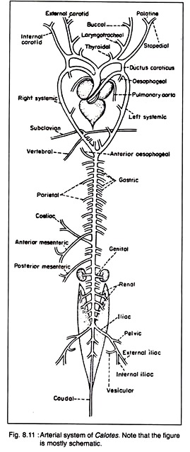  Pulmonary aorta:  It arises independently from the right portion of the ventricle and soon splits into two branches, each entering into a lung. It carries deoxygenated blood.  Left systemic aorta:  This aorta originates independently from the right (left to pulmonary aorta) portion of the ventricle and moves forward for some distance. Then it curves round the heart and goes downwards to meet the right systemic aorta a little posterior to the apex of ventricle. It carries mostly the deoxygenated blood. From the left systems arch four oesophageal arteries arise.  The first of these arteries arises from near the point of insertion of the left ductus caroticus while the origin of the fourth one is very close to the point of union of the two systemic. Parietal arteries do not originate from the left systemic arch.  Right systemic aorta:  This important aorta emerges independently from the right ventral margin of the base of the ventricle and moves forward. It then curves to the right side of the heart. It meets the left systemic aorta posteriorly to form the dorsal aorta. It carries oxygenated blood.  From the apex of the curvature of the right systemic aorta arises a single and common carotid artery which advances anteriorly and then splits into four arteries. The inner pair of these four branches or the external carotid arteries while the outer pair form the internal carotid arteries.  On both sides prior to its division into left internal and external carotids and right internal and external carotids one thyroid artery is given off from the common carotid.  The main branches from the right and left external carotids are the laryngotracheal artery (one from each) and three buccal arteries (from each). The internal carotids both left and right bifurcate at their tips into inner palatine artery and outer stapedial artery.  The external carotids and their branches supply blood to face and mouth, while the internal carotids and their branches supply blood to the brain. Thus it is to be noted that carotid arteries do not arise independently from the ventricle as they do in amphibians but instead arise from the right systemic aorta.  And as the right systemic arch carries oxygenated blood to anterior organs, specially the brain, this arch is supplied with oxygenated blood. The two internal carotids are connected to the systemic aorta of the corresponding sides by ductus caroticus. The ductus caroticus represents the remnant of embryonic radices between the third and fourth aortic arches.  From the right systemic aorta three oesophageal arteries are given out. The right systemic aorta before its meeting with the left systemic aorta gives rise to a subclavian artery which bifurcates into two and supplies blood to the forelimbs.  From the right systemic aorta a vertebral artery also originates to send blood to the vertebral column. The point of origin of the vertebral artery is situated very close to the subclavian branch. Just before meeting its left counterpart, the right systemic arch gives a pair of parietal arteries.  The right and left systemic aortae unit a little behind the heart and give rise to the dorsal aorta which runs posteriorly and gives branches to visceral organs and posterior parts of the body. The following arteries originate from the dorsal aorta chronologically along the anteroposterior axis.  These are:  (a) Anterior oesophageal artery. It is single and originates from the ventral surface of the dorsal aorta,  (b) First pair of parietal arteries from dorsal aorta which plunge into the parities of third thoracic vertebra.  (c) First and second pairs of gastric arteries which supply the cardiac stomach,  (d) Second pair of parietal arteries,  (e) Third, fourth and fifth pairs of gastric arteries followed by third pair of parietal arteries,  (f) Sixth and seventh pairs of gastric arteries followed by fourth pair of parietal arteries,  (g) Eighth pair of gastric arteries followed by fifth and sixth pair of parietal arteries. It is to be noted that the number of gastric arteries varies from 4-8 pairs.  (h) Anterior mesenteric artery which runs obliquely caudad to supply the intestine,  (i) Coeliac artery which runs obliquely cranial to supply the pyloric stomach. A splenic artery is given off by it to supply the spleen,  (j) Seventh and eighth pairs of parietal arteries.  (k) Posterior mesenteric artery or Hepato- intestinal artery. It arises from the right border of the dorsal aorta. It runs obliquely caudad and on reaching the intestine bifurcates into two—anterior and posterior. The anterior or hepatic supplies the gall-bladder while posterior or intestinal supplies the intestine.  (I) Ninth pair of parietal arteries,  (m) The right and left genital arteries. The point of origin of the right one is a bit up than its counterpart on the left,  (n) Tenth and eleventh pairs of parietal arteries,  (o) Left and right renal arteries. There may be more than one pair,  (p) Twelfth and thirteenth pairs of parietal arteries,  (q) One pair of iliac arteries. Each branch after its origin runs obliquely to the corresponding hind limb. From each a pelvic branch is given off to supply the pelvic girdle. Finally, each branch bifurcates into external and internal iliac. From near the point of bifurcation a slender vesicular artery is given off by each branch,  (r) The dorsal aorta now enters into the tail as caudal artery.  Type # 4. Venous System:  The deoxygenated blood from the different parts of the body is brought back to heart by means of veins except the pulmonary veins which carry oxygenated blood. The veins run parallel to the arteries, appear dark and in position are superficial to arteries.  The central meeting arena of all veins in the body is the sinus venosus. Sinus venosus is a triangular structure and its two base angles receive left and right Percival’s while the apex receives a single median postcaval (Fig. 8.12).  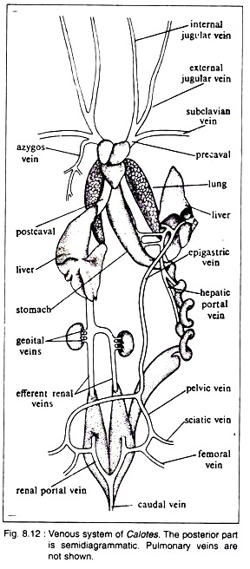  Each precaval vein has been formed by the union of three veins.  These are:  (a) The external jugular which brings back blood from the floor of mouth and tongue,  (b) The internal jugular which drains blood from the brain and  (c) The subclavian which draws blood from the forelimb.  The right precaval gets an azygos vein. The postcaval is constituted by the large median vein which is formed by the union of right and left efferent renal veins emerging from the two kidneys. Genital veins join the left and right efferent renal veins before their union. A pair of stout but short hepatic veins joins the median postcaval before its entry into the sinus venosus.  A median caudal vein carries blood from the tail region. The caudal vein ultimately bifurcates into two veins which enter into the kidneys. Each vein gives rise to the renal portal vein to the kidney and pelvic vein which receives femoral and sciatic veins from the hind limb.  The pelvic veins unite to form a median epigastric (or anterior abdominal) vein which ultimately opens into the left liver. The anterior abdominal vein and the postcaval are free of each other except through the renal portals in the kidneys. The blood from the visceral organs, i.e., stomach, intestine, pancreas, etc., enters into the left lobe of the liver by a hepatic portal vein.  In Calotes both renal portal and hepatic portal systems are present. These systems have got many advantages and fulfil the demand for a second set of capillaries through which blood must flow. The organisms having such a portal system are always provided with double supplies of blood, arterial and venous.  The pulmonary venous circuit comprises of pulmonary veins. From each lung two pulmonary veins carry blood to the heart. Of these veins, one comes out from the anterior part while the other comes from the posterior part of lung (Fig. 8.13). Near the left auricle all these four branches unite and open into the left auricle. The pulmonary veins bring oxygenated blood to the heart from the lungs.  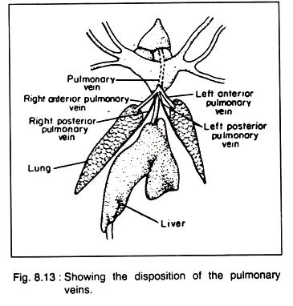  The lymphatic system is highly developed. The main lymphatic trunk becomes divided and enters into the precaval veins. Lymph hearts are present.  Type # 5. Nervous System:  The nervous system of Calotes consists of:  (a) Central nervous system,  (b) Peripheral nervous system consisting of cranial and spinal nerves which originate from brain and spinal cord respectively and  (c) Autonomic nervous system (or sympathetic nervous system).  Central nervous system:  The brain and the spinal cord constitute the Central Nervous System.  Brain:  The brain is encased in the cranium. The nervous tissues of the brain are protected by two meninges, called piamater and duramater. The piamater remains in close contact with brain and it is highly vascular. The duramater lies just outside the piamater and is mainly fibrous in nature. The two coverings remain separated from each other and the space between them is called subdural space.  Brain of an adult Calotes is differentiated into (a) Forebrain, (b) Midbrain and (c) Hind- brain (Fig. 8.14A).  Forebrain:  The forebrain consists of telencephalon anteriorly and diencephalon posteriorly. From the side wall of telencephalon emerges a pair of sac-like projections, called olfactory lobes. The posterior part of the telencephalon is elongated and is called cerebral hemisphere or cerebrum. The diencephalon bears on the dorsal surface two projections, called parietal organ and pineal body.  The parietal organ is situated anterior to the pineal body (Fig. 8.14 D, E). Another projection called paraphysis, is present in a reduced condition. From the ventral side of the diencephalon hangs a funnel-like structure, called infundibulum, on the apex of which is situated the pituitary body or hypophysis (Fig. 8.14C, D).  Midbrain:  The midbrain consists of a pair of oval optic lobes or corpora bigemina which arise as projections of the dorsolateral walls. Ventral to the optic lobes, there are a pair of longitudinal bands or peduncles, called crura cerebri, which connect the hindbrain to the midbrain.  Hindbrain:  The hindbrain consists of a narrow and non-convoluted metencephalon or cerebellum and a long myelencephalon or medulla oblongata which continues posteriorly with the spinal cord.  Thickenings inside the different brain regions:  The roof of the cerebral hemispheres is thin but the ventrolateral walls are thick. The thick region is called corpus striatum. The roof of the cerebral hemispheres is called neopallium, because the grey matters are situated on the outer margin. The roof of diencephalon is thin, highly vascular and is called roof-plates (see Fig. 8.14D).  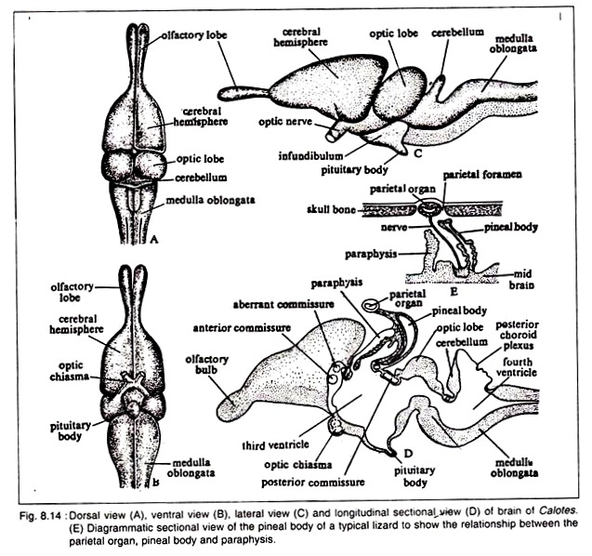  The lateral walls are called thalami and the floor is called hypothalamus. Parietal and pineal bodies arise from the roof-plate. The thalamus is thick. From the hypothalamus the infundibulum arises. The roof of the mesencephalon becomes thick to give rise to the optic lobes.  Its floor is also thick and gives rise to the crura cerebri. The roof of the metencephalon is thin and non-nervous but the floor is thick. The myelencephalon is similar to metencephalon in regard to its floor and roof.  Ventricles:  Internally the brain bears cavities which are continuous to one another and to the spinal cord. The cavity is filled with cerebrospinal fluid. The cavities in the cerebral hemispheres are called lateral ventricles or first and second ventricles. The diencephalon contains the third ventricle while the fourth ventricle is situated in the medulla oblongata.  The two lateral ventricles are communicated to the third ventricle or diacoel by a small opening, called foramen of Monro. The third and fourth ventricles or mesocoels are communicated with each other by a narrow passage, called iter or aqueduct of Sylvius.  Commissures in Brain:  Two sides of the brain are connected at places by transverse bands of nerves, called commissures.  The commissures are:  (i) Anterior commissure:  A wide transverse tract of nerve fibres connecting the two corpora striata.  (ii) Habenular commissure:  Anterior to epiphysis and situated between epithalamic ganglia.  (iii) Aberrant commissure:  Runs through the lamina terminalis and joins olfactory lobes. The presence of aberrant commissure in the brain of Calotes is regarded as the most important diagnostic reptilian feature.  (iv) Hippocampal commissure:  Hippocampus is the swollen part of the mid-posterior region of the cerebrum. The two hippocampi are connected by the hippocampal commissure.  (v) Posterior commissure:  It connects the posterior part of the two optic thalami and is situated just at the junction of diencephalon and mesencephalon.  Spinal cord:  It is the posterior prolongation of the brain through the neural canal. Its walls are thick and the roof and the floor bear dorsal and ventral furrows. Externally the spinal cord – is made up of white matter consisting of medullated nerve fibres and internally there.is grey matter containing ganglionic cells and non-medullated fibres.  Peripheral Nervous System:  The peripheral nervous system consists of nerve fibres which are either sensory or motor or mixed. The cranial and spinal nerves constitute this system.  Cranial nerves:  There are 12 pairs of cranial nerves in Calotes (besides the terminal nerve). The origin, distribution and biological nature of the first to tenth pairs of cranial nerves is exactly similar to that of Bufo. Fig. 8.16 will give an idea of the origin and the ramifications of the fifth and seventh cranial nerves in Calotes.  Fig. 8.17 shows the origin and distribution of the ninth and tenth cranial nerves of Calotes. The eleventh and twelfth pairs of cranial nerves are the (a) spinal accessory and (b) hypoglossal respectively.  The spinal accessory (XI) originates from the posterior part of medulla oblongata as efferent fibres and joins with the vagus. Along its course, this nerve receives series of rootlets from the spinal cord. The spinal accessory nerve supplies mostly the striated muscles of the pharynx, larynx and also the autonomic nervous system.  It is a sensory nerve. The hypoglossal nerve (XII) is also a sensory nerve which originates from the medulla oblongata and innervates from the medulla oblongata and innervates the muscles of the tongue and controls its movements during feeding.  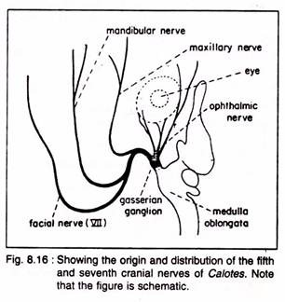  Spinal nerves:  There are several pairs of spinal nerves that originate from the spinal cord and emerge out from it between the vertebrae. The spinal nerves are mixed type of nerves. They originate separately and independently but ultimately combine to form a single cord. They originate by a dorsal root which is sensory and a ventral root which is motor in nature.  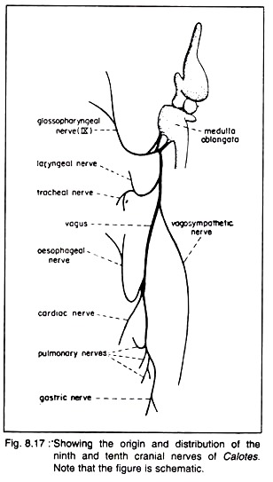  Each spinal nerve divides into four branches or rami.  These branches are:  (a) Dorsal branch, thin, short and supplies sense organs, glands and muscles,  (b) Ventral branch, long, thick and supplies hypo-axial organs,  (c) Meningeal branch, small and goes back to supply the neural canal and  (d) Ramus communicants which communicates with autonomic nervous system. Several spinal branches often meet together and form plexus.  Autonomic nervous system:  This system consists of a chain of complicated ganglia with receptor and effector nerves formed mostly by the offshoots from the ventral branches of the spinal nerves.  The branches from these ganglia innervate muscles of heart, lungs, digestive system and glands which work continuously and are not controlled by will. Autonomic nervous system comprises of two divisions of nerves which are structurally similar but functionally antagonistic.  These are:  (a) Sympathetic nerves having activating role and  (b) Parasympathetic nerves which have inhibitory action.  Type # 6. Excretory System:  The excretory system of Calotes consists of a pair of metanephric kidneys situated in the abdominal cavity. These are retroperitoneal in position and lie one on either side of the vertebral column. Each kidney is dark-red in colour and is lobed. The kidneys are free at the anterior end but are united along the inner margins at the posterior part. The posterior ends of the kidneys run over the cloacal chamber.  Histologically each kidney is made up of a central portion, the medulla and a peripheral portion, the cortex. The cortex contains numerous renal or Malpigian corpuscles. Each corpuscle consists of Bowman’s capsule which is a double-walled cup of epithelial cells.  The space between the two layers of the capsule is the beginning of the renal tubule. In the concavity of the Bowman’s capsule lies the glomerulus which is a spherical tuft of arterial capillaries.  The renal tubules open into the collecting tubule which communicates with the ureter. The kidney has a double set of capillary system. One set is formed by the afferent and efferent renal arteries while the other set is formed by renal and renal portal veins.  There are a pair of ureters arising one from each kidney. The ureters are short and open into the cloaca separately. From the lateral wall of the cloaca arises a single urinary bladder which is allantoic in origin. The urine of Calotes is semisolid in consistency and contains uric acid.  Type # 7. Reproductive System:  Sexes in Calotes are separate and it is difficult to distinguish between the male and the female from external morphological features.  Male reproductive system:  This system includes a pair of testes situated in the abdominal cavity which remain suspended by a special dorsal fold of the mesentery, called mesorchium. The testes are white oval bodies. The testis of the right side is larger in size compared to that of the left side and situated slightly higher up in the abdominal cavity.  The testes undergo a drastic change in size. In the breeding time they become larger than they are at the non-breeding period. From the inner surface of each testis runs the epididymis which receives the vasa efferentia. The epididymis proceeds posteriorly as vas deferens (Fig. 8.19A).  Two vasa deferentia open separately by small papillae into the cloaca but before opening into the cloaca each receives the ureter of the corresponding side. So through this common duct both urine and male gametes pass into the cloaca which is designated as the urinogenital duct.  The posterolateral side of the cloaca is provided with a pair of copulatory sacs each of which houses a hemipenis. The hemipenis is reversible. The hemipenes (plural of hemipenis) are actually the bilateral sacculations of the cloaca which extend posteriorly below the skin.  When everted, the hemipenes protrude through the cloacal aperture. The distal end of each hemipenis is large and rounded. The hemipenes are grooved to conduct sperms from the cloacal cavity of the male into that of a female.  Female reproductive system:  This system includes a pair of ovaries which have similar position as that of testes (Fig. 8.19B). Each ovary is fixed to the dorsal side by a special fold of mesentery, called mesovarium. The female gonoduct is called oviduct. The oviduct is attached with the body wall by a special fold of peritoneum, called broad ligament.  The anterior end of the oviduct is wide, funnel-shaped, ciliated and is situated near the corresponding ovary below the level of lungs. The oviducts are not coiled but are folded which run posteriorly to open independently into the cloaca.  The diameter of the oviduct shows gradual increase towards the posterior side in cross-section. The lower part of the oviduct is designated as the uterus where the eggs are stored temporarily prior to laying. In the anterior part of the oviduct there are many albumen glands and the posterior part is provided with shell glands.  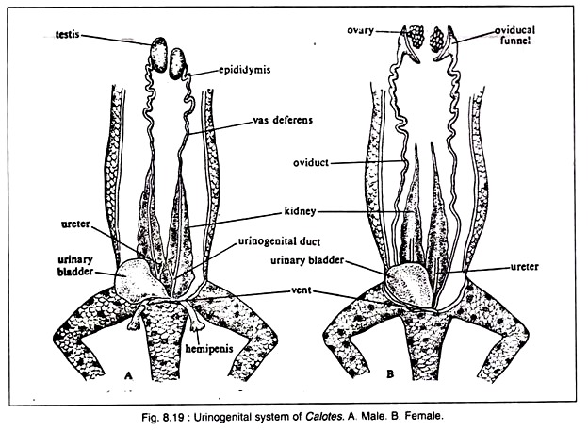  In Calotes, the fertilization is internal. Mature eggs are fertilized in the anterior part of the oviduct. The eggs are heavily yolked and are covered by calcareous shell.
UNIT V | Pigeon external feature, digestive system, respiratory system | External Features of Pigeon (With Diagram) | Chordata | Zoology  Article Shared by <="">  ADVERTISEMENTS:  In this article we will discuss about the external features of pigeon with the help of suitable diagrams.  Shape and Size:  The spindle-shaped or fusiform body of Blue Rock Pigeon is about 33 cm in length and is well adapted for rapid movement through the air.  Coloration:  Except the eyes and the feet which are pink, rest of the body of pigeon is a salty gray with glistening metallic green and purple sheen on the upper breast and around the neck. The wing has two black bars.  Body Divisions:  ADVERTISEMENTS:  The bilaterally symmetrical and compactly set body of pigeon is divisible into four regions- head, neck, trunk and tail. All of these body divisions are invested in a close covering of feathers which are directed backward and overlapping one another.  1. Head:  The head is small, rounded and mobile.  (i) Beak:  ADVERTISEMENTS:  Head is prolonged in front into a short, pointed, bill or beak, which is formed by an elongated upper jaw and comparatively smaller lower jaw. Both jaws lack teeth and remain ensheathed by a horny sheath or rhamphotheca. The terminal mouth is thus guarded by horny beaks and forms a wide gape.  (ii) Nostrils:  At the base of upper beak occurs a patch of naked, whitish, swollen area of soft skin, called operculum or cere. The cere overhangs on two oblique, slit-like external nares or nostrils which can be closed by the cere.  (iii) Eyes:  ADVERTISEMENTS:  On either lateral side of the head is located a large eye. The eyes are round and are guarded by upper and lower eyelids and a transparent third eyelid or nictitating membrane. The nictitating membrane can be drawn across the eyeball from the anterior upper comer of the eye. The eyelids lack eyelashes and eyebrows,  (iv) Ear apertures:  Below and behind each eye is an external ear opening which leads to a short tube, the external auditory meatus, closed by the tympanic membrane. These apertures are hidden under special auricular feathers.  2. Neck:  The neck is long, flexible and well demarcated from head and trunk. It helps in handling of food and compensates the forelimbs which have modified into wings.  3. Trunk:  The trunk is compact and spindle-shaped, bearing a prominent bony ridge, the keel or carina, at its mid-ventral line. There occurs a large, transversely elongated cloacal aperture on the ventral surface at the function of the uropygium (tail) with the trunk. The trunk bears two pairs of pentadactyl type limbs- one pair of wings and one pair of legs.  (i) Wings:  ADVERTISEMENTS:  In pigeons, two forelimbs are modified into two powerful organs of flight, the wings. Each wing remains attached high on the antero-dorsal side of the trunk. Each wing is elongated, flattened and distally pointed with its longitudinal axis at right angles to that of the trunk. It can be folded close to the body in the form of Z during rest and extended during flight.  The wings show the three typical divisions of the forelimb- upper-arm or brachium, forearm or ante-brachium and the hand or manus, all closely bound together by skin. The manus or hand bears three, imperfectly-marked and clawless digits, of which the second is the largest.  On the anterior or pre-axial border of the limb a fold of skin stretches between the upper-arm and the forearm called the alar membrane or pre-patagium. A similar but much smaller fold extends, post-axially, between the proximal portion of the upper-arm and the trunk, called the post-patagium.  (ii) Legs:  The hindlimbs or legs arise somewhat anteriorly from the trunk to balance and support the entire weight of the body at rest. Each hindleg comprises three parts: the thigh, shank and foot. The thigh is short, closely bound to the trunk, and directed downwards and forwards. The shank is long and extends from the knee downwards and backwards.  The foot is clearly divisible into a proximal portion, the traso-metatarsus, and four digits. The digits are long and clawed. The first digit is called hallux and is directed backwards. The remaining three digits, the 2nd, 3rd and 4th, extend forward. The legs are efficient organs of perching and locomotion with long toes and curved claws.  4. Tail:  After removal of the feathers it can be seen that the true tail is short, conical projection of the trunk, known as uropygium. It bears a group of elongated tail-feathers or rectrices. On the dorsal surface of uropygium is a papilla bearing on its summit the opening of a preen, coccygeal, or oil-gland.  It is the only integumentary or cutaneous gland found in birds. Its oily secretion is used for lubricating or dressing the feathers and beak (makes them water-proof and shining). It produces a specific recognition scent and it elaborates ergosterol, which, when exposed on the feathers, is transformed by sunlight to vitamin D.  It is assumed that the vitamin would be ingested during preening. It is also probably used for keeping the horny beaks from becoming brittle. The tail with its feathers is used as a rudder during flight and a balancer in perching.  Skin:  The skin of pigeon is dry, loose, hard and thin. Histologically, it consists of an outer epidermis of ectodermal origin and an inner dermis of mesodermal origin.  (i) Epidermis:  The epidermis is several layers thick and composed of an outer epitrichium, a middle stratum corneum and an inner stratum germinativum or stratum Malpighii. The epitrichium is composed of a single row of flattened delicate cells. The stratum corneum is horny and protective and made of flat cornified cells.  It is modified to form several exoskeletal structures, such as the corneoscutes or scales on the feet, rhamphotheca or horny covering on the beaks, claws and toes and feathers which covers the most of the body. The stratum germinativum is made up of large, cylindrical and continuously dividing cells. It gives origin to the cells of epitrichium and stratum corneum.  (ii) Dermis:  The stratum germinativum of epidermis is followed by dermis. The dermis consists of muscle fibres, nerve fibres, blood capillaries, and connective tissue.  The epidermis and dermis have no pigmented cells, however, pigments occur in scales and feathers only. The skin lacks in sweat and any other type of cutaneous gland, except the uropygial or preen gland present dorsally at the base of tail.  Exoskeleton:  The pigeon has well developed exoskeletal system which serves many functions such as protection of body from temperature fluctuations of environment, radiations and mechanical injuries of various sorts. Further it makes the body of pigeon well adapted for aerial mode of life.  The exoskeleton of birds is derived from epidermis and occurs in the form of horny claws, beaks, spurs, webs, scales, feathers. Spurs are lacking in pigeons. Spur is a bony outgrowth of tarsometatarsus in the male fowl and some other birds. It is covered by a horny, scale-like epidermal sheath and pointed in shape.  Male fowl uses it for fighting. In certain birds (plover,etc.), spurs may be found on carp metacarpus. Webs are modified fold of skin found on the feet of aquatic birds, such as ducks, geese and swans. It is found stretched between the toes. In cormorants, it includes all the four toes. Sometimes it leaves the hallux free.  (i) Scales:  In pigeon, the scales are confined to the shanks and feet and some at the base of the beak. The scales are cornified derivatives of the stratum germinativum of epidermis which form a protective covering of body parts and are shed and replaced by moulting. The scales of pigeons and other birds resemble with reptilian scales in every respect, which indicates the origin of birds from reptiles.  (ii) Feathers:  The entire body of pigeon is covered with a close and continuous covering of feathers, which constitutes the plumage. The feathers are found only in birds and are modified reptilian scales.  They are light, strong, elastic, water proof and show many colours due to melanin pigment of various shades as well as due to iridescence. Melanins range from black through brown to yellow, and laid down in the feathers by special cells in the papilla. Carotenoid pigments are also found, such as the yellow zooxanthin, the red astaxanthin.  Structure of a Typical Feather in Pigeon:  To understand the structure of a feather, a contour feather which occurs on general body, wing and tail, can be considered as typical. A typical contour feather consists of a central axis, main stem or scapus and an expanded distal portion, the vexillum or vane.  1. Scapus (Axis):  The scapus is divided into a basal portion, the calamus and an upper shaft or rachis.  (a) Calamus:  The calamus is hollow, tubular and semitransparent. The base of calamus remains inserted into a pit or follicle of the skin, from which non-striated muscle fibres pass to the feather and provide movement to each contour feather. The calamus opens below by a small opening called inferior umbilicus, which receives a small, conical, nutritive dermal papilla from the dermis.  The nutrients and pigments are passed through the dermal papilla into the feather from the dermis, during the development of feather. Another pore, called superior umbilicus, occurs on the ventral side of junction of calamus and rachis.  In flightless birds like cassowary, emu and extinct Dinornis, the after shaft is as long as the main feather, from which it arises. In some pigeons and many other birds, a small tuft of soft down feather, called after shaft or hyporachis, occurs near the superior umbilicus and covers it.  (b) Rachis:  The part of the scapus above the calamus is a rachis. It forms the longitudinal axis of the vane. It is solid, opaque, roughly quadrangular in transverse section and filled with a closely packed mass of pith cells. A longitudinal furrow, the umbilical groove, runs along the ventral or inner surface of the rachis throughout its length.  2. Vane:  The rachis bears a fan-like, webbed or expanded membranous part of the feather, the vexillum or vane. The vane is divided by rachis into two unequal lateral halves. Its proximal end is broader than the distal end. Each half of vane is composed of a series of numerous (about 600), parallel, closely spaced, delicate, lateral, thread-like structures called the barbs or rami. The barbs arise obliquely outwards from the two lateral sides of the rachis.  The size of barbs gradually decreases towards both the ends of the rachis. Each barb on either side bears a fringe of small, extremely delicate, oblique filamentous processes, the radii or barbules. The barbules are of two types- proximal barbules directed towards the base of feather and distal barbules directed towards the tip of feather.  The lower edge of distal barbules bears minute, hamuli, barbicels or booklets and the upper edge proximal barbules are deeply curled or rolled to form a groove and flange. Hooklets of distal barbules hook over the grooved edges of proximal barbules binding the barbs together.  With this limited sliding interlocking arrangement, all the barbs and barbules are loosely held together, so that the vane forms a flexible, firm, wide, flat and continuous surface for striking the air during flight. This interlocking mechanism can be broken down so that the barbs become separate, but can be joined again by “preening” the whole feather.  The feathers of ostriches and kiwis lack this interlocking mechanism of feathers of pigeon. The barbs and barbules of after shaft have no hooklets or barbicels.  Feathers are always shed or moulted at regular intervals, as a rule annually after the breeding season. Some species of birds have a second lesser moult later on. During moult the old feathers drop out and new ones are formed from the same papillae. There is an elaborate hormonal control of the moult, basically by the thyroid.  Kinds of Feathers:  In pigeon, the feathers are variously modified to serve different functions.  They may be of following kinds:  1. Quill or Flight Feathers:  The quill feathers have a strong rachis or shaft having barbules with an interlocking arrangement.  They are classified into following types:  (i) Remiges:  The quill feathers occurring on the wings and serving the purpose of flight are called pinions, wing quills or remiges (singular, remex). In remiges the posterior half of the vane is slightly broader than the outer or anterior half. Each wing of pigeon has 23 remiges which remain attached to its hinder border.  Out of 23 remiges, eleven remiges are attached to the hand and are called primaries or manuals. The seven of these are attached to the metacarpal region and are called metacarpals. The remaining 4 are attached to the phalanxes of second and third digits and are called digitals which are further distinguished into- one ad-digital connected with the single phalanx of 3rd digit, 2 mid-digitals attached with the proximal phalanx of 2nd digit, and 2 pre-digitals with the distal phalanx of 2nd digit. The remaining 12 remiges are attached with the ulna of forearm and are called secondaries or cubitals. At the anterior border of the first digit (pollex) are attached a tuft of feathers called ala spuria or bastard wing.  (ii) Rectrices:  The quill feathers occurring around the uropygium to form the tail of pigeon are called tail-quills or rectrices. In pigeon, twelve long rectrices are arranged in semicircle or fan-like manner on the tail or uropygium. In rectrices two halves of the vanes are almost equal in size. The rectrices act as a brake in alighting and as a rudder in vertical or lateral steering.  (iii) Coverts:  The quill feathers covering the bases of wing quills and tail quills are called coverts. The bases of the wing-quills are covered by several rows of upper and under wing- coverts, and the bases of the tail quills by upper and under tail-coverts. They are of smaller size than the quill feathers but both are structurally similar. They close the interstices between the calamuses (quills) of remiges and rectrices and, thus, presenting a continuous area to oppose the buoyancy of the air.  (iv) Contours:  The quill feathers forming the general covering of the body are called contours or pennae. They are smaller and woolly feathers having poorly developed barbules due to which barbs can be easily separated. These provide warmth and the smooth air flow, without turbulence.  2. Filoplumes (Hair Feathers or Pin Feathers):  The filoplumes are small, delicate, hair-like feathers which remain sparsely distributed over the body among the contour feathers. A filoplume consists of a short calamus and a long thread-like rachis with a few weak terminal barbs, and barbules without any hamuli.  3. Down Feather or Plumule:  The down feathers are small, soft and woolly and lack the rachis but have a short calamus. The calamus bears a fluffy tuft of barbs which are long, flexible and with short barbules having no hamuli. In a young one, the down feathers cover the body and are called nestling down feathers. They have a horny sheath covering the quill and basal portions of barbs.  In adult pigeon, the nestling down feathers are replaced by contour feathers. But, they persist as an undercoat beneath the contour feathers in many aquatic birds, such as ducks and swans, serving to increase the thickness of the insulating layer.  Other Kinds of Feathers in Birds:  4. Powder-Down Feathers:  These are specialised type of feathers, well-developed in tracts or powder-down patches in herons, parrots and cockatoos, birds of prey, pigeons and especially frog mouths (Podargus). These feathers produce some powdery fragments for cleaning the plumage. The powder is a derivative of the innermost walls of Malpighian layer of the feather papilla.  5. Rictal Bristles:  Some birds, such as fly catchers, goat-suckers and whippoorwills, have stiff hair-like feathers called rictal bristles at the base of bill (rictus) and eyes. Each rictal bristle has a short calamus, and a slender rachis with a few rudimentary barbs at its base. They do not occur in pigeons.  6. Other Types:  There are certain other kinds of feathers which do not occur in pigeons, but occur in different birds. For example, tactile feathers or vibrissae occur at the root of the beaks or round the eyes of nocturnal birds, such as owl. Other peculiar feathers, such as bristles at the gape of Night jars, eyelashes of Hornbills, wires of birds of paradise and ornamental plumes of many birds, are modified contour feathers.  Pterylosis:  The arrangement or distribution of feathers on the body is called pterylosis. In pigeons and majority of birds, except penguins, the feathers are not uniformly distributed over the whole body but are arranged in distinct patches or tracts called pterylae.  The pterylae are followed by featherless areas or apteria which are covered with filoplumes in pigeons and by down feathers in ducks and many other birds. In flightless birds apteria are usually found only in the young, the adult having a uniform covering of feathers.  The principal feather tracts or pterylae of pigeon are following:  (i) Head or cephalic. Covering the head.  (ii) Neck or cervical. On the neck.  (iii) Shoulder or humeral. Across the upper arm or humerus,  (iv) Spinal. Extending from neck to tail along the vertebral column,  (v) Ventral. It is a double tract with one branch running along each side of the breast.  (vi) Wing or alar. Composed of remiges with their coverts.  (vii) Tail or caudal. Composed of rectrices with their coverts.  (viii) Femoral or lumbar. Spreading obliquely on the outer side of the thigh,  (ix) Crural. Covering the shank of leg.  Development of Feathers:  Feathers, like scales, arise in the embryo from papillae of the skin formed of dermis with an epidermal covering. The down feathers and contour feathers have different types of development, therefore, should be discussed separately as under.  (a) Development of a Down Feather:  The mesodermal tissue of the dermis of delicate and semi-transparent skin of five-or six- day old embryo gather at a place to form a dermal papilla externally covered by epidermis. As the dermal papilla grows it takes the shape of a cone whose apex is directed backward.  The papilla then becomes sunk in a sac called the feather follicle, from which it protrudes as an elongated feather germ. Its vascular dermal interior having the dermal blood capillaries, nerves and connective tissues is called feather pulp. The feather pulp feeds the growing feather.  The Malpighian layer of distal part of feather germ proliferates in such a way as to form a series of vertical or longitudinal radiating thickenings or ridges, which later separate from one another converting into the rami or barbs.  The Malpighian layer of the epidermis at the base of the feather germ becomes horny or cornified to form calamus. The stratum corneum of the epidermis forms a horny, transparent and coherent cylindrical sheath, called periderm around the growing feather.  As the feather the feather germ is resorbed, the periderm almost parallel to one another and slightly calamus. On the barbs, the barbules develop the calamus to form pith. Thus, a rudiment papilla persists at the base of the feather, to down feather during ecdysis.  (b) Development of a Contour Feather:  In the development of contour feather, the feather papilla is formed from the lower or deep end of that of the down feather, so that the earlier down feather drops off from its apex. Its early development is the same as in down feather.  After the feather germ with its feather pulp, longitudinal ridges are not of the same size. Instead, two mid-dorsal Malpighian ridges thicken and fuse together to form a solid rachis which elongates and grows outwards more rapidly than the rest due to differential growth. As the rachis elongates, it carries up with it the remaining ridges which become the lateral barbs. New barbs appear below. A similar fusion of two ventral barbs with differential growth results in the formation of hyporachis or aftershaft.  Later barbules arise from both sides of the barb. The periderm splits and dries, the developing feather splits along the mid-ventral line and the barbs flatten out to form the vane. The portion of shaft which remains in the skin becomes calamus. The original basal aperture of feather germ becomes inferior umbilicus. The superior umbilicus develops later. The feather pulp inside the calamus dries to form the partition like pith.  Moulting or Ecdysis:  Shedding and replacement of feathers is moulting or ecdysis which takes place gradually, one moulting usually takes an average time of six weeks. At the base of each feather follicle, a dermal papilla persists from which new feathers will form. Thus, there is a continuous replacement of feathers throughout life. The replacement of feathers is seasonal in some birds such as peacock, while in other birds such as pigeon it is gradual throughout the year.  Pigmentation of Feathers:  The characteristic pigmentation or colouration of pigeon’s body is due to pigments in feathers and also due to characteristic arrangement of feathers. The feathers of pigeon and other birds show a varied and often brilliant colourations. The colours are produced partly by pigments and partly by reflection and diffraction effects (structural colouration).  The most common pigments are melanins, ranging from black through brown to yellow.  The colours are due to three factors:  (a) Pigment is deposited in the feathers during development by special cells in the papilla. The processes of these amoeboid chromatophores convey granules of pigment into the barbs and barbules, where they are laid down in layers between those of keratin. Carotenoid pigments are also found such as the yellow zooxanthin and red astaxanthin.  The colour that is seen, is due to absorption of some wavelengths of light by the pigment, thus, black, red, brown, yellow and orange colours are seen. White colour is not due to white pigment but is caused due to reflection of light from the feather without absorption of any wavelengths of light rays. In blue colours incident light is reflected from a layer of spongy keratin, pierced by holes 1-2 µm in diameter which absorbs the red and reflects blue light.  (b) Structural arrangement or striations of feather surface are prismatic; these cause iridescence due to reflection of light, thus, producing iridescent hues metallic colours, gray and some shades of blue. In iridescent feathers interference of light in thin surface films gives colours like those of soap bubbles.  (c) A combination of pigments and prismatic striations of the feather produces green in which the yellow pigment combines with the structural blue. The colouration of birds are for concealment, recognition, and sexual stimulation and, hence, as the basis of their social life.  The actual colour patterns vary with the habits of the bird. Concealing (cryptic) colouration is very common. Even the bright colours may serve this purpose, by breaking up the outline of the bird when at rest or in motion. Most birds are dark above and pale below. The feathers often show mottled or speckled patterns rather than homogeneous colour.  Finches and other birds living in sunlit upper branches show bright yellow, yellow-green, and blue colours, either singly or combined. Birds like thrush and blackbird living in thickets are usually dull brown or black. In most species colouration is a compromise between concealment and display, female is cryptic, the male conspicuous {e.g., ducks). Some colour pattern may be a warning of distasteful quality, e.g., magpie colour pattern of black and white.  Uses of Feathers:  The feathers are unique structures which are found only in birds.  They serve a varied array of functions which have been summarised below:  1. Protection:  Feathers form a lightweight, impervious, flexible, durable and waterproof body covering. They protect the underlying tender skin from all kinds of mechanical, chemical, pathological and environmental injuries.  2. Heat Retention:  The birds have a constant body temperature which commonly remains in between 104° and 112°F, even in subzero weather. Thus, the feathers serve the most important function of retention of heat because the plumage forms an efficient, non-conducting covering with its innumerable dead air spaces, useful as insulation. In cold weather the heat loss is reduced to minimum by fluffing out the feathers, which increases the depth of insulating material by adding to the air spaces within the feathery layers. In warm weather, the feathers are often held close to the body to allow some escape of body heat.  3. Flight Adaptation:  Feathers make the bird’s body well adapted for aerial mode of life. They are light, elastic, horny structures which make the body of birds of quite light weights. Further, the thin, flat and overlapping wing and tail feathers, with their close almost airtight linkage due to the interlocking arrangement of barbules, form surfaces to support the bird in flight.  4. Camouflaging (Protective Colouration):  The feathers of different birds have quite characteristic protective colouration like the colouration of their surroundings, which make them indistinguishable from their habitual surroundings and, thus, serve to protect them from their enemies.  5. Sexual Dimorphism:  Feathers provide protective colouration and also sexual display. Sexual dimorphism is common in monogamous as well as polygamous species. Colours and erectile plumes become sign stimuli which evoke or release specific reactions and whole pattern of behaviour in rivals and mates.  Ornaments like bars and spots on the wings and tail, fully exposed only during flight in many gregarious birds, and often widely different in closely allied species, are probably recognition marks which enable stragglers to distinguish between a flock of their own and other species.  For example, on many birds the crown feathers are modified into crests (peacock), topknots (tufted titmouse), ornamental plumes (California quail), etc. Some birds have special ruffs (ruffed grouse) or pinnae (prairie chicken) about the neck. Breeding plumes (cigrettes) in certain herons and egrets, upper tail, coverts in peacocks and elongated decoration in the streamers of some birds of paradise, serve the similar secondary sexual function.  6. Formation of Nest:  Some birds such as eider-duck and long-tailed-tit, use the feathers of other birds in the formation of warm and comfortable nests for their nestlings.  7. Other Uses:  The powdery secretions of powdery down feathers of many birds (e.g., herons, bitterns etc.) help in keeping the plumage clean and free from ectoparasites. The feathers also provide a characteristic individuality to each species of bird, thus, have significant role in speciation. The spine-tipped rectrices of chimney-swifts and woodpeckers help them in clinging to vertical surfaces. Markings on feathers are recognition marks to their fellow birds.  Feathers are used for stuffing cushions and mattresses. In some birds patches of special feathers without a rachis break up to make a greasy “powder down”.  The digestive system of pigeon is well developed and includes an alimentary canal and the digestive glands.  Alimentary Canal:  The alimentary canal of pigeon (Fig. 26.28) is long, tubular and coiled. It comprises mouth, buccal cavity, pharynx, oesophagus, stomach, small intestine and large intestine which opens to the exterior by cloacal aperture. All the segments of alimentary canal fall into following three categories- foregut or stomodeum, midgut or mesenteron and hindgut or proctodeum.  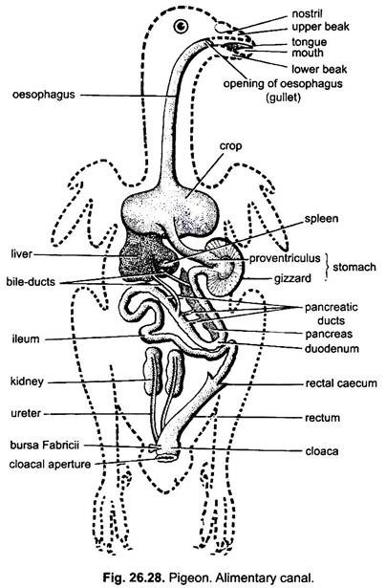  The portion of alimentary canal from mouth to stomach region is lined by ectodermally derived layer.  It includes following organs:  (i) Mouth:  ADVERTISEMENTS:  The anterior most opening of alimentary canal is called mouth. In pigeon, mouth is a wide slit-like aperture, bounded by the upper and the lower horny beaks having no teeth. The mouth is followed by buccal cavity.  (ii) Buccal Cavity:  The featureless buccal cavity has a large, narrow, triangular and pointed at the tip the tongue at its floor. The tongue has few taste buds and mucous glands, and has the function of manipulation of food. The buccal cavity is followed by pharynx.  (iii) Pharynx:  The posterior most part of buccal cavity may be called the pharynx. A pair of elongated apertures, the posterior nares, opens in the roof of the pharynx. They are covered by palatal folds of skull roof. Just behind the posterior nares opens a single median aperture of the pharyngotympanic or eustachian tubes. At the floor of the pharynx occurs an oval aperture with tumid lips which is called glottis. The glottis opens into the trachea. Posteriorly, the pharynx opens into the oesophagus.  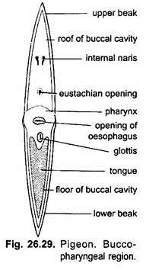  (iv) Oesophagus and Crop:  Oesophagus or gullet is a long, wide, distensible and thick-walled tube which runs backward through the neck to join a large dilated reservoir or crop. It is a large, thin-walled, bilobed, elastic and non-glandular sac. The crop enables the bird to store quickly swallowed food for later digestion. It is specially large in graminivorous (gram-eating) birds such as pigeons, finches, buntings, parrots, etc.  The grains are moistened and softened in it. The epithelial lining of the crop in both sexes thickens and sheds a white, slimy, proteinous and fatty “crop milk” during the breeding season on which the youngs are fed by both parents. Pigeon milk is produced by the degeneration of the epithelial cells lining the crop, under the control of prolactin hormone, secreted by the anterior lobe of the pituitary gland. This hormone stimulates and controls the formation of pigeon’s milk. Pigeon’s milk contains water (65-81%), protein (casein) (13.3-18.8%), fat (6.9-12.7 %) and lactose (1.5%).  It is more nourishing than the cow’s milk. Pigeon’s milk contains 35 per cent of fat in comparison to 3 to 5 per cent in cow’s milk. The young ones fed on it double their weight in two days. The pigeon’s milk is regurgitated to the youngs.  The crop also contains some mucus secreting glands. Beyond the crop, before opening into the stomach, the oesophagus become thick-walled and narrow tube.  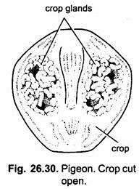  (v) Stomach:  ADVERTISEMENTS:  The stomach is differentiated into an anterior glandular proventriculus and a posterior muscular gizzard.  (a) Proventriculus:  The proventriculus is a small, thick- walled and glandular structure appearing externally as a slight dilation of the oesophagus but it is a gastric structure. Its thick mucus lining secretes the gastric juice. The spleen is a small, oval red body and remains attached to the right side of the proventriculus by peritoneum.  (b) Gizzard:  The gizzard represents the pyloric region. It is large hard, muscular and laterally compressed having the shape of biconvex lens. The thick walls of gizzard have thick muscles radiating from two tendons. Its narrow lumen is lined by an epithelium in which are present numerous minute tubular glands, which secret a fluid (koilin) which becomes thick, horny and of a yellow or green colour and lines the gizzard. Its yellow or green colour is due to regurgitated bile.  The cavity of gizzard always contains small tones or grit swallowed by the bird. These stones help the gizzard in grinding the food. The gizzard into small intestine and the opening of gizzard into small sphincter, called the pyloric valve or pylorus. In carnivorous birds the gizzard is not so muscular.  2. Midgut or Mesenteron:  The midgut, mesenteron or small intestine is a narrow tube and has a lining of endodermally derived epithelium. The small intestine is divided in an anterior duodenum and a posterior ileum. The bile and pancreatic ducts usually open into the distal limb of duodenum. In pigeon the left bile duct enters close to the pylorus.  (a) Duodenum:  The duodenum arises from the dorsal side of gizzard so that the pyloric opening of gizzard into duodenum lies close to the cardiac opening of proventriculus into gizzard. The duodenum forms a U-shaped loop enclosing the pancreas between its two limbs.  (b) Ileum:  The portion of the small intestine behind the duodenum is called ileum Ileum is a long and coiled tube of uniform diameter. Its inner epithelial lining is thrown into numerous minute, finger-like processes or villi, which greatly increase its area of secretion and absorption.  3. Hindgut or Proctodaeum:  The slender ileum continues into large intestine of similar diameter. The function of ileum and large intestine is externally marked by the presence of a pair of small conical, blind pouches, the rectal or colic caeca. The rectal caeca probably absorbs some water from digestive food. The large intestine or hindgut (proctodaeum) is a short tube and comprises an anterior rectum and a posterior cloaca.  (а) Rectum:  The rectum is narrow and is of same diameter as the ileum. It opens into cloaca. Its opening into cloaca is guarded by an anal sphincter.  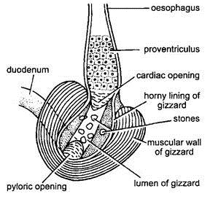  (b) Cloaca:  The cloaca is a large chamber and divided into three linear compartments: an anterior coprodaeum which receives the rectum, a short middle urodaeum into which urinary and genital ducts open, and a proctodaeum which opens to the outside by the cloacal aperture or vent.  The urinary products are made solid by absorption of water in the urodaeum and the walls of other chambers serve a similar purpose. A small, thick-walled, glandular, blind pouch of lymphatic tissue, the bursa Fabricii, lies on the dorsal side of the cloaca.  It is lined with endoderm, and opens into the proctodaeum. In a young bird it forms lymphocytes, and probably it produces antibodies and protects it against local infection, but it atrophies in the adult before sexual maturity. It is also called cloacal thymus because, like thymus, it produces lymphocytes. Like thymus, it is prominent in young animals and usually much reduced in the adult.  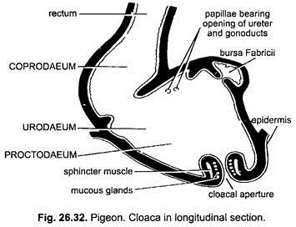  Digestive Glands:  In pigeon, following digestive glands occur:  (i) Buccal Glands:  Pigeon has no salivary gland in the buccal cavity, but has a median sub-lingual gland and a pair of angle glands near the corners. These glands are the only buccal glands which secrete mucus to moisten the food and probably the amylase enzyme. The tongue also bears few mucous glands.  (ii) Gastric Glands:  The epithelial lining of proventriculus contains many gastric glands which secrete certain gastric juices containing peptic enzymes.  (iii) Liver:  The liver of pigeon is large, compact, dark red, bilobed, containing a large right lobe and a small left lobe. From each lobe of the liver arises a bile duct, the left bile duct opens into the proximal limb near the pylorus and the right duct opens into the distal limb of duodenum. In pigeon, gall bladder is lacking, but it is present in Gallus and many other species. The liver secretes bile Juice.  (iv) Pancreas:  Between two limbs of the duodenum is a large, compact, reddish digestive gland, the pancreas. Pancreas gives off three separate pancreatic ducts which pour the pancreatic secretions containing many enzymes into the distal limb of duodenum.  (v) Intestinal Glands:  The epithelial linings of intestine have many glands which secrete many enzymes. The duodenum is lined with villi and single or branched crypts of Lieberkuhn. Goblet cells are also present.  Physiology of Digestion:  Food and Feeding:  The pigeon is graminivorous and it feeds chiefly on cereals, pulses, seeds, etc. These seeds are picked up with the beak, manipulated by tongue and lubricated inside the buccal cavity with the secretion of buccal glands. The food is swallowed as such, because beaks lack teeth.  Digestion:  The food which is lubricated and moistened by the secretions of buccal glands inside the buccal cavity passes through the oesophagus into the crop, where it is stored. Inside the crop, the food is softened by joint action of body warmth, water, mucus, amylase enzyme of buccal secretions and also due to bacterial autolytic action.  From crop the food passes into proventriculus where it is chemically acted by peptic enzyme of gastric juice. From proventriculus the food enters the gizzard where mechanical breakdown of food takes place by muscular contractions of gizzard wall and grinding action of small stones inside the lumen of gizzard.  In gizzard little digestion of food occurs and it is made acidic by secretion of its walls which have many hydrogen ions. The partly digested food, the chyme, passes through the pylorus into the duodenum. In the duodenum the chyme is mixed with bile, pancreatic juices and intestinal secretions.  The chemical conversion of fats, proteins and carbohydrates into glycerol and fatty acids, amino acids and monosaccharides, respectively, takes place in duodenum like other vertebrates. The bile salts help in the digestion and absorption of fats. Thus, in duodenum, all the three classes of foodstuffs (i.e., proteins, fats and carbohydrates) are converted into readily diffusible micromolecules (i.e., amino acids, glycerol and fatty acids and monosaccharides).  These micromolecules readily diffuse into the thin walls of ileum and mix into the blood. The bile salts help in the digestion and absorption of fat. Thus, digestion, absorption and assimilation of food occurs in the small intestine.  The undigested portion of food passes to the rectum, where absorption of remaining water takes place. The faecal matter which is almost dry due to absorption of water is finally ejected through the cloacal aperture.  The large surface area, high temperature and great activity of birds necessitate a high food intake, especially in the smaller types. This is due to rapid passage of food through the gut. The amount of food taken per day may reach nearly 30 per cent of the body weight (6g) in the very small gold crest and about 12 per cent in starling weighing 75g. The food is very efficiently utilised inspite of the rapid passage.  Pigeon - Respiratory System :-  The flight activity requires a continuous and abundant supply of oxy-gen . Hence, the respiratory system of pigeon is highly developed and well differentiated. The respiratory system consists of external nostrils, glottis, larynx, trachea, bronchus and lungs.  The external nostrils are a pair of slit like apertures occurring at the base of upper beak. They communicate to the pharynx by internal nostrils. A glottislies behind the tongue. It opens into the larynx. The larynx opens into a trachea. The trachea is a long, cylindrical and flexible tube running back- ward through the neck. On entering the thoracic cavity, the trachea expands into a syrinx or voice box. Later it divides into two bronchi, one for each lung. The walls of tracheal and bronchial tubes are supported by a series of closely set cartilagenous rings. Each bronchus enters a bright red lung. The bronchus divides and subdivides into smaller branches, ultimately ending in fine air capillaries. Lungs are solid spongy organs. They do not hang freely in the thoracic cavity but are lodged firmly in the ribs. Some of the branchial tubes pass through the lungs and communicate with the air cavities in the bone. There are nine air sacs. They are a median interclavicular, a pair of cervical, two pairs of thoracic and a pair of abdominal air sacs.  The air sacs help to maintain high body temperatures. They make the body lighter and help in flight.  Mechanism of Respiration :-  In birds the expiration is an active process. The process of inspiration is passive. In a resting bird, the sternum is moved up and down with the help of intercostal and the abdominal muscles.  During flight, the sternum is rendered immovable due to the support of wings, but the body cavity is raised and lowered by the action of wings and by the lowering of the vertebral column.  Pigeon  Sub phylum - Vertebrata  Class - Aves  Order - Columbiformes  Type - Columba livia  Birds are easily recongnised group of vertebrates. In birds every part of the body is modified to suit their aerial mode of life. Birds possess feathers, beak and feet modified in relation to their aerial life.  The Pigeons are flying birds(carinate). They are known both as wild and domesticated forms. The Pigeons are seen both in tropical and temperate zones. About 10 species of Pigeons are found in India. The pigeons fly in flocks and roost together. The domestic pigeons have many varieties, namely panter, fantail and tumblers. They differ in size, colouration and feather ar-rangement. All of them are, however, descendants of the rock pigeon-columba livia.
 | Circulatory system of pigeon | Circulatory System of Pigeon (With Diagram) | Zoology  Article Shared by <="">  ADVERTISEMENTS:  In this article we will discuss about the circulatory system of pigeon.  Two different fluids circulate through the body of pigeon. One fluid, the blood, along with heart and the blood vessels constitute the blood vascular system. Another fluid, the lymph, and the lymph channels are included under the lymphatic system.  ADVERTISEMENTS:  Blood-vascular system:  This system includes blood, heart and the blood vessels:  (i) Blood:  Blood consists of plasma and corpuscles. The red blood corpuscles are oval in shape and nucleated. The white blood corpuscles are present in much lesser number, but are of different types.  ADVERTISEMENTS:  The different types of white blood corpuscles are:  (i) Lymphocytes,  (ii) Heterophils,  (iii) Polymorphonuclear-pseudo-eosinophilic granulocytes,  ADVERTISEMENTS:  (iv) Basophils,  (v) Eosinophils and  (vi) Monocytes.  Blood platelets are absent in pigeon, but the blood clots quickly. New blood cells are formed in the bone marrow and the blood corpuscles are destroyed within the spleen. Spleen is a red coloured body oval in shape, situated on the right side of the proventriculus and attached with it by peritoneum.  (ii) Heart:  The heart is an oval organ placed in the anterior part of the thoracic cavity but ventral to the oesophagus. Heart is quite large in size in proportion to body size. It is enclosed by a thin white membranous pericardium and the pericardial cavity contains a serous fluid. The auricles and ventricles are distinctly separated by a groove called the coronary sulcus.  Sinus venosus is absent and is absorbed in the wall of the right auricle. Both auricle and ventricle are completely divided into right and left chambers (Fig. 1.116). Thus, heart is completely four- chambered and all the chambers are lined by endocardium.  The right auricle is slightly larger than the left auricle. The ventricles are very powerful. The left ventricle contains a round cavity while the right one has a crescentic cavity partly surrounding the left. The auricles and ventricles are divided internally by inter-auricular and inter-ventricular septa, respectively.  ADVERTISEMENTS:  The right auriculoventricular valve is flap-like and muscular in nature. The presence of a single right auriculoventricular valve is a diagnostic feature of pigeon. The left auriculoventricular valve is membranous and provided with two cusps (bicuspids) which are attached with the ridges of the ventricular wall.  Cord-like fibres (chordae tendineae) are attached to the margins of the auriculoventricular valves and to the walls of ventricles by papillary muscles. These muscles control the activity of the auriculoventricular valves via the chordae tendineae. The right auricle receives deoxygenated blood from three caval veins and the left auricle receives oxygenated blood through four pulmonary veins.  From the left ventricle the single right aortic arch originates and conveys oxygenated blood to the different parts of the body. The right ventricle gives rise to pulmonary arch which carries deoxygenated blood to the lungs. The left ventricle is usually called systemic ventricle and the right is called pulmonary ventricle.  The openings of the arches are guarded by three cup-like thick semilunar valves. The working of heart is controlled by elaborate intrinsic nervous system of heart. The wall of the right auricle bears sinuauricular node (or pacemaker) and the atrial septum bears auriculoventricular node. A special ring of Purkinje fibres is also present around the right auriculoventricular wall. The rate of systole and diastole is much faster than that in other vertebrates.  Mechanism of circulation through heart:  During the diastolic phase, the heart relaxes and the auricles receive blood from the veins. The right auricle gets the deoxygenated blood and the left auricle is filled up with oxygenated blood from the lungs via the pulmonary veins. The systolic action starts from the right auricle.  It actually begins from the sinuauricular node and passes to the auriculoventricular node. This wave then spreads to the remaining parts of the heart. At the time of auricular systole, the blood comes to ventricles through the auriculoventricular aperture. When the ventricles start contraction, the deoxygenated blood from the right ventricle is pushed to the lungs by the pulmonary arches.  Single right aortic arch from the left ventricle conveys the oxygenated blood to the different parts of the body. The heart of pigeon is a double circuit heart and there is no chance of mixing up of oxygenated and deoxygenated blood except in the capillaries. This is a significant evolutionary advancement in birds over reptiles.  (iii) Blood vessels:  The blood vessels include the arteries, veins and capillaries. The arteries supply blood to the different parts of the body and break up into arterioles and finally to finer anastomosing branches—the capillaries. The capillaries reunite to form the venules which ultimately form the veins.  Arterial system:  In pigeon, only the right aortic arch is present (Fig. 1.117 and 1.120). It arises from the left ventricle and passes backward between the auricles arching over the bronchus of the corresponding side. It then reaches the mid-dorsal line of dorsal body wall and runs backward as the dorsal aorta.  The innominate or brachiocephalic arteries are unequal in length; the right one is smaller than its left counterpart. The innominate arteries originate from the same region of the emergence of right aortic arch. The left systemic arch is absent in all adult birds. But vestige of the left systemic arch is present in the form of a solid ligamentous tissue extending obliquely forward (Fig. 1.117).  The arterial system of pigeon comprises of the following aortae and their branches:  Aortic arch:  An aortic arch originates from the left ventricle and then curves over the right bronchus. It reaches the dorsal body wall and then proceeds backwards as the dorsal aorta. This right aortic arch, immediately gives rise to two stout innominate or brachiocephalic arteries. Each innominate artery gives rise to common carotid and subclavian arteries. The common carotid arteries run parallel with each other along the neck region.  Each common carotid artery at the region of the thyroid gland divides into:  (a) A stout vertebral artery,  (b) A slender comes nervivagi, and  (c) An internal carotid artery.  The internal carotid arteries — after their emergence — converge anteromedially and run forward side by side through hypapophysial canal of the cervical vertebrae. In the anterior region of the neck the paired internal carotid arteries come out of the hypapophysial canal and depart laterally to give off external carotid arteries.  The other important arteries are:  A slender syringobronchial artery — supplies oesophagus, trachea, syrinx and bronchus. Comes nervi vagi artery—gives many branches to thyroid, crop, oesophagus, skin of neck etc. The comes nervi vagi artery passes alongside the vagus nerve and opens into the external carotid very near to its origin from the internal carotid artery.  A small anterolateral branch of comes nervi vagi gives off many smaller arteries. The external carotid artery gives origin to (i) hyomandibular artery, and (ii) facial artery. Both these arteries give off many tributaries (Fig. 1.117).  Subclavian artery:  The subclavian artery is a very stout vessel and gives rise to many arteries. After its origin it divides into  (i) an axillary artery, and  (ii) a pectoral artery.  Pectoral artery:  This artery branches profusely and supplies the breast muscles.  Axillary artery:  This artery is the continuation of the subclavian artery in the armpit or axilla. The axillary artery makes a slight curve and penetrates the brachial plexus and finally runs outward as the brachial artery to the arm. The pectoral artery ramifies into the pectoral muscles. The pectoral artery gives off a slender internal mammary artery (outer) which gives blood to the outer wall of the thoracic cavity.  Some of the branches of the subclavian artery are (Fig. 1.118):  (i) Sternoclavicular artery gives branches to sternum, coracoid and clavicle.  (ii) Accessory sternoclavicular artery supplies blood to the adjacent muscles  (iii) Internal mammary artery (outer) supplies the inner wall of the chest cavity.  (iv) Axillary artery proceeds to the arm as the brachial artery and gives off (a) a coracoscapular branch (b) a profunda brachii, (c) a circumflexa humeri, and (d) a superficial brachial. Anteriorly, the axillary artery near the elbow-joint region divides into two unequal branches.  The branches are:  (i) Ulnar artery. This is a larger branch and gives cubital artery to the elbow joint and runs between the extensor and flexor muscles of the ulna.  (ii) Interosseous artery. It gives off a superficial ante-brachial artery into the pre-patagial muscle and proceeds anteriorly through the pronator muscles.  Dorsal aorta and its branches (Fig. 1.119):  The dorsal aorta runs along the mid-dorsal wall of the body cavity and sends the following branches:  (i) Dorsal intercostal artery:  It supplies the intercostal muscles.  (ii) Coeliac artery:  It arises from the dorsal aorta as a single artery to supply the abdominal viscera. It gives a short splenic artery to the spleen.  (iii) Anterior mesenteric artery:  It supplies the small intestine.  (iv) Genital artery:  This artery supplies to the gonad. In male, the testis gets the spermatic artery, while the female gets the ovarian artery to the ovary.  (v) Renal arteries:  The renal arteries comprise of three pairs of arteries supplying the three lobes of the kidney:  (a) Anterior renal arteries:  These paired arteries supply blood to the anterior lobe of the kidney,  (b) Median and posterior renal arteries:  Both these arteries are paired and supply the median and posterior lobes of the kidney.  (vi) Femoral artery:  These paired elongated branches pass through the kidney to supply blood to the proximal region of the hind limbs.  (vii) Ischiadic artery:  These paired arteries supply blood to the posterior part of the hind limbs.  (viii) Internal iliac artery:  The dorsal aorta divides posteriorly to form two internal iliac arteries, a posterior mesenteric artery and a single caudal artery.  (ix) Posterior mesenteric artery:  This single artery supplies the mesenteries of the posterior side.  (x) Caudal artery:  Single slender vessel originates as continuation of the dorsal aorta to supply the tail region.  Pulmonary arch:  The pulmonary arch arises from the right ventricle and immediately after coming out of the heart; it bifurcates to send pulmonary arteries to the lungs (Fig. 1.120). The pulmonary arch conveys deoxygenated blood from the heart to the lungs for oxygenation.  Venous system:  The venous system of pigeon is peculiar and shows the following characteristics:  (i) Each lung gives out two pulmonary veins opening into the left auricle.  (ii) Two precavals and one postcaval open directly into the right auricle (Fig. 1.121). There is no trace of sinus venosus.  (iii) Considerable reduction of renal portal vein.  The veins in pigeon may be divided into three categories:  1. Pulmonary,  2. Systemic and  3. Portal veins.  1. Pulmonary veins:  The pulmonary veins constitute a very short circulatory circuit and carry oxygenated blood from the lungs. These veins enter the left auricle.  2. Systemic veins:  Three principal systemic veins — two precavals and one postcaval — drain deoxygenated blood from the capillaries of the body and open separately into the right auricle.  Veins anterior to the heart:  The paired precavals with all the veins opening into them are included under this category.  Each precaval receives:  (i) Jugular vein,  (ii) Brachial vein,  (iii) Pectoral vein, and  (iv) Internal mammary vein.  Jugular vein:  This vein receives several small veins from the crop and the shoulder, the vertebral vein and other veins from the head and neck. The vertebral vein brings blood from the vertebral column and spinal cord to the jugular vein. The veins from the crop and shoulder are small and numerous. Their number and disposition are variable—so they are not given specific names.  The left and right jugular veins are connected anteriorly by a small transverse connecting vein called jugular anastomosis. The anastomosis gets veins from the venous sinuses of the brain. This cross-connection in the jugular veins is a special adaptation for the flexibility of neck. The connection below the head prevents stoppage of blood circulation if one jugular vein is compressed during universal movement of the neck or head.  The jugular vein receives facial vein (carrying blood from the skin and muscles of the head), tracheal vein (brings blood from the trachea), cervical cutaneous vein (originates from a plexus in the skin of neck) and oesophageal vein (gets blood from the oesophagus). These small veins are not shown in Fig. 1.121.  The precaval vein is formed by the union of the following three veins:  Brachial vein:  The brachial vein receives blood from the corresponding wing. Some small branches from the shoulder also open into it.  Pectoral vein:  This vein is formed by the union of profusely branched veins from the pectoral region.  Internal mammary vein:  This vein brings blood from the sternum, coracoid region and the ribs.  Veins posterior to the heart:  The veins which are posterior to the heart include the following:  Postcaval vein:  This vein (Fig. 1.121 and 1.122) is formed by the fusion of two iliac veins. Each iliac vein is the continuation of the femoral vein bringing blood from the leg region. The femoral vein passes through the kidney tissue. The postcaval receives few hepatic veins from the liver and a small vein from the ligament of the gizzard. Genital veins (spermatic vein in case of male and ovarian vein in female) are short veins which empty into the iliac veins.  Renal veins:  These veins bring blood from the kidneys and open into the iliacs as well as into the renal portal vein.  Sciatic vein:  This vein from the thigh opens into the renal portal vein.  Internal iliac veins:  These paired veins bring blood from the dorsal pelvic region.  Caudal vein:  This small vein comes from the uropodium. Coccygeomesenteric or inferior mesenteric vein. This vessel runs anteriorly in the mesentery t participate in the hepatic portal system. It also gets branches from the rectum. The blood from this vein also flows to the renal portal vein (Fig. 1.122).  3. Portal veins:  The hepatic and renal portal veins are also considered under the posterior veins. The renal portal vein originates at the junction of the coccygeomesenteric, internal iliac and caudal veins (Fig. 1.122). Each renal portal vein passes through the kidney tissue of that side and opens into the femoral vein and also receives sciatic vein.  The renal portal vein is peculiar, because it never breaks up into capillaries in the kidney, but sends off a few small branches. Small renal veins open to this vessel. The hepatic portal vein forms an elaborated system. This system drains blood into the liver from the abdominal viscera (Fig. 1.123).  The hepatic portal system includes:  Gastro-duodenal vein which is formed by the pancreaticoduodenal vein and left gastric vein. The pancreaticoduodenal vein also gets a vein from the last part of the small intestine and the right gastric vein. The mesenteric veins are included under this system.  Lymphatic system:  The lymphatic system is well-developed and elaborate. Numerous lacteal vessels emerge from the small intestine. These vessels unite to form paired thoracic ducts. These ducts eventually open into the precaval veins.
 | Excretory and reproductive system of pigeon | Urinogenital System of Pigeon: Excretory, Reproductive System  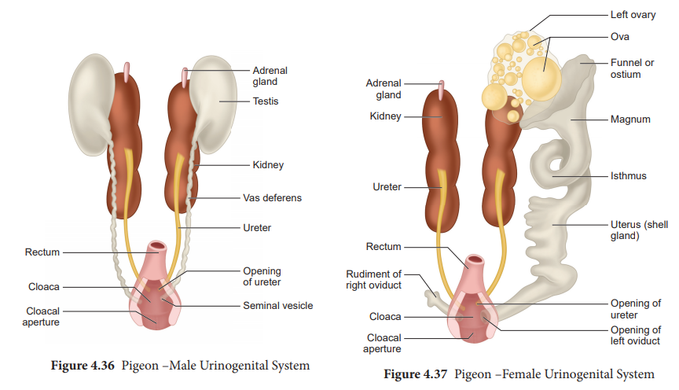  Urinogenital System and Anatomy of Pigeon: Excretory, Reproductive System  Urinogenital system  Excretory System  The paired kidneys which are metanephric are flat, elongated and lobulated. The ureters lead directly backward to open into the urodaeum or middle compartment of the cloaca; there is no urinary bladder. The nitrogenenous waste is excreted in the form of uric acid and discharged as a semi-solid mass. Adrenal bodies lie attached to the ventral surface of the kidneys as small yellowish elongated streaks.  Reproductive system.  A pair of ovoid testes are attached to anterior end of the kidneys by peritoneum (Figure 4.36). From each testis leads the vas deferens which runs backwards along the outer side of the ureter of that side, and opens on a small papilla into the urodaeum. The vas deferens is dilated into a seminal vesicle at its hind end. There is no copulatory organ.  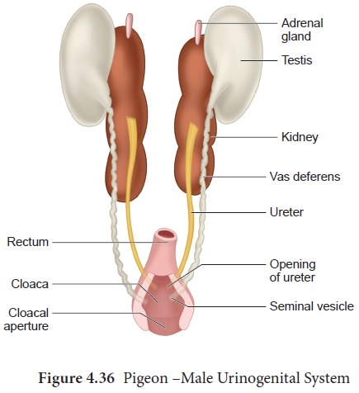  The female reproductive organs consist of a single ovary on the left side which is an adaptation to aerial life and an oviduct which opens into the body-cavity by a funnel-like aperture at the anterior end and posteriorly opens into the urodaeum (Figure 4.37).  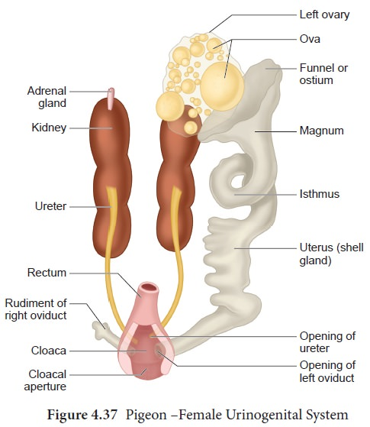
 | Rabbit external features, morphology, digestive, respiratory and circulatory system | External Morphology of Rabbit (With Diagram) | Chordata | Zoology  Shape, Size and Colour:  The rabbit is about sixteen inches (40 cm) in length from mouth to anus and weighs two to four pounds. Its body is pointed anteriorly and broad posteriorly, which is covered with soft uniform fur or hairs. It keeps the body temperature constant, i.e. 38.8°C., acting as heat insulator.  The colour of the European wild rabbit, Oryctolagus cuniculus, is dusty brown above but the ventral side and lower part of tail remains white. Its colouration is protective camouflaging with the surroundings. The colouration of the domestic varieties of rabbits varies greatly, e.g., it may be pure white, pure black or white with brown or black patches, etc.  Divisions of Body:  The rabbit shows a typical mammalian form of the body which consists of head, neck, trunk and tail. The trunk is further divisible into thorax and abdomen.  Head:  The head is large and spherical posteriorly but produced anteriorly into a large pointed blunt snout or muzzle.  The head bears the following structures:  1. Mouth:  The snout has a terminal transverse slit-like mouth, which is surrounded by two soft, fleshy movable lips. The upper lip is divided in the middle into right and left halves due to a vertical cleft extending up to the nostrils. Such a divided lip is known as the hare lip, due to which the upper front incisors are exposed.  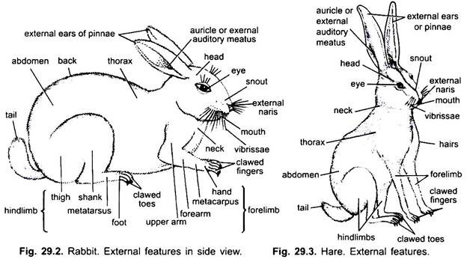  2. External Nares:  Just above the mouth are two oblique slit-like opening, the nostrils. The nostrils are surrounded by a bare moist skin, the rhinarium and lead into nasal or olfactory chambers.  3. Vibrissae:  From the sides of the upper lip thick tactile hairs vibrissae or whiskers project outwards. The hairs are stiff, long and sensory in function, because they have nerve endings around their bases.  4. Eyes:  A pair of eyes are situated at the sides of the head, each having movable upper and lower eyelids with very fine, short eyelashes. A small white coloured third eyelid, the nictitating membrane, is also present in the inner anterior comer of the eye. The nictitating membrane is also movable and stretched across the cornea and used for cleaning cornea.  5. External Ears or Pinna:  A pair of large, movable trumpet-shaped external ears or pinnae is found situated at the posterior lateral side of the head. The long pinnae are movable in all directions to receive the sound waves. Each pinna has an external auditory meatus at its base, which is closed below by the tympanic membrane. Both the pinnae remain upright when the rabbit is on the alert and laid back on frightening and running.  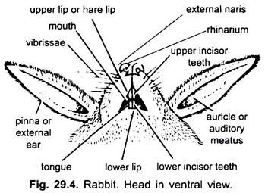  Neck:  The neck is an extension of the body which connects the head with the trunk at a slight angle. It enables the head to move in all directions. The neck of the rabbit is short and flexible. Its short neck is advantageous in its burrowing and fast running habits.  Trunk:  The neck is followed by large, cylindrical trunk, which is divided into anterior thorax and posterior broad, soft-bellied abdomen. The thorax or the chest forms a bony cage having ribs at the sides and sternum ventrally. The abdomen is without ribs and sternum. The cavity of the thorax is known as thoracic cavity in which tender body parts like heart and lungs are protected.  1. Teats:  On the ventral side between the thorax and abdomen are situated 4-5 pairs of well-developed and functional teats or nipples in females and rudimentary in males. The 4 or 5 pairs of mammary glands open on the outside at the teats.  2. Anus:  At the posterior end of the abdomen, at the base of tail is found the anus, which is the external opening of the digestive tract. A pair of hairless depressions is found in both the sexes, one on each side of the anus, called the perineal pouch into which the ducts of the perineal glands open. The secretion of the perineal glands has a strong odour, characteristic of rabbit.  3. Urinogenital Aperture:  Urinogenital opening is situated at the tip of the penis in male in front of anus. The penis is cylindrical, muscular and covered by the skin. In the male a pair of scrotal sacs are situated, one on either side of the penis, in which testes are lodged. The scrotal sacs are thin-walled bags of skin.  In the female the slit-like urinogenital aperture or vulva is present beneath the anus and at the anterior margin of vulva is present a rod-like clitoris which is similar to the penis of the male.  Limbs or Appendages:  The trunk bears two pairs of pentadactyle limbs. Both pairs of limbs take part in locomotion and support the weight of the body. Forelimbs are shorter than the hindlimbs.  1. Forelimbs:  The forelimbs are short and are held rigid to take the shock at the end of a leap. Each forelimb has a proximal upper arm or brachium, a middle forearm or antebrachium and the distal hand or manus with a wrist or carpus, palm or metacarpals and five fingers or digits with sharp, curved claws. The forelimbs are used for digging the burrow. The palm is hairy.  2. Hindlimbs:  The hindlimbs are longer and more powerful than the forelimbs. Each hindlimb has a proximal thigh, a middle shank or crus and a distal foot or pes with an ankle or tarsus, metatarsals and four clawed digits. Hallux (first toe) is absent. The hindlimbs are main locomotory organs. The sole is hairy.  Tail:  A short, bushy tail is found at the hind end of the trunk. The lower surface of the tail has a white hairy patch in wild rabbit, which is used for warning signal to other rabbits when danger approaches.  Locomotion:  The mode of locomotion in rabbits may be of three types- viz., walking, running and leaping. For walking, firstly, the forelimbs are moved forward as a whole nearly through 90 degrees therefore, the hands are directed in the same direction as the head and the pre-axial end of the limb remains situated near and parallel to the side of the body.  Then the upper arm is bent backwards, the forearms forward, while the hand rests with palms downward on the ground. Exactly in the same way, the hindlimbs are moved forward, hence, the preaxial side is near the body but the thigh remains directed forwards, while the shank is bent backwards and the sole of the toot comes in contact with the ground. So in such movements in rabbit, the limbs he under the body forming vertical levers.  How the Rabbit Digestive System Works  The initial stages of rabbit digestion are the same as most mammals. When a rabbit eats, the food travels from the mouth, down the oesophagus, into the stomach, and on to the small intestine. The small intestine is responsible for absorbing the nutrients from the food. As food travels along it, enzymes break the food down into individual nutrients that are small enough to pass through the lining of the intestine and be absorbed into the blood stream. Enzymes can't breakdown fibre, so in most mammals the fibre portion of the food would travel on through the colon and be excreted as waste. However, in rabbits the colon sorts the fibre into two types, digestible and indigestible.  Digestible fibre has nutrients locked away inside it, so the colon diverts it to the caecum for processing. The left over indigestible fibre doesn't contain any useable nutrients, but it is still essential to the digestive process, as it has helped carry the food through the digestive system. Its job is now complete, so the colon forms it into the hard round droppings your rabbit leaves in his litter tray and it passes out of the body as waste.  Meanwhile, in the caecum, a colony of special bacteria ferment the digestible fibre, breaking it down to release the stored nutrients. The caecum can absorb some of the nutrients but most need to go back through the small intestine to be absorbed. To achieve this, the fermented fibre moves back into the colon, where it is coated in protective mucus, before being excreted from the body as special droppings, called cecotropes or cecal droppings. The rabbit eats these droppings (a process called cacography) so they pass through the digestive tract again. In their new format, the small intestine can easily absorb the nutrients.  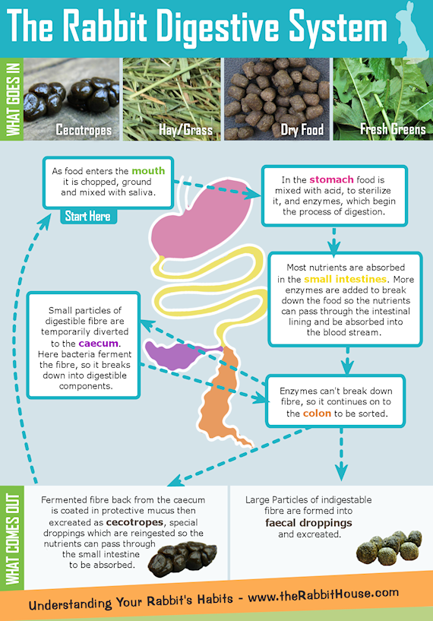  Why the right diet is important  Having such a specialised digestion system has drawbacks. Whilst it's very efficient at processing high fibre - low nutrient food like grass, the wrong types of food or sudden diet changes can easily disrupt it throwing the whole digestive system out of balance. For example:  - Too little bulky hay or grass to help food move along the gut slows it down and stops food travelling at the optimum speed for the digestive process to work.  - Too much carbohydrate or protein can send the gut into overdrive and produce sticky unformed droppings.  RESPIRATORY SYSTEM AND ORGANS IN RABBIT  INTRODUCTION  The energy is required for various metabolic activities in an individual. This energy is obtained by oxidation of end products of digestion at cellular level. Hence oxygen is essential for the maintenance of life. The oxygen is involved in oxidation by releasing carbon dioxide along with energy.  According to William S. Hoar, the intake of oxygen and expulsion of carbondioxide is called respiration. However, Yapp defined the process of respiration as energy releasing oxidative process. The process of respiration in vertebrates occurs in three phases namely,  - External respiration  - Circulatory phase  - Internal or Tissue respiration  External respiration  In this phase of respiration the atmospheric oxygen enters into the blood supplied to respiratory organs and carbon dioxide from the blood is sent outside. The exchange of gases between the atmosphere and the respiratory organs is known as external respiration. It is also regarded as ventilation of respiratory organs.  Circulatory phase  In this phase the oxygen that diffuses into the blood is carried to the different tissues along with blood circulation. The carbon dioxide from different tissues is also brought to the respiratiory organs through the blood. This transportation of gases through blood constitutes Circulatory Phase.  Internal respiration  In the third phase of respiration the oxygen that enters into the tissues involves in oxidation of food stuffs. As a result of oxidation, energy, carbon dioxide,water and nitrogenous wastes are formed. The energy is utilised for normal vital activities while the water and nitrogenous wastes are sent outside through excretory organs. Carbon dioxide is sent outside through respiratory organs. This ultimate energy releasing process at tissue level is called Cellular respiration or Internal respiration.  RESPIRATORY ORGANS IN RABBIT  The respiratory organs in rabbit are a pair of lungs. The respiratory system starts with a pair of external nostrils present at the anterior end of the snout. The nostrils open into nasal passage that is situated above the buccal cavity.  The nasal passage is separated from the buccal cavity by a palate. The nasal passage opens posteriorly into the pharynx by internal nostrils. The nassal passage helps in (a) olfactory sensation (b) Filtering the air and (c) Warming up the inhaled air.  The pharynx in rabbit has two openings namely the gullet and the glottis. The gullet leads into oesophagus while the glottis leads into the trachea. The glottis is guarded by a cartilaginous flap like structure called Epiglottis. The epiglottis prevents the entry of food into trachea by closing the glottis.  Larynx  The anterior part of trachea consists of larynx or voice box. It encloses a cavity called Laryngeal chamber. Two pairs of membranous folds called vocal cords are present inside the laryngeal chamber. One pair of vocal cords are true and the second pair are false. When air is sent outside the vocal cords vibrate to produce sound.  The wall of the larynx is supported by four cartilages namely a thyroid cartilage, a cricoid cartilage a pair of arytenoid cartilages. Thyroid cartilage is in the form of a broad ring, lying in the ventral and lateral walls of the pharynx. This cartilage is incomplete dorsally. The lower ring - like cartilage is cricoid which is broad dorsally and narrow ventrally. The arytenoids are present at the anterior end of dorsal side of cricoid. There is also a pair of small nodules called the cartilages of santorini present at the apex of arytenoid.  Trachea  The larynx opens into trachea or wind pipe that runs along the length of neck, ventral to the oesophagus. The trachea enters into the thoracic cavity and divided into two branches called Bronchi.  The trachea and bronchi are supported by incomplete cartilaginous rings called tracheal rings. Each bronchus enters into the lung of its side. The bronchus is further divided into small branches called bronchioles within the lung. Each bronchiole divides into number of alveolar ducts. The alveolar ducts terminate in Air sacs or Infundibuli formed of many alveoli. The alveoli are highly vascularised with blood capillaries. Smallest bronchioles are not supported by tracheal rings. Bronchioles are lined with mucous membrane. The wall of air sacs is made up of thin layer of flattened cells supported by highly elastic connective tissue. It is also supplied with large number of blood capillaries.  Lungs  The lungs in rabbit are hollow pinkish, spongyjobed bags, lying in thoracic cavity or air tight pleural cavities. They are surrounded dorsally by the vertebral column ventrally by sternum, posteriorly by the diaphragm, anteriorly by the neck and laterally by the ribs. The ribs are operated by two sets of intercostal muscles.  The internal surface of lungs is greatly increased and it is several times the surface area of the body. The left lung consists of two lobes namely left anterior and left posterior lobe.  The right lung consists of four lobes namely anterior azygos, right anterior, right posterior and posterior azygos. Inside each lung the bronchiole terminates in a cluster of air sacs or alveoli. Gaseous exchange occurs within the alveoli.
 | Rabbit – Excretory and reproductive system | CIRCULATORY SYSTEM OF RABBIT  - The circulatory system in animals is the main transport system.  - In lower animals like protozoa, porifera and cnidaria the transportation of oxygen and nutrients to different organs of the body and expulsion of carbon dioxide and nitrogenous wastes occur by means of diffusion through body surface.  - However, in higher animals the diffusion of substances does not occur more efficiently due to complexity of the body organisation.  - A special transport system is essential for transportation of various substances to each and every corner of the body. Consequently the circulatory system is evolved in the animals.  - In Arthropoda and Mollusca other than Cephalopoda, open type of' circulatory system is present.  - In open type of circulatory system, definite blood vessels are absent and the flow of blood is confined to sinuses or spaces present in the body.  - In Cephalopoda (Mollusca), Annelida and Chordata, closed type of circulatory system is developed.  - In the closed type of circulatory system the blood flows always in definite blood vessels and capillaries. In this system the various nutrients, gases, hormones and wastes are directly supplied to the tissues or mediated by tissue fluids.  - The circulation is maintained by a pumping centre called heart and blood vessels like arteries and veins.  - The circulatory system of higher animals is most efficient because of closed circulation.  - The circulatory system of rabbit is closed type i.e., the blood flows through blood vessels only. The circulatory system constitutes,  a. Heart  b. Arterial System  c. Venous System and  d. Blood  EXTERNAL STRUCTURE OF HEART  - The heart of rabbit is conical, muscular and lies in thoracic cavity between the two lungs.  - The broader end of heart is towards upper side while the conical end is directed downwards.  - The heart is slightly towards left side and enclosed by a double walled pericardium.  - The inner pericardial layer is called visceral layer while the outer pericardial layer is called parietal layer.  - A narrow space is left between the two pericardial layers, called pericardial cavity that is filled by pericardial fluid.  - The pericardial fluid helps in protection of the heart from external shocks and injuries.  - The pericardium is applied to the diaphragm to maintain the position of heart in the thoracic cavity from lungs through pulmonary veins.  - Two aortic arches originate from the ventricles.  - A carotico-systemic aorta originates from the left ventricle while a pulmonary aorta arises from the right ventricle.  INTERNAL STRUCUTRE OF HEART  - The two auricles are internally separated by inter-auricular septum.  - Similarly the two ventricles are internally separated by interventricular septum.  - The two auricles are communicated with the ventricles by openings called auriculo-ventricular apertures.  - The two pre-cavals and one post caval open into the right auricle.  - The opening of posterior vena cava is guarded by a membranous fold called Eustachian valve.  - The right auriculo-ventricular aperture is guarded by three membranous flaps which constitute tricuspid valve.  - The tricuspid valve allows the flow of blood from right auricle into right ventricle but prevents the backward flow of blood from ventricle into auricle.  - The inner surface of the walls of the ventricle is provided with number of ridges called columnae carneae and few conical elevations called the papillary muscles.  - The free edges of the tricuspid valves are connected to the papillary muscles by white fibres called chordae tendinae.  - From the left anterior angle of right ventricle a large blood vessel called pulmonary aorta arises that carries blood to lungs.  - The base of pulmonary aorta is guarded by three semilunar valves which prevent the backward flow of blood from pulmonary aorta into ventricle.  - The left auriculo-ventricular aperture is guarded by two membranous flaps called bicuspid valve or Mitral valve.  - The free edges of these flaps are continued into chordae tendinae attached to the papillary muscles of ventricle.  - At the right angle of left ventricle arises a large aortic trunk called carotico-systemic aorta.  - The base of carotico - systemic aorta is guarded by three semilunar valves which allow the flow of blood from left ventricle into aorta but prevent the downward flow.  WORKING OF THE HEART  The heart of rabbit exhibits rhythmic contractions and relaxations.  - The contraction is called Systole while the relaxation is called Diastole.  - The systole and diastole are together referred as Heart beat.  - The heart beat is initiated by a special node of muscular tissue called sinu - auricular node present on the inner wall of right auricle.  - The sinuauricular node acts as pace maker and generates certain power in the form of electric impulses.  - The frequencies of the impulses are governed by nerve fibres.  - Such impulses are conveyed to the muscles of heart to exhibit rhythmic contractions and relaxations.  - The impulses are also picked up by another node called auriculo-ventricular node lying on the inter-auricular septum.  - The impulses are conveyed to Bundle of His and purkinje fibres running through inter - ventricular septum to carry to the wall of ventricles.  - The right auricle receives impure or de-oxygenated blood from different regions of the body by two superior venae cavae and one inferior vena cava.  - The left auricle receives pure or oxygenated blood from the lungs by means of pulmonary veins.  - When the auricles are filled by blood they contract to force the blood into the two ventricles through auriculo- ventricular apertures.  - When the ventricles are filled with blood, they contract to force the blood into aortic trunks.  - The backward flow of blood from the ventricles into the auricles is prevented by the closure of bicuspid and tricuspid valves. The closure of the bicuspid and tricuspid valves produces first heart beat.  - When the ventricles contract the semilunar valves situated at the base of carotico - systemic trunk and pulmonary aorta are opened.  - As a result the deoxygenated blood from the right ventricle is forced into pulmonary aorta while the pure blood from left ventricle is forced into Aortic arch.  - Now the semilunar valves close to prevent the downward flow of blood from aortic trunks into the ventricles.  - The closure of semilunar valves produces the second heart beat.  - The pulmonary aorta carries deoxygenated blood to the lungs for aeration.  - The aortic trunk supplies pure blood to different organs of the body.  - In different parts of the body the blood gets deoxygenated due to the release of CO₂.  - The aerated blood from lungs and deoxygenated blood from the tissues enter into the heart to repeat the circulation once again.  Excretory System of Rabbit (With Diagram) | Chordata | Zoology  This system is generally responsible for the elimination of metabolic waste products (nitrogenous waste products in the form of urea, etc.), excess of salts and water from the body. The organs of excretion in rabbit are a pair of kidneys, ureters and a urinary bladder.  Kidneys:  The kidneys are metanephric and main organs of excretion.  1. External Structure:  The kidneys are two, dark red and bean-shaped attached to the dorsal abdominal wall outside the coelom, one on either side of the vertebral column. The right kidney is situated somewhat more anterior than the left. Each kidney is ventrally covered by peritoneum. The outer side of each kidney is convex and inner side is concave having a notch or depression, the hilum or hilus. A renal artery enters the kidney at hilus and a renal vein comes out of it through the hilus.  2. Internal Structure:  In a longitudinal section, the mammalian kidney is seen enclosed in a thin capsule of fibrous connective tissue.  Cortex:  Beneath the capsule is the cortex part of the kidney which is homogeneous and light in colour.  Medulla:  This is the inner region of kidney which is dark in colour.  Pelvis:  It is a large, funnel-shaped space in the centre of kidney towards the hilus. The urine is collected here and later drained off by the ureter.  Pyramids:  In rabbit and man, the medulla is formed of a number of lobes, called pyramids, and the cortex is continued inside between the pyramids to form renal columns of Bertini. In rat the conical pyramid is single. The pyramids are projected into the pelvis. The kidney is formed of a mass of fine, long, convoluted tubules, called the uriniferous tubules or nephrons embedded in connective tissue having blood and lymph vessels, nerves and smooth muscle fibres.  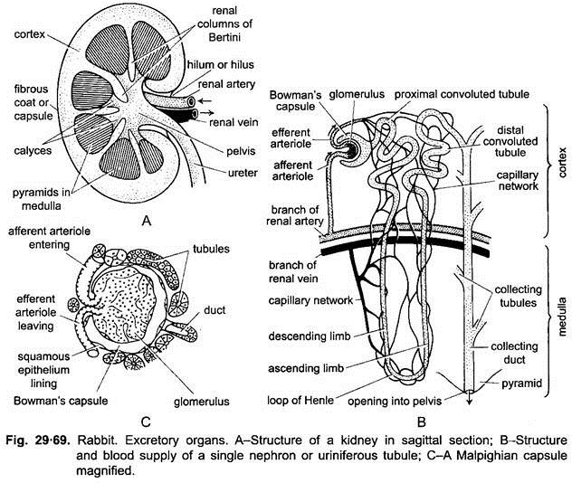  Each uriniferous tubule is formed of a Malpighian capsule and convoluted duct.  The Malpighian capsule consists of a proximal cup-shaped Bowman’s capsule in the cortex and in its lumen is present a tuft of blood capillaries, called glomerulus. The Bowman’s capsule enclosing the glomerulus is collectively known as Malpighian capsule or renal corpuscle.  The convoluted tubule behind the Malpighian capsule is divisible into three regions:  (a) Proximal convoluted tubule,  (b) Henle’s loop and  c) Distal convoluted tubule.  The proximal convoluted tubule starts from the Bowman’s capsule and makes a few coils in the cortex and then proceeds downwards as descending limb in the medulla to form a thin loop of Henle. It again proceeds towards the cortex as ascending limb and again extends towards the cortex as ascending limb and forms a few coils in the cortex, called the distal convoluted tubule.  The distal convoluted tubule joins with one of the larger collecting ducts. The collecting ducts collectively form a pyramid and finally open into the pelvis. The wall of the tubule is made of cuboidal epithelial cells which are ciliated at interval, whereas the wall of Bowman’s capsule is formed of single layer of squamous epithelium.  Blood supply of the kidney- The renal artery after entering into the kidney divides and redivides forming several arterioles. Each arteriole enters a Bowman’s capsule as an afferent arteriole which capillarises to form the glomerulus and then an efferent arteriole emerges from the glomerulus and again capillarises around the convoluted tubule to distribute the blood in the remaining part of the tubule.  These capillaries unite together to form a venule and a number of such venules unite together to form a renal vein which comes out of the kidney from the hilus. The diameter of efferent arteriole is larger than the efferent arteriole. Branches of renal artery and renal vein run along the junction of cortex and medulla and give branches to the glomerulus and receive branches from them respectively.  Ureters:  Each thick-walled ureter starts from the hilus and runs backwards along the dorsal abdominal wall and opens posteriorly into the neck of urinary bladder.  Urinary Bladder:  The urinary bladder is a pear-shaped, transparent muscular sac, situated in the pelvic region ventral to the rectum and connected to the ventral abdominal wall by a suspensory ligament. It serves as urine reservoir.  The posterior narrow neck of the bladder bears a circular sphincter muscle. The neck of urinary bladder opens into a thick-walled, muscular canal, the urethra. In male, it is much longer and passes through the penis and opens at its tip. It is called urinogenital canal. In female, it is short and unites with the vagina to form the vestibule and opens out by a slit-shaped vulva.  Physiology of Excretion:  The nitrogenous waste products of metabolism in rabbit are generally urea which is synthesised in the liver from amino acids, by a cyclical chain of reactions. The urea is then carried through the blood into the kidneys where it is eliminated with the urine. Urine formation in kidneys occurs by ultrafiltration, selective reabsorption and secretion.  1. Ultrafiltration in Glomerulus:  Blood comes under high pressure in the glomerulus through the afferent renal arteriole whose diameter is greater than that of efferent arteriole. Here ultrafiltration occurs through the permeable walls of the capillaries of glomerulus.  Thus, due to ultrafiltration the dissolved substances of the blood, e.g., urea, salts (sodium and potassium), glucose, water, etc., are filtered into the lumen of the cup of Bowman’s capsule. Now the blood contains corpuscles, proteins and fats. This filtrate is known as glomerular or capsular filtrate. The remaining blood constituents pass into the efferent arterioles. This process is simply a physical process.  2. Selective or Tubular Reabsorption:  The glomerular filtrate contains some useful substances like water, glucose, amino acids and some salts. These useful substances are reabsorbed in the proximal convoluted tubules from the glomerulur filtrate. The absorbed substances then pass into the blood circulation through capillaries of the efferent arterioles found around the convoluted tubule which finally joins to form renal venules.  The maximum water is reabsorbed in the loop of Henle and no reabsorption occurs in the distal convoluted tubule. Glucose, amino acids and some urea are reabsorbed in the proximal convoluted tubule, while chloride and bicarbonate of sodium are reabsorbed in the proximal and distal convoluted tubules. The water and urea are reabsorbed by passive diffusion. Amino acids, salts and sugars, etc., are reabsorbed by active transport  Thus, as the glomerular filtrate passes through the convoluted tubule, the useful substances are reabsorbed and the concentration of waste products including urea increases.  3. Tubular Secretion:  In this process some substances like remnant urea, creatine, creatinine, ammonia, hydrogen, potassium ions, various drugs, etc., are secreted into the lumen of tubule from the efferent capillaries surrounding the tubules.  After tubular secretion the substance which is left in the tubule is rich in excretory wastes and finally known as urine which contains nearly 95% water, 2% urea, 6% Ca and Na chlorides, some uric acid, creatinine, ammonia, etc. It also contains a pigment, urochrome, formed by the breakdown of haemoglobin. It gives yellow colour to the urine.  The urine, thus, formed passes into the collecting tubule and finally reaches the pelvis and ureter from where it is collected in the urinary bladder. The bladder contracts and forces the urine outside through the urinogenital canal and urinogenital aperture.  Besides excretion, kidney regulates the body fluids (blood and water) within the body, thus, also acting as homeostatic organ. Homeostasis is the method for regulating concentrations and contents within the body to preserve equilibrium in any animal.  4. Other Organs of Excretion:  Besides kidney, some other organs also perform excretory functions. The CO₂ evolved during tissue respiration is removed by the lungs. Some amount of water is removed in the form of vapours with the expired air and some salts are also removed with the sweat. Bile salts and bile pigments are removed by the alimentary canal which are produced in the liver.  Rabbit Reproduction - Anatomy & Physiology  The male rabbit is known as the buck.  Penis  The penis has a rounded penile sheath and urethra. It can be easily extruded in rabbits over 2 months of age.  Testes  The rabbit has two testes that descend at approximately 12 weeks of age. These testes are large with epididymal fat pads. In the adult male they lie in two almost hairless scrotal sacs which are cranial to the penis (in the majority of placental mammals they lie caudal to the penis). The inguinal canal remains open throughout life.  Accessory Sex Glands  The seminal vesicles open into the prostatic section of the urethra. The bulbourethral glands are small and paired. They form a bilobed swelling in the dorsal wall of the urethra, just behind the prostate.  Mammary Gland  Male rabbits do not possess nipples.  The female rabbit is known as the doe.  Uterus  The female rabbit has a bicornuate duplex uterus. This has two separate uterine horns and no uterine body. Each horn has its own cervix, and the two cervices open into a single vagina.  The mesometrium is a major fat storage organ. It is very friable and contains many vessels, however only minor anastomoses exist between the uterine and ovarian vasculature.  The age of sexual maturity varies with breed:  - Small breeds mature at ~5 months  - Larger breeds mature as late at as 8 months.  Rabbits are induced ovulators with no well-defined oestrous cycle. The female rabbits have periods of sexual receptivity every 4-6 days and the oestrus period lasts ~14 days. Ovulation occurs within 10 hours of coitus.  The breeding season lasts from January to October in the UK.  Does can become quite territorial and this needs to be taken into account when planning any matings. It is advisable to take the doe to the buck rather than the other way round.  Pregnancy diagnosis  Foetuses may be felt by gentle abdominal palpation as early as 10 days post breeding as 1 to 1.5cm masses in the caudal ventral abdomen. At 18 days they should be 2.5 to 3cm in length.  Radiography or ultrasonography can be used after 21 days if necessary.  Gestation  The gestation period of a rabbit is 29-35 days.  Pseudopregnancy may occur, which lasts approximately 18 days. It can be caused by infertile mating, or the presence of a male nearby. The dam is unable to conceive during this time. During pseudopregnancy, the corpus luteum secretes progesterone, which causes the uterus and mammary glands to grow.  Litter  The litter size can vary from 4-12 offspring.  The young are altricial - born hairless, deaf and blind. Offspring are totally dependent on their mother for the first few weeks of life. They are protected from the environment and predators by the nest which is made by the doe using hair from her dewlap. If the nest is disturbed, the doe may cannibalise the offspring.  Mammary Gland and Lactation  The doe has four or five pairs of nipples. The mammary gland develops in the last week of pregnancy. Suckling is stimulated by a pheromone produced by a gland near the nipple.  Consumption of water and caecotrophs by the doe increases 10-fold during lactation.  Rabbit milk is richer than cow's milk, it has an unusually low lactose content and a very high protein and fat content.  Composition:  - 13% Protein  - 9% Fat  - 1% Lactose  - 2.3% minerals  Kits are best sexed at birth or at weaning (5-8 weeks of age). In between those times it can be difficult to exteriorise the genitalia.  Sexing is performed by gentle pressure on the genital orifice which everts the penis or vulva. The male has a cylindrical organ with a rounded to oval-shaped urethral opening. The female vulva has a leaf-like appearance with a slit-like opening.  In the male the testicles descend at around 12-14 weeks of age and can be palpated, although they can be retracted into the abdomen if the rabbit is stressed.
REFERENCES

